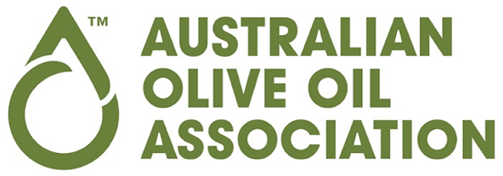
MEDIA RELEASE

17 April 2024
_________________________________________________________________________________

How To Ensure You Buy Quality Olive Oil
The Australian Olive Oil Association (AOOA) says there is an easy way to ensure you buy premium quality, authentic olive oil. Look for AOOA’s Certified Quality Seal on the bottle.
The Australian Olive Oil Association is Australia’s independent peak body for Australian olive farmers, olive oil distributors, international olive oil producers and industry associates. The Association has been testing the quality of olive oil in the Australian market for 30 years. The Association is a signatory to the International Olive Council’s (IOC’s) global quality monitoring program, and regularly tests oils to ensure they meet or exceed the International Standard for olive oil quality and authenticity.
AOOA General Manager Jan Jacklin said it was no secret olive oil prices have jumped in recent months. “Consumers have noticed the price increase and that’s as a direct result of the global shortage of olive oil. Spain is the world’s largest producer of olive oil and crops have been decimated by drought for the past two years.
“Because supply is short, the wholesale price for olive oil has soared and we’re seeing those price increases on supermarket shelves around the world.”
The Certified Quality Seal program pioneered by the Australian Olive Oil Association sets the benchmark when it comes to olive oil quality. Oils which qualify for AOOA’s Quality Seal are rigorously tested in IOC accredited laboratories to ensure the oil meets or exceeds the International Standard.
“Olive oil is a premium product. It adds so much flavour to dishes and the health benefits are well documented. The Quality Seal provides consumers with a simple and effective way of identifying olive oil that is authentic and delivers exceptional quality,” Ms Jacklin said.
Brands which qualify for AOOA’s Quality Seal include Squeaky Gate, Sandhurst, Hunter’s Dream, Sumich, Moro and Filippo Berio.
In a separate testing program, AOOA independently monitors the quality of olive oil on the Australian market annually.

“In the last 10 years we’ve tested more than 300 samples of olive oil in accredited laboratories and 99% were authentic and correctly graded,” Ms Jacklin said. “Consumers should feel very confident about buying olive oil based on these results.”
“As well as the annual testing program we keep watch on the market and if there are concerns about a particular olive oil, we will have that oil independently tested and notify the brand of the test results. If a quality or labelling issue is found, which is rare and generally only in lesser-known brands on the fringe of the market, we will report it to the ACCC or the state government food authority in individual states.”
“Olive oil is a beautiful product to be celebrated. We know Australians love it and we want them to use more of it.
“Our recent ‘Get Drizzling’ campaign highlighted the flavour a drizzle of olive oil brings to everyday dishes. By drizzling olive oil on everything from smashed avocado to a superbly cooked steak and even ice cream, it’s easy to add another layer of flavour and lift the meal to something more impressive.
“Ultimately we want to change people’s behaviour by encouraging them to drizzle olive oil on every dish. It’s simple, has health benefits and is delicious,” Ms Jacklin said.
Australia is now moving into the olive harvest (April to June) and Ms Jacklin noted some early concerns about the 2024 harvest.
“While we don’t know exactly where the harvest will land, there are concerns about a crop shortage this season which may lead to further pressure on prices.”
However, she added, “There has been good rain at the right time for olive groves in Spain and this bodes well for a good international harvest later this year and early next year.
“A successful harvest overseas may help to create downward pressure on global prices and we may see that impact in mid 2025,” she said.

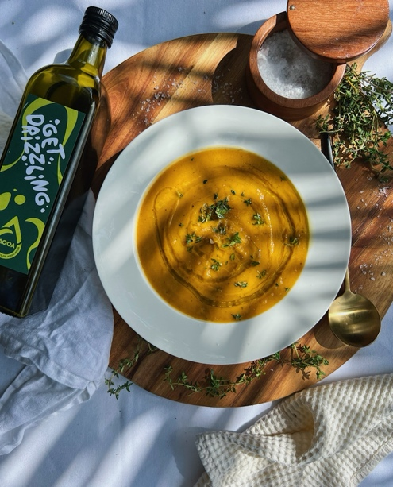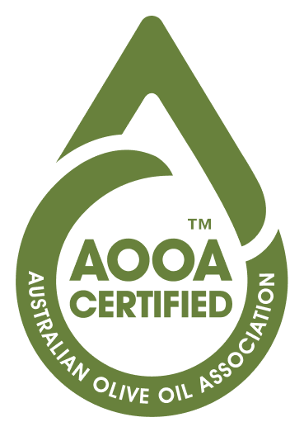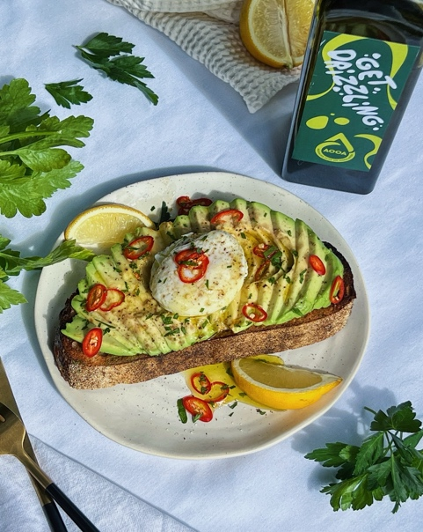
A drizzle of olive oil adds flavour The AOOA Quality Seal Finish your dish with a drizzle of olive oil

For more information:
Jan Jacklin
gm@aooa.com.au | 0417533281
www.aooa.com.au www.getdrizzling.au

The Australian Olive Oil Association is Australia’s leading independent industry association for olive oil. Members include Australian olive farmers, olive oil distributors, international olive oil producers and industry associates. AOOA members represent the majority of olive oil sold in Australia.
The Association is focused on the promotion of olive oil, international trade standard and fair competition in the Australian industry.

