Andrew Oliver
Assistant Gallery Director
Bungendore Wood Works Gallery
02 6238 1682
gallery@bwoodowrks.com.au

Release Date 24/4/2024
FOR IMMEDIATE RELEASE
Bungendore Wood Works Gallery, Best Gallery in Australia 2024, selected by the USA World Art Awards Board is remembering Ukraine and Gallipoli.
This commercial Gallery is celebrating 40 years and is situated at the crossroads with King’s Highway to the South Coast, defining the village of Bungendore, 30 minutes from Canberra.
This quiet achiever Gallery now distinguishes itself with a headline supporting Ukraine War of Independence 2020 on a large entrance wall painted in Ukraine National Flag colours.
The wall and on the floor in front of the wall are changing installations continuing until September 30.
And for this special Day, this outreach gallery has strung a banner from the outside veranda posts fronting the Kings Highway intersection.
REMEMBERING UKRAINE
ON THIS SPECIAL DAY
AND EVERY DAY

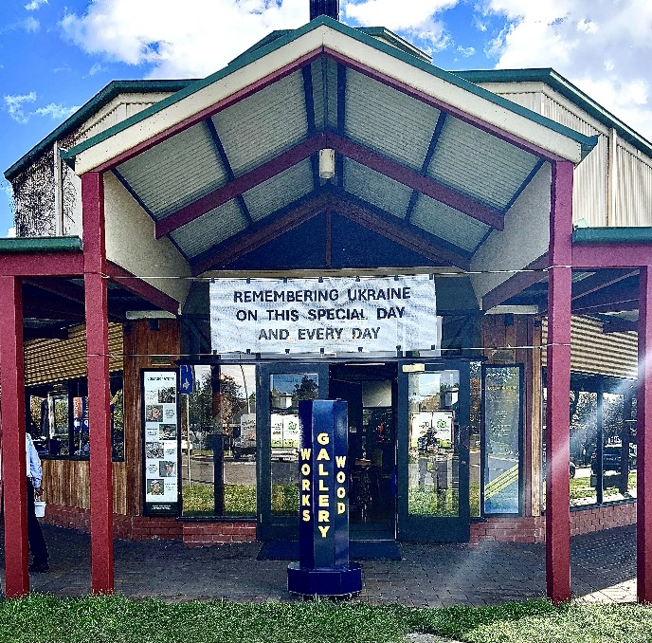

“I am not Ukrainian. No one in my family is Ukrainian. I do not even know any Ukrainians.”
This according to visionary David MacLaren OAM, retiring Director of the Gallery for forty years:
“But I do know a little history. And I do Remember both World Wars, and the devastation to two generations of young people. The resulting world order democracies have set in place and the values of a peaceful existence. These values, this order, is worth everything to preserve.”
David MacLaren OAM
“Please visit us to see our entrance Wall dedicated to Ukraine, help us celebrate our forty years, and especially see why we were selected The Best Gallery in Australia 2024.”
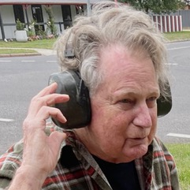
Founder, owner, Art Director David MacLaren received an OAM in 2018 for service to the Arts and the Community.
2 National Tourism Awards
The Wood Works Gallery received 2 National Tourism Awards in 1992 and 1993, and has won 8 ACT Tourism Awards in 1990, 1991, 1992, 1993, 1994, 1998, 2000 and 2001, a NSW Significant Attraction Award in 2003, ACT Specialised Tourism Services Award in 2007, NSW Independent Retailer of the Year Award in 2008 followed by Australian Independent Retailer of the Year Award in 2008 and the 2014 Capital Region Tourism Award for Visitor Experience.
Heritage and Contemporary
This 500 square meter gallery was designed by local architect, Maurice Barnes to be a contemporary addition to the heritage buildings defining the intersection on the King’s Highway from Canberra Queanbeyan to the South Coast.
All Australian Timbers
The Gallery was built in 1994 from West Australian Jarrah, Tasmanian Oak, NSW Flooded Gum and Victorian Ash.

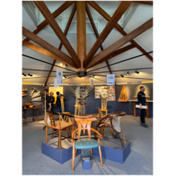

www.bwoodworks.com.au
World Art Awards
The 2024 World Art Awards Selects Bungendore Wood Works Gallery in Australia, and among the Best Galleries and Museums in the World, 2024. [Thom Bindz, President, on behalf of the World Art Awards.]
The first annual World Art Awards has selected the 20 Best International galleries and Museums for 2023.” This year is the second year of these International Awards.
Local gallery wins big on international stage.
Local Regional commercial Gallery wins international: One of 20 Best Galleries in the World 2024.
Bungendore Wood works Gallery celebrating its 40th year wins Best Gallery in Australia 2024 – World Art Awards
A Place for Wood Workers
The Wood Works defines itself since 1983: “A place for wood workers to display their works, where diversity is encouraged, and fine skills are essential.” Attracting most of the best makers in Australia for forty years.
Sculpture and Fine art complement the studio furniture in settings that set a stage for appreciation.
The Collaborators
The Collaborators: Six Designer Makers in Search of Authenticity. This Exhibition is David MacLaren’s Farewell Exhibition and as such is rendered as a Play in Three Acts that closes September 30 2024.
The Exhibition is a look back at David’s 40 years as Founder, Director, and to some of his past as an aspiring playwright in Manhattan in the late 60’s early 70’s before he discovered his Wood Working passion.


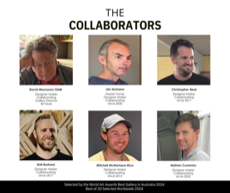

The play The Collaborators; Six Designer Makers in Search for Authenticity references Luigi Pirandello’s Six Characters Searching for an Author. Pirandello born in 1887, received a Nobel Prize for literature in 1937.
[Image: Pirandello with Einstein]
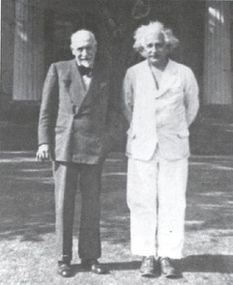

David MacLaren OAM
Designer Maker
bwoodworks.com.au
gallery@bwoodworks.com.au
+61 2 6238 1682
Founder Owner Artistic Director Bungendore Wood Works Gallery 1983
Founding Executive Bungendore Chamber of Commerce 1989
Founding Committee Bungendore Community Foundation 2004
Founding Committee: Bungendore Town Centre and Environs Advisory Committee to Council 2008
Founder David Stewart Mac Laren Design 2022
davidmaclaren.com.au
dmaclaren64@yahoo.com
+61 6238 1682

