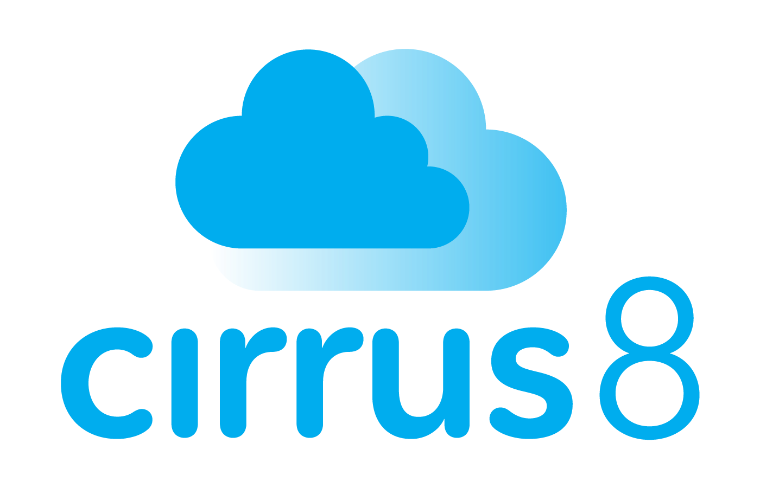

Media Release
25 January, 2024
For Immediate Release
Contact: Dee van Rooyen, Senior Sales and Marketing Manager – Cirrus8 Email: dee@cirrus8.com.au | Phone: 0438 726 912
Breaking Real Estate News: Cirrus8 Announces Strategic Play Bringing David Matulis Onboard For International Expansion
Cirrus8, a leader in commercial property management software in Australia and New Zealand, is delighted to announce the appointment of David Matulis to its Senior Leadership Team. David brings a wealth of experience in the Commercial Real Estate (CRE) industry, further solidifying Cirrus8's commitment to understanding and innovatively addressing the sector's complexities.
David's illustrious career includes a role as Associate Director – Property Accounting, at Fitzroys in Melbourne. His expertise spans project management, property trust accounting software system implementation, facilities management, and senior leadership. Renowned for his customer-centric and strategic approach, David's inclusion in the team is a testament to Cirrus8's dedication to delivering exceptional service and solutions.
Reﬂecting on his new role, David expressed enthusiasm about the synergy between his experience and Cirrus8's ethos. "Part of the appeal of joining Cirrus8 was undoubtedly the many positive experiences I have had dealing with Cirrus8 previously as a customer," he said. "I'm looking forward to playing a role in Cirrus8's continued success with the goal of further enhancing the strong customer service and relationships already provided by the team."
David's primary focus will be enhancing customer experience throughout their journey with Cirrus8 and its international expansion. His appointment is a strategic move for Cirrus8, aligning with its vision of being at the forefront of innovative and customer-focused solutions in the commercial property management space.

Cirrus8 prides itself on the extensive CRE knowledge base of its team. As the only Australian-owned and based cloud solution in this specialist commercial property management and accounting space in Australia, Cirrus8 has become the most recommended commercial property management software in Australia and New Zealand.
Since its inception in 2016, Cirrus8 has experienced signiﬁcant growth in Australia, expanding into New Zealand recently and now setting its sights on international expansion. The company serves a diverse customer base, including commercial real estate agents, fund managers, syndication groups, and property owners and managers. Read more about Cirrus8 on their website www.cirrus8.com.au.

End of Release

