Press Release

After a busy year, delivering pioneering drone light shows across regional Australia and interstate, culminating in Kooranup Wadjemup (Rottnest) at last month’s Fremantle Biennale, WA-based business Stellar Lights is pleased to announce, it was twice named a winner in the 4th International Drone Show Competition at the Live Design International Trade Show (LDI) in Las Vegas last week.

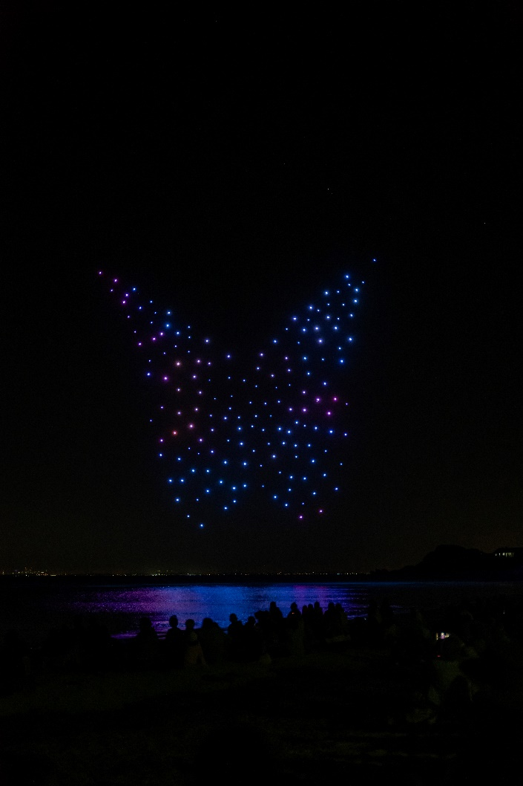
Figure 1 – Kooranup Wadjemup

Stellar Lights was awarded first place in the category “Drone Show with a Small Fleet” for their production titled “The Seagull and the Sea”. The show, produced by Ron Bradfield Jr and Jarrad Russell, playfully explores the lives of seagulls, integral to coastal myths and often seen as symbols of good luck. Using 60 drones to bring the story to life and evoke nostalgic memories of childhood beach adventures, the show has been premiered at Cottesloe Primary School and most recently at the City of Cockburn’s Rotary Spring Fair where Stellar’s technical team delivered another world-first, successfully flying the drones around a huge Marri tree as part of the spectacle.
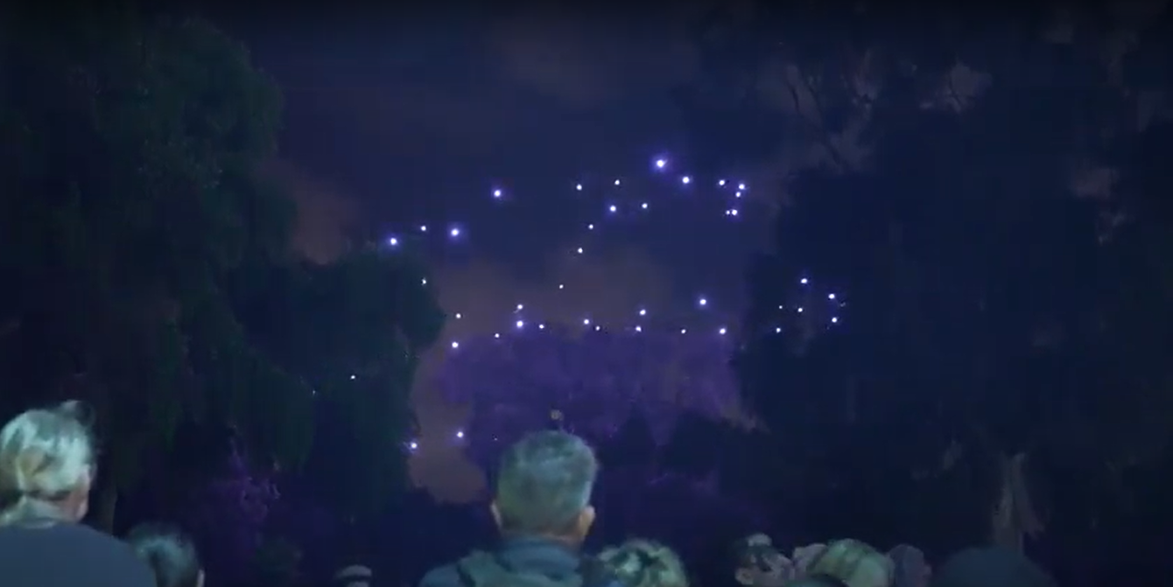

Commenting on the success of the show, Stellar’s Business Development Manager, Tim Fraser said “Seagulls was developed to address a gap in the market. Our brand of high quality, creativity-led shows were in high demand, but many of our clients didn’t have the budget required to develop one of these productions from storyboard to full show. We pre-produced “The Seagull and the Sea”, a 60-drone show on the basis that we could make it available to several clients at a much more accessible price point”.
Stellar Lights also picked up second place in the fiercely competitive “Drone Show Storytelling” category for “Nyinggulu”, a show developed by the Fremantle Biennale’s First Lights team, within which Stellar Lights are the Technical Directors. “Nyinggulu” was developed with local artists Hazel Walgar and Sonya Edney as the centerpiece of the “Dark Sky Festival” commemorating the total solar eclipse witnessed in Western Australia's Ningaloo region in April 2023.

This award backs up the first prize Stellar took out in the same category in 2021 for Ilona McGuire’s acclaimed “Moombaki”, Fremantle Biennale’s debut drone light show.

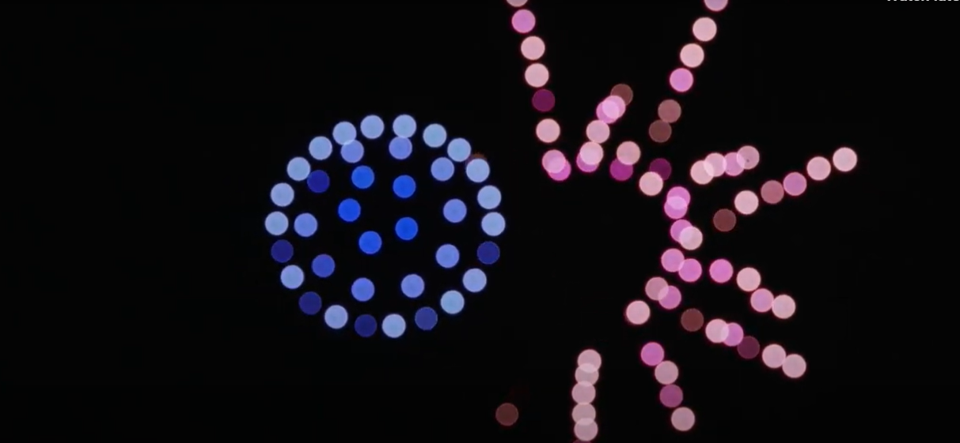

Commenting on the team’s success, Stellar’s Managing Director Rob Lednor said “recognition in a global competition through two awards, voted on by industry peers and a panel of experts is a testament to the combined efforts of our team. The creative talent we work with here in WA is immense and to win these two awards puts us on a level with global industry heavyweights who have thousands of drones and millions of dollars in venture capital their disposal. We a truly punching well above our weight on a global scale and can’t wait to take our brand of shows out onto the international market in 2024.”

www.stellarlights.com.au
www.firstlights.com.au
Contact Information: Rob Lednor + 61 41 095 3282

