A New Generation of Probiotic Products Launching Across China
Australia's VPROBITIC Explores Wider Chinese Market in A Partnership with CRPCG

CHINA INTERNATIONAL IMPORT EXPO (CIIE), November 8, 2023, Australian probiotic technology company Melbourne Brand Pty Ltd and China Resources Pharmaceutical Commercial Group Co., Ltd (CRPCG). Signed a strategic partnership agreement. The two parties will work closely to continuously bring together the latest innovations in Australian and European biotechnology to the CHINA market. The first-generation VPROBIOTIC probiotic health products are introduced to China through China Resources Pharmaceuticals’ mature national channel network.

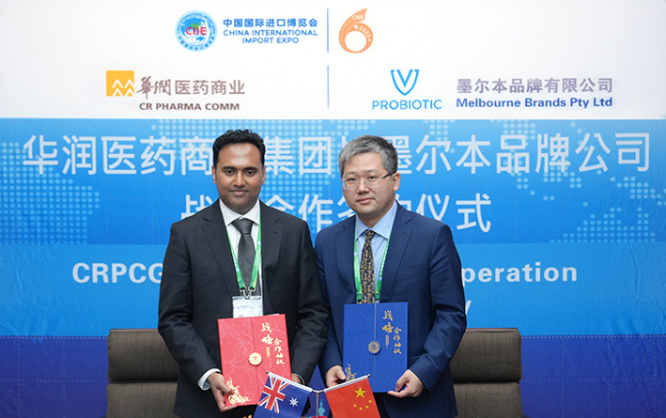

（Above: Mr. Roneel Anand, CEO of MB., and Mr. Guan Ziqi, Head of the International Division of CRPCG., signed a strategic cooperation agreement as representatives of Chinese and Australian enterprises. ）

According to 2021 United Nations data, the life expectancy at birth in China is 76.9 years, ranking 39th in the world. In addition to genetic and socioeconomic factors. Intestinal health has an impact on life expectancy. Researchers found that compared with other elderly people, centenarians have a different gut flora1. Intestinal health is easily overlooked and attracts attention when most people encounter serious problems or are diagnosed with diseases. At present, it has become a global consensus that probiotics have a healthy regulatory effect on the human body.

The global probiotics market is expected to grow at a CAGR of 8.1% from 2022 to 2027, from an estimated USD 57.8 billion in 2022 to USD 85.4 billion. China's probiotic market is expected to grow at a compound annual growth rate of 12.23%, from US$9 billion (equivalent to approximately RMB 65.5 billion) in 2020 to reach US$20.8 billion (equivalent to approximately RMB 152.1 billion) in 2027.

Mr. Roneel Anand of Melbourne Brand Company said: "Thanks to the support of Austrade, the CHINA INTERNATIONAL IMPORT EXPO (CIIE) provides a wonderful opportunity for Australian companies to connect with Chinese partners. The development of the probiotic industry in Australia and Europe is very mature. In the probiotic industry as a leader in bacterial research, we offer the VPROBIOTIC range, which is of high quality and is formulated with clinically tested and patented strains and manufactured in a TGA facility in Australia. Our product range helps patients and consumers to have a healthy intestinal tract and prolong life. At present, our new generation of VPROBIOTIC professional compound probiotic products are widely used in children, women middle-aged, and the elderly.

Mr. Anand also said, "We believe that our collaboration with China Resources Pharmaceutical Commercial Group (CRPCG) is a win-win cooperation. CRPCG is one of the largest distributors and sellers of pharmaceuticals and health products in China. It also has an extensive sales network covering every corner of China. We believe that they will be the best partner for VPROBIOTIC. Through cooperation, more Chinese consumers and patients can benefit from using VPROBIOTIC and have a 'good gut, good health, and good life'."

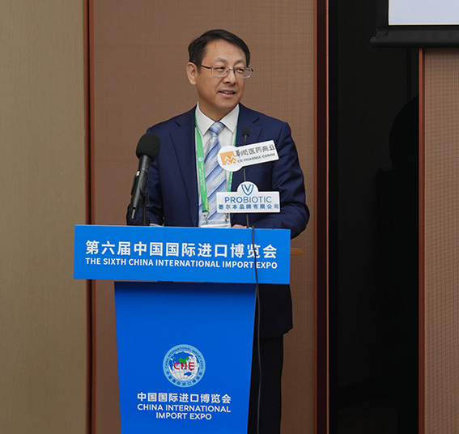

（Above: Mr. Wu Jianjun, Chairman of China Resources Pharmaceutical Commercial Group,
delivers a speech at the signing ceremony. ）

Regarding this cooperation, Mr. Wu Jianjun, Chairman of China Resources Pharmaceutical Commercial Group Co., Ltd., said: "China Resources Pharmaceutical Commercial Group has always been rooted in the industry with its excellent professional service capabilities. Now, the CIIE has become a new development pattern for China a window, a platform to promote high-level openness, and international public goods shared globally. In this strategic cooperation with Melbourne Brands Pty Ltd, China Resources Pharmaceutical Commercial Group will provide a comprehensive channel network, deep coverage, and diversified channels which will accelerate the coverage of Melbourne Brands products in the Chinese market and continue to improve the accessibility of high-quality products to consumers. Although the development of China's probiotic industry is still in its initial stage, I believe that through our company, and cooperation with Melbourne Brands, relying on our industry knowledge and resources of both parties, we will be able to jointly promote the healthy development and growth of the Probiotics market in China!"

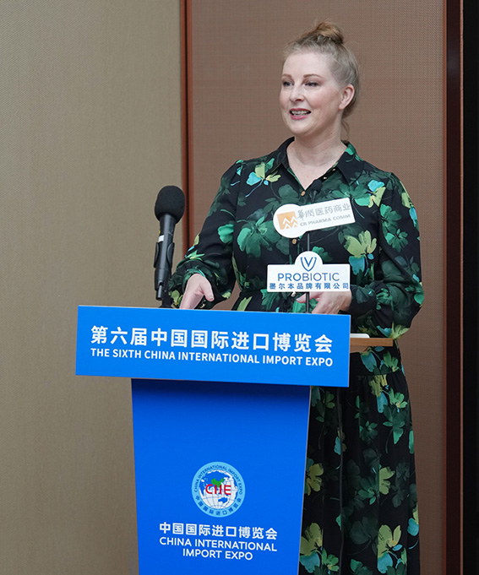

（Above: Ms. Andrea Myles, STC, Austrade, Deputy CG, Australian Consulate-General, Guangzhou, delivers a speech at the signing ceremony. ）

Ms. Andrea Myles, Deputy Consul General, Australian Consulate-General, Guangzhou, said: "China is Australia's largest trading partner. The economies of China and Australia are highly complementary. Australia's health industry is world-renowned for its high quality and R&D capabilities. According to CMA (Complementary Medicine Australia), statistics show that nutritional and healthcare products exported from Australia to China account for 14% of China's imported nutritional and healthcare products, equivalent to US$824 million. Among them, probiotics, as a new category, maintain strong growth. In fact, Chinese consumers have become aware of considering the role of probiotics on the human immune system, Australia’s professional probiotics are widely used in the fields of children and adults’ intestinal health and female urinary health.” Ms. Andrea Myles also wished China Resources Pharmaceutical Commercial Group and Melbourne Brands Company, a successful partnership. And noted another successful case of Sino-Australia cooperation. "

Increasing evidence shows that the intestinal microbiota can affect multiple extraintestinal systems including immunity, endocrine, cardiovascular, and central nervous system (CNS). Scientists are deeply studying the role of probiotics in the "gut- In the field of "heart/brain-axis", preparations of various probiotic strains have been widely used in the restoration and maintenance of intestinal microecology. By continuously developing the types and functions of probiotics, probiotics are also gradually being used. In other fields, such as sports nutrition, weight loss, depression, diabetes and other sub-healthy people's conditioning and rehabilitation. It is hoped that through international cooperation at various levels, there will be more breakthroughs and innovations in the future, allowing probiotics to play a more significant role in human health care.
About China Resources Pharmaceutical Commercial Group Co., Ltd.
China Resources Pharmaceutical Commercial Group Co., Ltd. (referred to as China Resources Pharmaceutical Commercial) is a large state-owned pharmaceutical distribution enterprise under China Resources Pharmaceutical Group and one of the business units of China Resources Group's comprehensive health sector. It is a large-scale comprehensive pharmaceutical commercial distribution leader with more than 430 subsidiaries. China Resources Pharmaceutical Commercial is engaged in pharmaceutical product marketing, logistics and distribution, and providing pharmaceutical supply chain solution services. Mainly engaged in Western medicine preparations, chemical raw materials, Chinese patent medicines, Chinese medicine pieces, medical equipment, medical consumables, biological products, nutritional and health care products, etc. China Resources Pharmaceutical Commercial Group Co., Ltd. has a leading pharmaceutical distribution and pharmaceutical retail platform with nationwide network coverage in China, providing highly specialized and efficient pharmaceutical product logistics and distribution, marketing promotion and other innovative value-added services to upstream suppliers and downstream customers.
About Melbourne Brands Pty Ltd (VPROBIOTIC)
The global headquarters of Melbourne Brand Pty Ltd is in Australia. Melbourne Brands is committed to the innovative research and development, production, and promotion of OTC, health foods, vitamins, and medical devices in markets such as Australia, New Zealand, and China. Melbourne Brands Pty Ltd owns the professional probiotic brand VPROBIOTIC; VPROBIOTIC products are supported by more than 40 proprietary probiotic strains and clinical experience, with more than 37 years of extensive use experience in Europe, Australia, and the world.

VPROBIOTIC is committed to helping patients improve their diseases through probiotics, allowing people to live healthier and longer lives. All Probiotic strains have undergone scientific research and testing. "All diseases are closely related to the intestinal tract." VPROBIOTIC will also launch a series of effective scientific formulas in the future for the rehabilitation of various diseases related to the microbiome.

Ref1-date source: https://amp.theguardian.com/business/2023/nov/05/
Ref2-date source: Probiotics Market，Published Date: Oct 2022|1 Report Code: FB 2269

