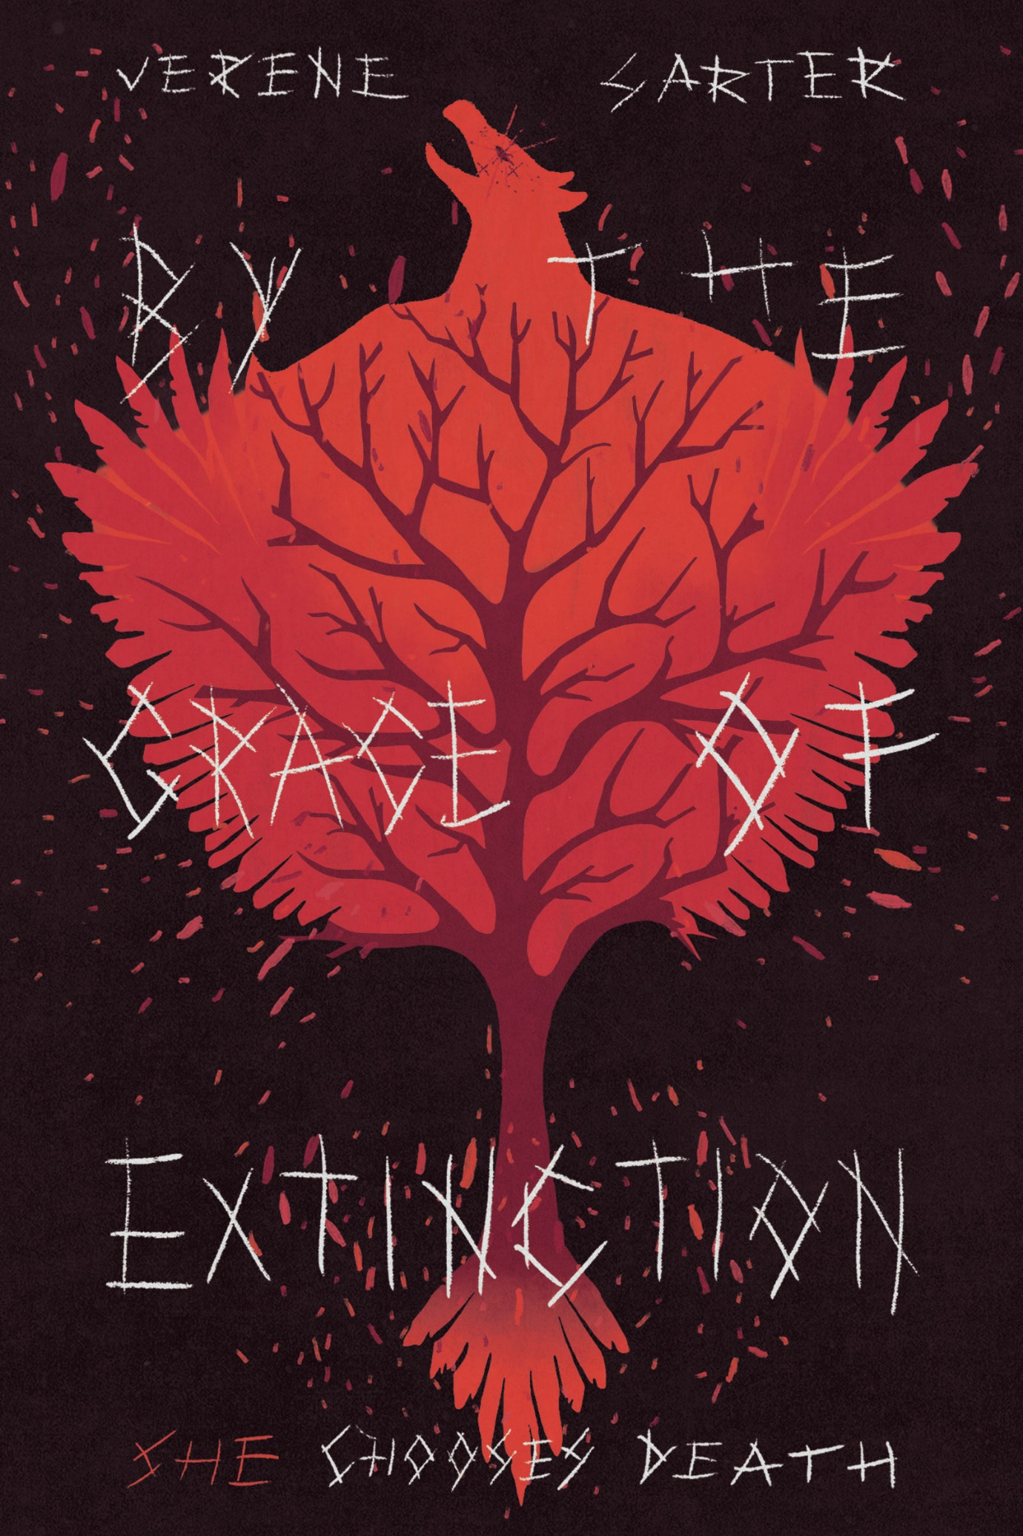
FOR IMMEDIATE RELEASE: Six billion years in the future, the people of that time haven’t learned a damn thing either: When fiction hits close to home

For More Information, Contact:
Verene Sarter
+61 424 882 703
howdy@verenesarterstuff.com
www.verenesarterstuff.com

GOLD COAST, QUEENSLAND, AUSTRALIA—13th November 2023
‘By the Grace of Extinction: She Chooses Death’ is set six billion years in the future where humanity has gone extinct because fighting climate change wasn’t profitable enough. The main race of people are humanoid salamanders, who live in underwater caverns. The story follows Iaina, the outcast shaman bound by duty to solve her village’s problems. And she does do this…
But the politics of the village dictate that the causes of the ‘new’ problem, and hence the solutions, to be too radical.
If infertility wasn’t the crisis the village is grappling with, they would live long enough to discover why people form civil rights and social justice movements. Or even dare to dream they have rights. Dignity and self-determination.
Iaina is a shaman. She could stop her species’ fate in its tracks. But she doesn’t. Because she finally learns to walk away and accepts that sometimes people just aren’t worth winning over. Sometimes you have to go it alone.
All she can do is boycott and divest, and by aligning herself with the rightful order, she also sanctions.
“Marl, it can’t be,” Iaina said in disbelief.
Iaina’s phoenix necklace once again seared her.
“Ow,” she said.
“I’m afraid that’s the nature of what you’re dealing with,” Marl said.
“How can I fix this…?” She asked.
“Knowing what you know now… Why do you still want to help them?” Marl asked gently.
The necklace now simmered.

The phoenix necklace is Iaina’s conscience.
Strength in numbers is all that matters. The grassroots always has a path forward. If approval isn’t sought, it can’t be denied. If society doesn’t work for everyone, can it even be said that it works at all?
Verene Sarter hails from the East Coast (of Australia). She has no education to build her life upon, only passion and frenetic productivity. Currently she is working… and will be for quite some time (even longer than anyone thinks, probably, when they extend the retirement age again). Verene Sarter is a working woman. She enjoys convincing herself to work on her second book, killing herself at the gym and thinking about doing a comedy open mic. These endeavours will pave the way to her future.
If only the salamander people had more time. They could’ve avoided our fate…
But like us, life follows after them precisely because they got out of Life’s way.

By the Grace of Extinction: She Chooses Death
Verene Sarter
On Sale: 31st August 2023
Price: $14.43
Pages: 78
ISBN: 9780645853803

