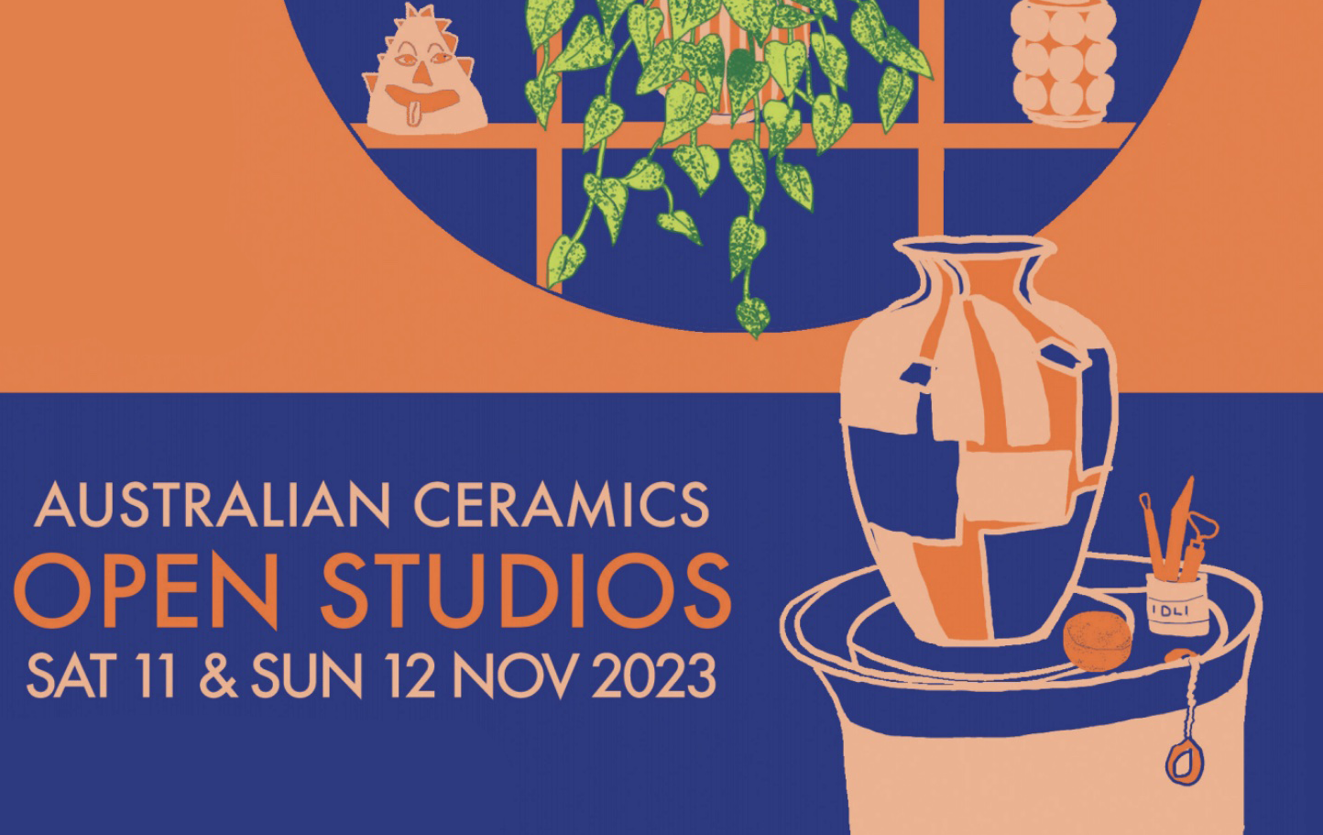

2023 AUSTRALIAN CERAMICS OPEN STUDIOS MEDIA RELEASE

Australian Ceramics Open Studios is an annual, nationwide, weekend event now in its 11th year; over 200 potters and ceramic artists in cities and regional areas around Australia will open their studios to the public. Celebrate clay, community and creativity by visiting your local potter on Saturday 11 & Sunday 12 November. view the artists and their locations HERE.

Open Studios is a great opportunity to meet the makers in your community, purchase artworks before the Christmas rush, and celebrate the diversity of practice. There will be workshops, demonstrations, kiln firings and great conversation with potters located in the suburbs, cities and rambling rural settings.

For curious artists, Open Studios shows the breath of full-time, part-time, hobbyist, and the occasional dabbler ceramicists, providing a rare opportunity to see how they set up their studio.

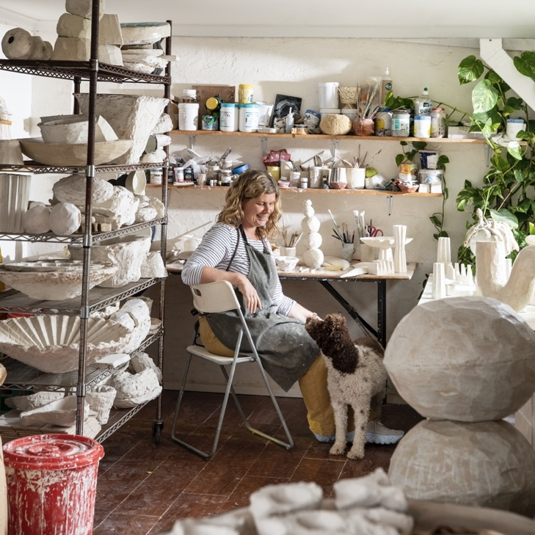 | ‘A few people were studio hopping and filled me in on how their day was going. It was a lovely way to build community.  I met a few ladies who were inspired to turn their garage into a ceramic studio after seeing mine. That alone made it worthwhile. I’m always happy nerd out on ceramic talk with other makers.’  Kirsten Perry  Naarm / VIC

'My Open Studio experience is a focus point of the year.’  Reanne Brewin  Gumbaynggir Country / NSW | 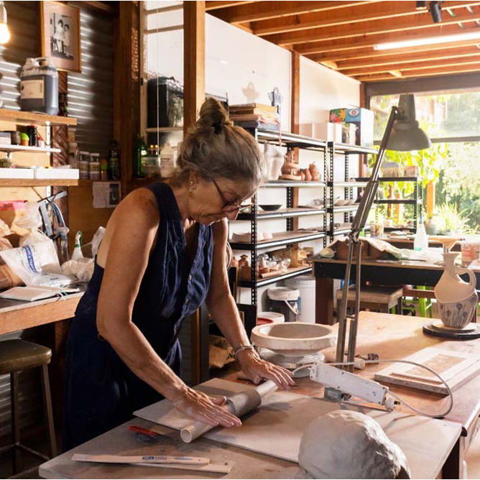

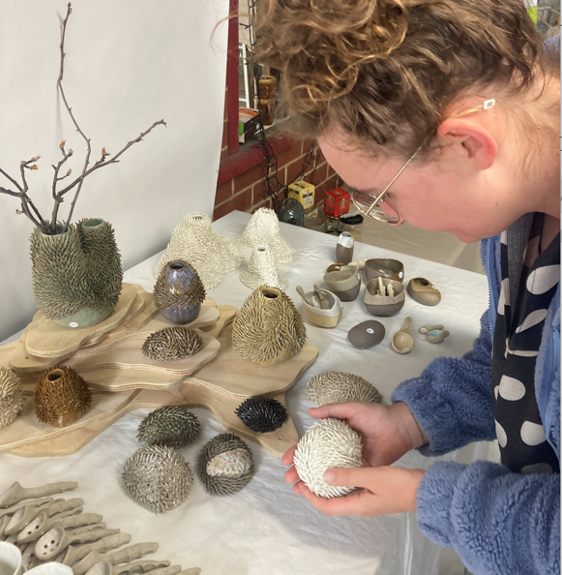 | 'I was truly surprised and overjoyed with how many visitors I had, especially as it was my first open studio through TACA. I had visitors who were making the weekend of it and used the map to bounce from one studio to another all across Perth. It was also a great chance to meet other potters close by and nerd out on all things clay!'  Holly O'Meehan  Walyalup / WA

For images of Reanne Brewin, Holly O'Meehan and Kirsten Perry’s artwork and studios click HERE.

The ACOS 2023 poster was designed by Kaurna Yerta (SA) ceramicist Ayesha Aggarwal, more information on Ayesha and her practice can be found via our interview with Ayesha HERE.
The full ACOS 2023 identity can be accessed HERE.

FULL LIST OF PARTICIPANTS HERE. Follow our Instagram and Facebook for up -to-date information on the national two-day event.

ACOS 2023 participants are keen to talk about their practice and their Open Studio. For interviews with participating artists in your region, additional images or any further information contact Debbie Pryor CEO of Australian Ceramics on 0468 354 274 or ceo@australianceramics.com.

