MEDIA RELEASE

Australian Success Story for BIBS Pacifiers
Parents of newborns choose quality baby brand, now available in 700+ Woollies stores

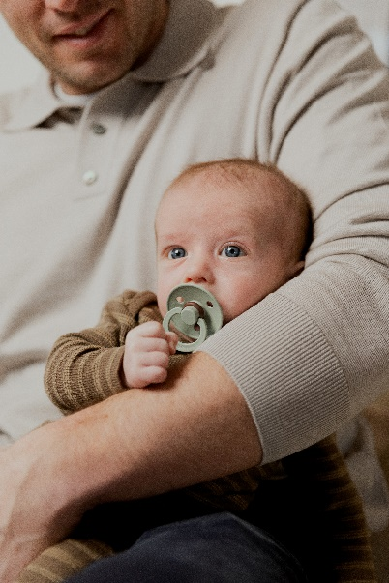
28th June 2023 | Moorabbin, Victoria
Popular Danish baby brand BIBS continues to enthral babies and parents alike, rolling out its best-selling and innovative Night Glow range in close to 720 Woolworths stores nationally.

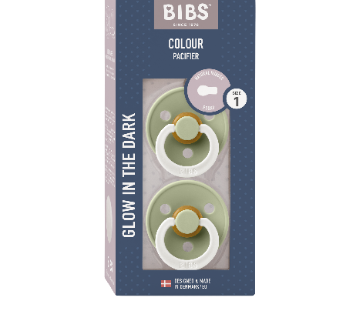
Celebrity mum Martha Kalifatidis, who headlines the Bonds Baby Search campaign, is among many parents of newborns who’ve made the iconic brand the preferred choice for their little ones. Even Prime Minister Anthony Albanese was snapped holding radio host Kyle Sandilands’ little boy Otto with a BIBS pacifier.
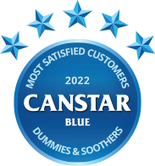
BIBS took out the converted Canstar Blue award named Australia’s BEST dummy by Aussie parents. Against stiff competition, BIBS scored five stars across the board for baby’s ease of use, quality, durability and overall satisfaction. Safe, trusted and loved, BIBS pacifiers have seen dramatic growth worldwide since its inception in Denmark in 1978.
Known for its focus on quality, sustainability and safety, the European brand has created a soothing range that’s widely recommended by midwives.

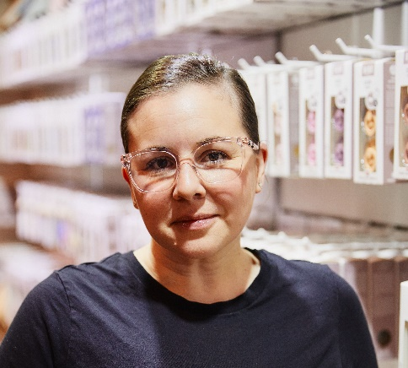
Local distributor Kollektive manages BIBS from its Melbourne-based operation and is the Australian success story behind the brand. Kollektive’s Founder and Managing Director Melinda Farley comments, “It’s unsurprising to see parents continue to choose quality, trusted products for their children despite tough economic conditions. As demand for BIBS continues to soar we’re delighted to make it easier for parents to conveniently pick up a pack at Woollies across Australia. Although we recognise the need to partner with leading channel partners like Woolworths, we will continue to champion small independent retailers who appreciate the repeat and referral traffic a brand like BIBS brings. Entrepreneurial spirit is in our DNA and we will continue to support our large network of small independent network with continued innovation and agility especially in this evolving and challenging retail environment”

Notes to editors
For enquiries, contact Melinda Farley
Mobile: 0428 055 634 | Email: melinda@kollektive.com.au | https://www.kollektive.com.au LinkedIn: https://www.linkedin.com/in/melindafarley/
Boilerplate
Based in Moorabbin, Victoria, bootstrapped Kollektive was founded in 2017 to become the exclusive distributor for popular, in demand baby and children’s brands in Australia and New Zealand, including BIBS (Denmark). Founder and Managing Director Melinda Farley (nee Podesta) has adopted a unique, entrepreneurial approach in championing smaller independent retailers while carefully selecting leading channel partners as demand continues to soar for brands in the portfolio. Kollektive distribute close to a million BIBS pacifiers a year in Australia and New Zealand. Melinda (37) is a mother of four children and works full time with husband and director Robert Farley in the business.

