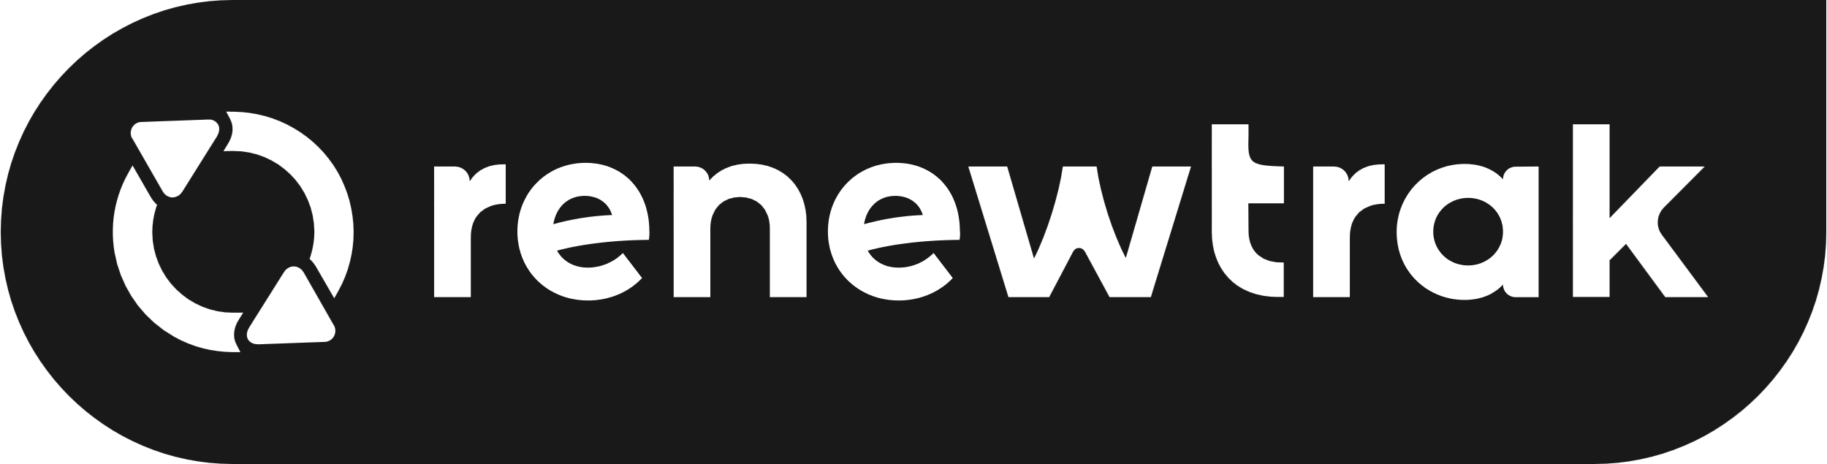
VMware selects Renewtrak for global customer retention and growth.
SYDNEY, New South Wales, March 8, 2023. For immediate release.
Renewtrak is pleased to announce a significant expansion of our relationship with VMware.
VMware was faced with the following challenges:
“When we’ve earned the loyalty of over 500,000 customers globally, across a global partner community of 28,000, transitioning our perpetual contracts to subscription requires a renewals and sales automation solution that can scale across the long tail,” said David Pinto, Senior Director – Strategy, Planning and Operations, VMware Revenue Lifecycle Management.
“With a significant percentage of our contracts sitting within our long tail business segment, we require a low-to-zero touch renewals approach to support and enable our renewals-focused teams and our partners to extend customer touch points across the post-sales lifecycle journey.”
“By partnering with Renewtrak and adopting its automation platform, we were able to future-proof our highly transactional renewals business with an out-of-the-box, M/L and AI powered platform to improve productivity, cost efficiencies and global scale capabilities” David Pinto, Senior Director – Strategy, Planning and Operations, VMware Revenue Lifecycle Management
The Renewtrak Solution
VMware selected Renewtrak, a software solution that runs on Azure, due to its flexible renewals and digital sales workflow, as well as its collaborative approach to enterprise partnerships. This allowed VMware to easily integrate its renewals, perpetual-to-SaaS subscription licence conversion efforts, workflows, and quoting systems into a single, easily deployable architecture. By using Renewtrak, VMware was able to streamline its renewals process and leverage the platform’s capabilities to drive scalable customer engagements and revenue growth.
Unlike homegrown, outsourced, and traditional renewals software, every aspect of Renewtrak’s renewals is built to optimise the renewals process for sales, customer success, renewals, and operations teams. Renewtrak is powered by a machine learning architecture that is constantly learning from over 20,000,000 renewal interactions per year on Renewtrak’s platform. Renewtrak’s M/L powered engagement engine recovers 10% more revenue for their customers than those relying on traditional methods.
Renewtrak’s platform also provides teams with unparalleled adaptability and ease of use. Thanks to the flexibility of the core Ingestion API, VMware can now instantly add new products, new pricing, new geographies and transition customers to preferred product, pricing and billing models.
Outcomes:
Now that Renewtrak’s infrastructure serves as the connective layer across VMware’s product offerings, VMware can grow lifetime customer value and reduce operational costs, leading to further opportunities to maximize revenue. “The increasing depth of our product suite is making Renewtrak a powerful revenue multiplier for software businesses globally– without them having to lift a finger,” commented Mathew Cagney, CEO Renewtrak.
“We’re thrilled that VMware chose to partner with Renewtrak to streamline the renewals experience across its product offerings.” With this partnership, VMware joins leading enterprises using Renewtrak today to scale and adapt. Renewtrak now processes more than $3 billion in renewals annually for its customers.

About Renewtrak
Renewtrak is the world’s leading Renewals and Subscriptions platform for technology companies.
Thousands of technology businesses globally from start-ups to enterprises use Renewtrak’s software to digitize and automate their renewals and sales processes.
Our platform optimizes revenue retention and powers growth for the World’s Leading Technology Companies, transforming their Renewals and Subscriptions business through automation.
For further information please visit: https://www.renewtrak.com/
Media enquiries: mathew.cagney@renewtrak.com CEO Renewtrak

