9 March 2023
Ventia selects Asseti for Reality Digital Twins
Ventia, one of the largest essential services providers in Australia and New Zealand, has selected Asseti as its enterprise-wide partner for reality digital twins and spatial data. Designed for managers of data-rich assets, the partnership will drive contextual insights for the assets that Ventia maintains on behalf of its clients.
Ventia sought a solution that offered intelligence at scale to drive real-time insights into its asset management portfolio. Following a detailed pilot phase at Ventia key sites, Asseti will be rolled-out as a core component of Ventia’s next-generation digital ‘metabase’ concept. It will integrate into Ventia’s existing asset management framework and provide enhanced real-time site management.
By pushing the boundaries of asset performance management using geospatial data, Asseti’s platform supports a diverse range of asset classes, supported by automated asset registers, componentisation, defect reporting, and change tracking over time, including from satellite, as well as enterprise security features.
Gary Dring, Ventia Group Manager Innovation said Ventia assessed many solutions in the market before selection.
“Asseti’s ability to generate detailed and insightful information across large asset networks in close-to-real-time was a standout feature for us.
“By augmenting Ventia’s strong service delivery and digital innovation with Asseti’s proprietary data model, we see Asseti as being core to further our digitised service offering,” Mr Dring said.
Aonghus Stevens, CEO of Asseti, said that he was excited to work with Ventia.
“We’re thrilled to partner with Ventia and to be implementing Asseti across the diverse range of contracts within the Ventia business.
“Ventia is a clear market-leader across the entire essential services sector. We look forward to working together to help Ventia deliver innovative digital transformation in the way assets are managed, using big data, and to provide an even better outcome for Ventia and its clients,” said Mr Stevens.
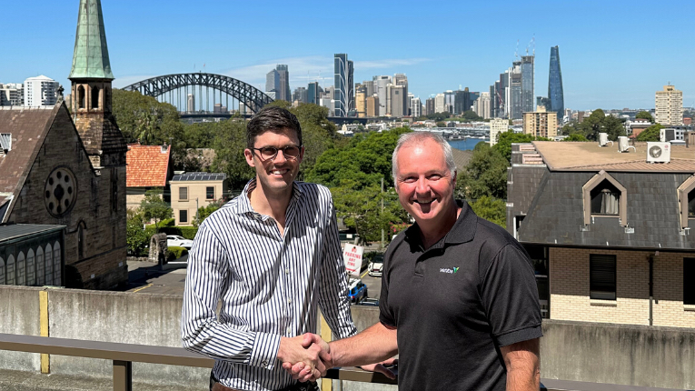
- ENDS -

About Asseti
Asseti is a cloud-based platform that enables the management of enterprise asset portfolios to be safe, compliant and operational throughout the life of the assets. Asseti intelligently monitors thousands of sites from resources and government infrastructure to telecommunications and healthcare. Asseti’s turn-key data to asset insights powers decisions around maintenance and upkeep across real assets on a global scale. Learn more at www.asseti.co

About Ventia
Ventia is a leading essential infrastructure services provider in Australia and New Zealand, proudly providing the services that keeps infrastructure working for our communities. Ventia has access to a combined workforce of more than 35,000 people, operating in over 400 sites across Australia and New Zealand. With a strategy to redefine service excellence by being client focused, innovative and sustainable, Ventia operates across a broad range of industry segments, including defence, social infrastructure, water, electricity and gas, resources, environmental services, telecommunications and transport. Learn more at www.ventia.com.

