
MEDIA RELEASE

Indigenous Leader Advocates for Unity on Australia Day

My children say to me, “Happy Invasion Day, Dad.” But I say to them, “Happy Unity Day.” These powerful words come from Pastor James Dargin, a recognised Indigenous leader and elder in Wollongong, who has a deep love for people and for Australia.
James has seen much pain and suffering in his life and his message is simple: we need to forgive so we can build a united future for our children.
According to James, there is no better opportunity to practice this than on Australia’s national holiday. “Let’s not change the date of the 26th of January,” he says. “But let’s change our heart on the 26th of January.”
James continued, “I grew up with mental abuse, physical abuse, sexual abuse. I was tied to a bed; my brother was tied under our house. My brother was put on a hot stove. I grew up with racism. I grew up with a lot of abuse. And it got to a point for me to hide that abuse is that I was on alcohol and drugs for 40 years straight.”
As a result, James is convinced that division over issues like Australia Day is unproductive and ultimately destructive. He has a better vision for how we can celebrate:
“Let’s come together and call it Unity Day, Forgiveness Day — to forgive each other, to love one another. It should be a day of celebration, of love. Hug someone. Forgive somebody. Love somebody. That’s what we should be celebrating. What happened in the past was horrific. Let’s come together, let’s build a future for the next generation. One I forgive you is worth a thousand sorrys.”
James has not always thought this way about Australia Day. He grew up thinking about it as ‘Invasion Day’. He said that perspective often stirred up anger in his heart. But no longer: “Now that I forgive, that pain, that anger, has been removed and replaced with love and joy and unity.”
Now he wants everyone to know the freedom that forgiveness brings. “Let’s share Unity Day with the whole nation. Draw it anywhere, put it on your t-shirt, share it on social media.” James concludes his reflections saying, “So on the 26th of January, Unity Day, love somebody, hug somebody, forgive somebody, because we are one.”

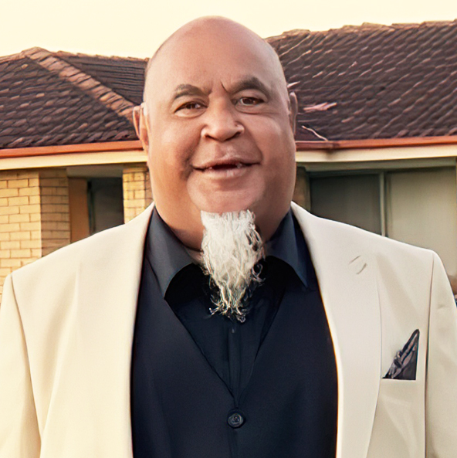

In Peace, Joy. Love and Forgiveness,

By Ps James Dargin
Wollongong, NSW

Media Contact:
James Dargin
M: 0475 383 119

Indigenous Leader Advocates for Unity on Australia Day by Indigenous:
Ps James Dargin. VIDEO Duration: 1:17 Seconds
https://youtu.be/sllMzdQCOsQ

WISH SOMEONE HAPPY UNITY DAY: Indigenous Leader Advocates for Unity on Australia Day: Ps James Dargin. VIDEO Duration: 4:58 Seconds https://youtu.be/aYefn70die8

