

PRESS RELEASE

Australian Surrealist, Charles Billich masterpiece is unveiled in Siena Italy.

For Immediate release October 20, 2022

This past weekend Australian Surrealist Charles Billich original oil painting “Siena Galactica” valued at $500,000 AUD was unveiled at the Dali Universe exhibition in Siena Italy.
“Siena Galactica” created by surrealist Charles Billich is the third painting commissioned by Art Evolution president Christopher Talbot. These visually stunning paintings pay homage to some of the most important historical venues chosen by the Dali Universe to house the Dali Sculpture collection.
About Siena Galactica
For a period, the magnificent Siena Palazzo Delle Papesse was the home of Galileo and is now the home of the Dali exhibition. The narrative of Siena Galactica is that of science. From the time that Galileo angered the Catholic Church, by confirming the Copernicus theory that the earth is not the centre of the universe through to the invention of the atomic bomb, these champions have irrevocably altered our perception of reality. As with the previous Dali Inspired commissions Talbot curated the direction of the painting and Charles Billich made manifest that vision. In celestial form the left-hand corner of the painting shows Salvador Dali, Isaac Newton, Galileo Galilei, Cosimo II de’ Medici, Copernicus, and pope Urban VIII. These figures are uniquely intertwined though the ages by science and the focal point of this painting is the Palazzo Delle Papesse. The circular nature of the painting allows a flat earth view of Siena, it includes the Palazzo Delle Papesse, many Dali sculptures and shows that time as we know it is a human construct and as men of science, they all knew that in the quantum World anything is possible.
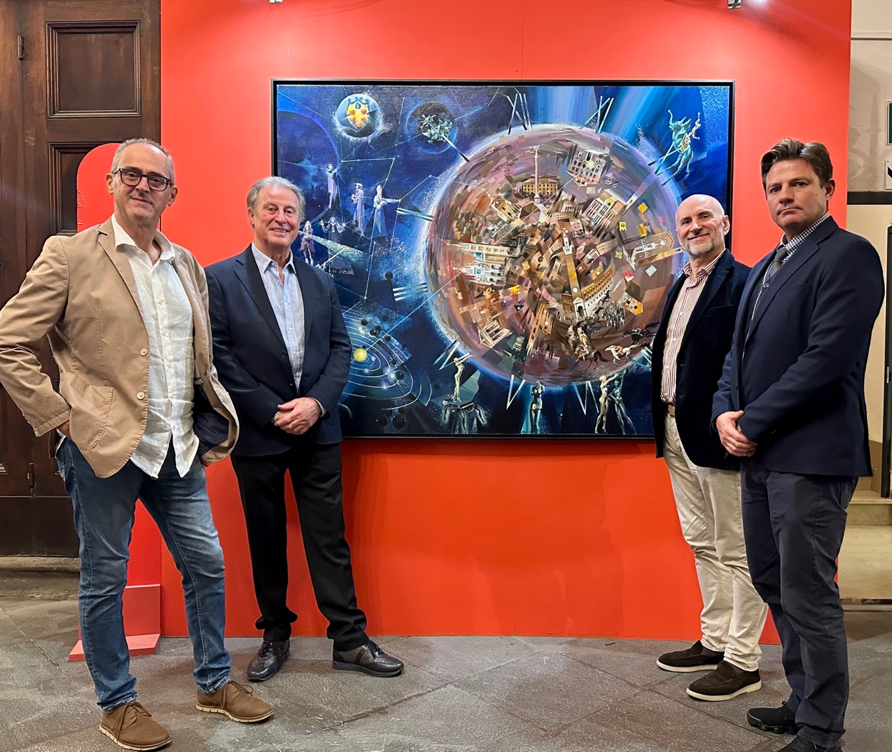
In attendance at the unveiling “from left to right” was Alessandro Marchini, Galileo historian and Director of the Siena Astronomical Observatory, Christopher Talbot President Art Evolution, Ferucchio Carminati, Director of the Dali Siena exhibition, James Sanders, Dali Universe International project manager.
Siena Galactica is now proudly displayed at the entrance to the Siena Dali exhibition and limited editions are available through the Dali Universe Siena, or Art Evolution Canada and Australia.
About Charles Billich

It can certainly be said that Charles Billich is one of the most important living artists in the world and at 88 years of age he is also one of the most credentialed artists of all time. Indeed, his extensive list of awards and achievements are almost beyond comprehension. His artworks are in the collections of the Vatican, The White House, The United Nations, Billich was named USA Sports Academy artist of the year and in 2009 was a recipient of the Florence Biennale, to name just a few.

About the Dali Universe

The Dalí Universe are owners of the largest collection of Salvador Dalí sculptures in the world. The Dalí Universe are International Dalí exhibition specialists who also manage visitor attractions in Paris France, Siena Italy, Matera Italy, Prague Czechoslovakia.
These meaningful collaborations between The Dali Universe, Art Evolution and Charles Billich seek to celebrate surrealism and perpetuate Dali’s vision of immortality.

About Art Evolution

Art Evolution is an international art company and publisher with locations in Canada, France, and Australia. Our primary focus are investment level artworks which are available through our website, galleries, and visitor attractions. In Australia, Art Evolution operates the largest Salvador Dali exhibition in the Southern hemisphere. In Canada we have recently opened a gallery in the historical town of Cochrane Alberta to service our Canadian clients.
Christopher Talbot -President Art Evolution

For further information or to arrange an interview please email info@artevolution.com

