Media Release – Date Tuesday 8 November
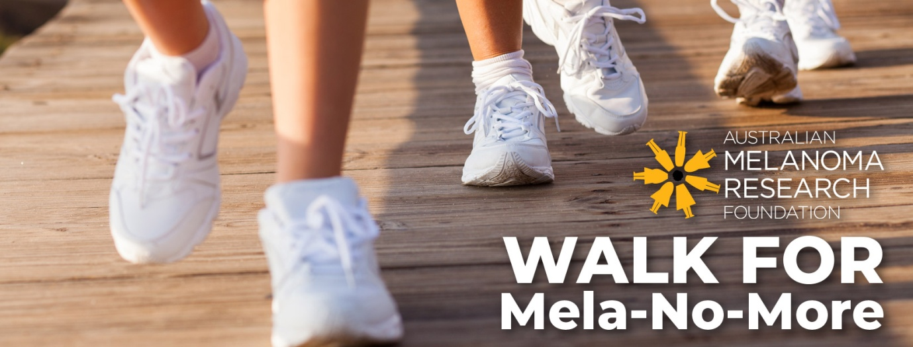
National Skin Cancer Action Week -Walk for Mela-No-More at your own pace.
The Australian Melanoma Research Foundation (AMRF) is urging everyone to Walk for Mela-No-More during National Skin Cancer Action Week (NSCAW) from Monday 21 to Sunday 27 November 2022.
The death rate from melanoma is higher than the national road toll so this initiative raises vital funds to support research, awareness and prevention programs.
“Melanoma is known as Australia’s national cancer because we have the highest incident rate in the world,” said Marisa Chilcott, CEO AMRF. “Research has led to great improvements in patient outcomes in the past 10 years and with further investment, we hope that in another decade, no Australian will die of melanoma. It’s continued research and prevention that will make the difference. More than 90% of all melanoma’s can be treated successfully if caught early.” Marisa concluded.
You can create your own challenge in your own time. It’s just a matter of creating an online fundraising page and invite friends and family to support your fundraising during National Skin Cancer Awareness Week. The timing and challenge is up to each individual. It can be a daily walk, a marathon run or a bike ride or swim.
AMRF continues its commitment to change outcomes by highlighting these alarming statistics and raising awareness of sun safety during NSCAW as summer approaches.
Join us this November and help raise much needed funds for research, so we can continue to support early career researchers investigating pathways that can lead to more treatment options.
Other melanoma facts
- Most common cancer in 15–39-year-olds
- Is on the increase in people aged over 60 years
- Is the fourth most common cancer in Australia
- One in three Australian will be diagnosed with a skin cancer in their lifetime and melanoma is the most dangerous.
About AMRF
AMRF is a national, registered charity that was founded in 2006 by a dedicated group of volunteers. AMRF’s mission is to significantly contribute to the prevention, early detection and treatment of melanoma to improve patient outcomes.
Action: Sign up now and be part of our life changing work.
For interviews with Marisa Chilcott contact 0422345426

