
MEDIA RELEASE

A Tribute to Queen Elizabeth II by
Indigenous Australian Leader Ps James Dargin

Australian Indigenous leader James Dargin has paid a tribute to Queen Elizabeth II, saying he has great respect for the Queen and urges Indigenous Australians to honour her as a mother and a grandmother.

‘She Will Be Missed’
Ps James Dargin said, “I have a lot of respect for the Queen because what she has done in her journey. All Indigenous people around the world should honour and thank her.

Honour the Queen as a mother and honour her as a grandmother. We all have mothers and grandmothers, and we honour them. We should do the same for the Queen.

God gave her a job to do. What she did was not only for her family but for the Nations and for the Commonwealth. Let's honour this amazing and beautiful woman who set an example for all of us. God has got a mission for all of us. And I think we should honour the Queen for hers.

God looks at our heart not at what we do. We should do the same for the Queen. The Queen walked in the unknown with a beautiful heart and a desire to serve her people.
Queen Elizabeth II was an amazing and beautiful woman.

She's going to be missed.”

True Leader of Her Country
Ps James Dargin said, “She took care of her own country, but she had responsibility for other countries, like Australia and the other 52 Commonwealth countries. We have a lot to be thankful for. All indigenous people around the world should honour and thank her for her service. I have a lot of respect for the Queen because of what she has done for us. I wouldn't be able to do what she does.

Not only because she's got a title. Honour her as a mother and grandmother. You see she has always looked after her own family and worked to keep them together and that's what we should be doing. Keeping our families together. Loving one another and forgiving each other. But the Queen she is going to be missed. Because there's no one like her.”

Peace, Joy, Love and Forgiveness.
Ps James Dargin said, “We are all individually made. Each of us has a purpose on this earth. Peace, Joy, Love and Forgiveness. I believe that is unity. That's what this nation is about. This is what it's about being on this earth. True unity is coming together in love and forgiveness.

Through the Queen and the Royal Family, the Gospel came to Australia and other nations.”

Come Together in Unity
Ps James Dargin said, “Forgiveness is one of the biggest things to achieve unity. You can't come together if you do not forgive.

We need to come together, not looking at each other as Aboriginals or non-Aboriginal or other nationalities. We need to come together as children of God as brothers and sisters. It's about the heart. When you connect your heart with others in love that's true unity.

We all have the same spirit. We're all made in the image of our Father in Heaven. We were in him before the foundation of the world. The unity that the Father had with the Son is ours as well if we come together in love.

If we don't forgive each other, there is no unity. The power of forgiveness is powerful even when you are persecuted. The power of love will come and overpower the persecution that you suffer. This all comes from our heart.

You should forgive people. Because if someone comes against you, they planted a seed, and that seed will grow and get bigger. In the end you just become more bitter and angrier. That is why you must forgive.

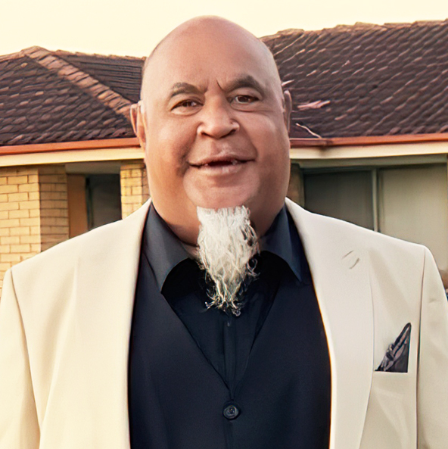
Do not receive these negative seeds of unforgiveness as these seeds will grow and the only person, it will hurt is you. It is your choice as God doesn't go against your free will.”

In Peace, Joy. Love and Forgiveness,

By Ps James Dargin
Warilla, NSW

Media Contact:
Warwick Marsh
M: 0418 225 212
E: warwick@webshield.net.au

"A Beautiful Heart": A Tribute to the Queen by Indigenous Australian Leader Ps James Dargin. VIDEO Duration: 52 Seconds
https://youtu.be/vCm1-6jy2sg

Powerful Testimony: Australian Indigenous Leader Honours & Prays for the Queen: Ps James Dargin. VIDEO Duration: 44 minutes
https://youtu.be/Iw8VzkyNQAk

“She will be missed”: A Tribute to the Queen by an Australian Indigenous Leader
ARTICLE: 1:2 Minute Read: https://tinyurl.com/mrxm8yvu

