MEDIA
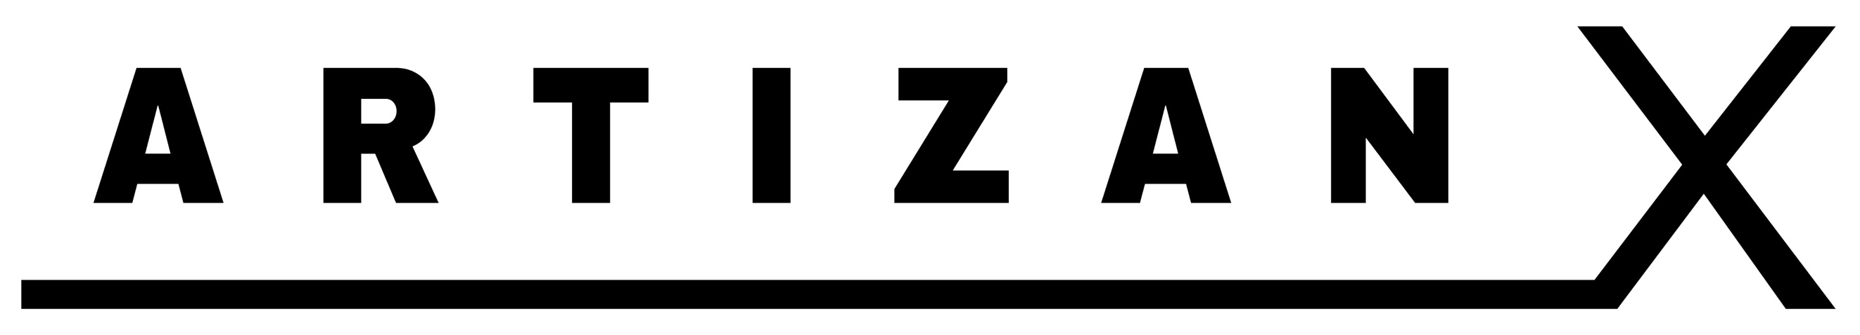
RELEASE
For release 7 July 2022

TROY CASSAR-DALEY RELEASES ‘BACK ON COUNTRY’ NFT PAINTING SERIES

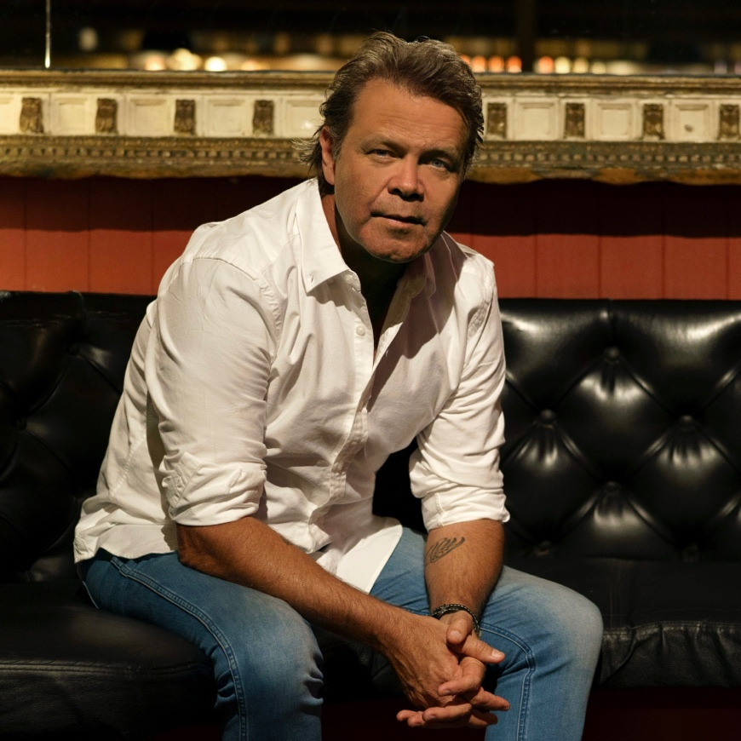

Back On Country is a collection of 8 paintings from country music icon Troy Cassar-Daley. He is a proud Gumbaynggirr / Bundjalung man who comes from a long line of storytellers. His passion to pen stories about this land and what lies at the heart of it has been a driving force in his career. Whilst an acknowledged art painter, this is Troy’s first NFT release. These paintings are only available as NFTs.

Rivers And Stars

Alice Springs

Stars At The Old Camp

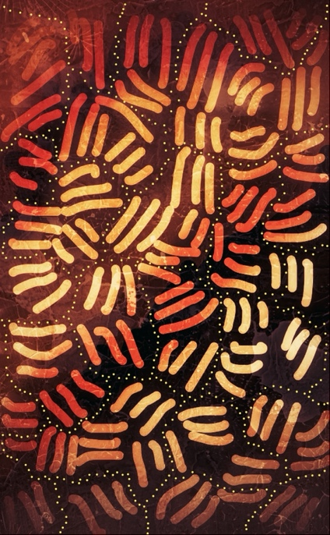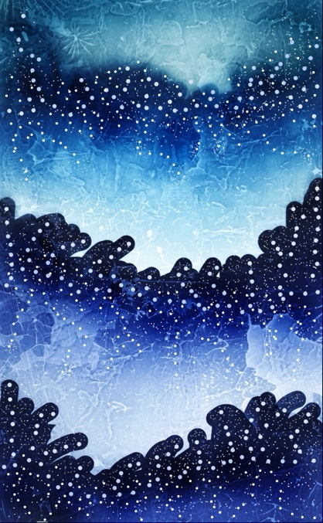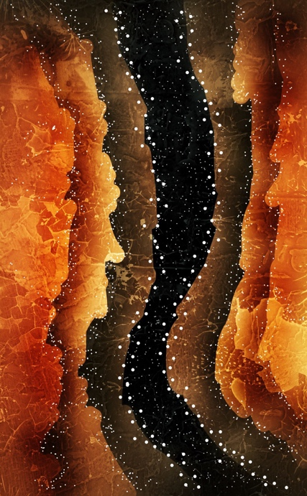

View all eight BACK ON COUNTRY NFT painting here - http://serenade.co/@TroyCassarDaley

On the NFT drop, Troy says, “I’m thrilled to be working with Serenade and ArtizanX on my release of my Back On Country painting series. These paintings have been inspired by moments in time, and connection to people & country. Being able to make this series available via NFTs provides another medium to share my art and stories.”

Max Shand, Founder & CEO Serenade said” It’s an incredibly proud moment for Serenade to be working with an Australian great on this continuation of Gumbaynggirr / Bundjalung storytelling. At Serenade, we believe in bringing fans closer to their favourite artists, and what better to achieve this than sentimental, nostalgic storytelling, presented through unique and beautiful artworks.”

About Troy Cassar-Daley
Troy has been awarded numerous accolades including 40 Golden Guitars, 5 ARIAs, 3 APRA Song of the Year awards, 9 Deadlys (Australian Indigenous Artist Awards), 4 CMAA Entertainer of the Year awards plus 2 NIMAs (National Indigenous Music Awards). In 2017 Troy was honoured as the 50th inductee into the prestigious Australasian Roll Of Renown. He has had numerous gold and platinum albums and achieved a staggering 32 Number 1 chart singles
About Serenade
Serenade is the music eco-friendly NFT marketplace for fans to buy, sell, collect and showcase limited-edition digital collectibles. All in one place https://serenade.co/

About ArtizanX
ArtizanX is an artist management company - we transform and reimagine artist brands through innovative business models, powerful storytelling, compelling content and immersive experiences. We connect artist brands to fans and build communities!

CONNECT WITH TROYCASSARDALEY AT:
FACEBOOK | TWITTER | INSTAGRAM | YOUTUBE | WEBSITE

Purchase Back On Country series here: http://serenade.co/@TroyCassarDaley
View series here: https://smarturl.it/BackOnCountryNFT
Watch series here: https://smarturl.it/BackOnCountryNFTvid

www.artizanx.co

For further information about BACK ON COUNTRY
Please contact Roxanne Brown, Artist Manager:
rox@troycassardaley.com.au

