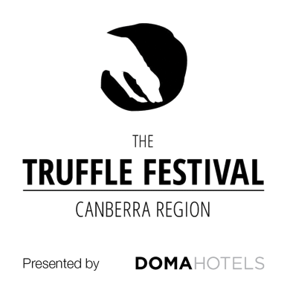

Media release
June 10, 2022

Truffles are back on the menu for 2022

The wait is almost over for truffle lovers pining for a sprinkling of ‘black gold’ on their scrambled eggs.

The winter solstice on Tuesday, June 21 marks the official start of truffle season, and truffle growers, winemakers, restaurants, cafes, cooking schools, farmers’ markets and more across the ACT and southern NSW are gearing up to celebrate the return of Tuber melanosporum, better known as black winter truffle.

The Truffle Festival Canberra Region presented by DOMA Hotels will kick off this year with an exclusive cocktail evening at Sydney’s Little National Hotel on Monday, June 20, where truffle dishes will be matched with award-winning wines from the National Wine Show of Australia.

The festival’s signature event for 2022 will be a multi-course truffle dinner celebrating local food and wine heroes at Canberra’s luxury Hotel Realm on Friday, July 1.

The dinner will be followed by a packed program of growing workshops, truffle hunts, food and wine pairings, signature menus, cooking classes and chef demonstrations across the ACT and southern NSW until the end of the truffle season in mid-August.

“The festival is in its 14th year and has been hugely popular with visitors from Sydney since it began, due to the easy three-hour drive from the city centre to some of the country’s best truffle farms,” festival president Dick Groot Obbink said.

“While truffles are available all over Australia, those grown in the Canberra Region are prized by chefs, providores and discerning foodies alike because the climate around Canberra almost perfectly matches the growing conditions of the famous French truffle region.

“Even better, Canberra is the only capital city in the world where truffles are grown right on the doorstep, so they can be harvested and on restaurant tables or in home kitchens within just one or two hours.”

Mr Groot Obbink said he was delighted to announce the festival’s inaugural partnership with Canberra’s leading hotelier, DOMA Hotels, as festival naming rights sponsor.

“DOMA’s five-star hotels, restaurants and bars have a natural synergy with an exclusive and sought-after product like truffles, and we are delighted to welcome the group as our major partner this year,” Mr Groot Obbink said.

DOMA Hotels Director Patrick Lonergan said the group was delighted to be supporting one of the Canberra Region’s most enduring and popular gourmet festivals. “We are a proud Canberra-based business, and now have a luxury hotel in Sydney too, and the truffle festival aligns perfectly with our focus on supporting local communities and events,” Mr Lonergan said.

DOMA Hotels is offering discounted stays to festival visitors throughout the 2022 truffle season, which can be booked via the Truffle Festival Canberra Region website.

Mr Groot Obbink said another highlight of this year’s festival would be a competition celebrating the unsung heroes of the season – truffle dogs.

“We felt it was about time we shone a spotlight on the super-sniffers responsible for unearthing the ‘black gold’ enjoyed by truffle festival visitors,” he said.

“The dogs are always a highlight for guests to our farms so we’ve given them their own page on our festival website – a gallery of good boys and girls where visitors can learn about their super skills, and their embarrassing habits, and vote for their favourite dog to be in the running to win a pair of tickets to join a truffle hunt as well as 100g of premium black truffle.”

Tickets to the Canberra gala dinner are $180 per person, or $1500 for a table of 10.
Book Canberra tickets

Tickets to the Sydney cocktail evening are $87 per person.
Book Sydney tickets

Check out the full festival program, book a discounted stay at a DOMA Hotel and vote for your favourite truffle dog at: www.trufflefestival.com.au

Media contact
Michelle Rowe
PitchPerfect Media
michelle@pitchperfectmedia.com.au
0400 003 852

