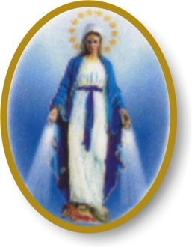
PRESS RELEASE
For immediate release.
PERTH AUSTRALIA 31/05/2022.

GOD EMPOWERED WATER FOR VISITING AUTHOR AT MEDJUGORJE.
Vials of this empowered ‘water’ are available to the public right now. Amazingly, God gifted the ‘water’ to 49 year old Trevor Knuckey in 1990 when he visited the little village of Medjugorje in Bosnia. He had not been near a church for 35 years and his past was overflowing with shortcomings, flaws, and failings, prior to his being selected for incredible experiences with God. He self published a book about it. Trevor devised a method for people in need of healings to obtain some of this ‘water’ from the Medjugorje Centre charity by donation. The only beneficiary of donations, is the charity which uses 100% for charitable purposes.
Trevor uses the ‘water’ and has benefited by the removal of persistent arthritic pain from his left foot. He has distributed some to people who have placed testimony to their benefits on the Medjugorje Centre website, where there is more information.
Trevor says, “I am dumbfounded as to why God should have selected me to distribute the empowered ‘water’ to people needing healings. I think the Pope or Dalai Lama would have been a more worthy selection. However, I do inform everyone that I was awarded the Order of Australia Medal for over 30 years of community service in a variety of roles on Australia Day, January 2021. I mention this to hopefully show I have some credibility”.
This ‘water’ can be obtained by using the ‘Donation’ page on the charity’s website www.medjugorjecentre.org.au and following the prompts.
ENDS
Name: Trevor Knuckey OAM. Post: PO Box 4035 Swan View WA 6056.
Email: medjugorjecentre@hotmail.com Phone: 0439 441 163

