iam8bit asia is now taking pre-orders for Persona's 25th
Anniversary 15-LP retrospective box set!
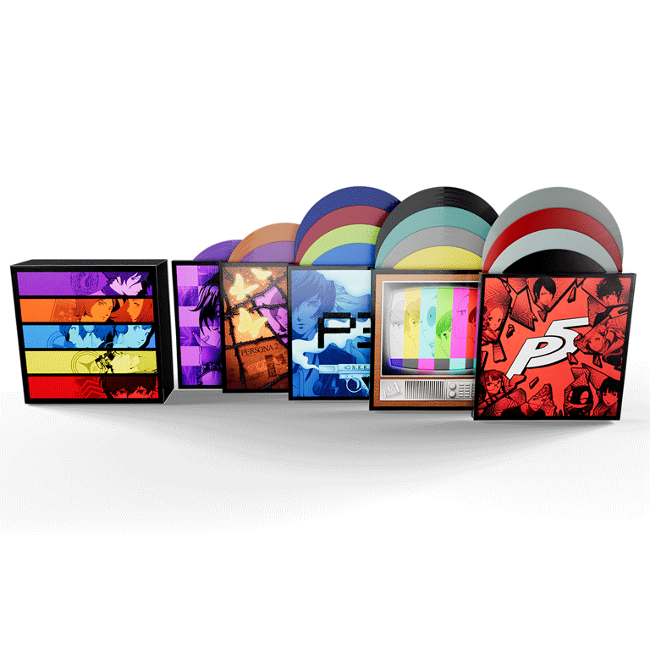
iam8bit asia, which sells game music and related goods based on the concept of "turning games into art," is now taking pre-orders for the Persona‘s 25th Anniversary Deluxe Box Set.
Reservations will be accepted for a limited time only, so don't delay in making yours!
The collection bundles together more than eight-and-a-half hours of ATLUS Sound Team’s newly remastered music from Persona 1, 2 (Innocent Sin and Eternal Punishment), 3, 4, and 5. Each of the 15 LPs are pressed on colored vinyl and themed to each Persona. Since personalization has long been a touchstone in Persona, each game-specific box is customizable using included sets of unique stickers. The entire collection slides into a beautiful slip case, which celebrates the iconic series’ 25th anniversary.
The Persona 25th Anniversary Deluxe Box Set is ¥50,490, and fans can also purchase each entry within the collection individually. Persona 1-2 are bundled together and will sell for ¥11,880. Persona 3, 4, and 5 are priced at ¥12,980 apiece.

The albums are scheduled to arrive in Q3 2022.

Please take this opportunity to see the unique and creative works of iam8bit.

PRODUCT INFORMATION

◆ Persona 25th Anniversary Deluxe Vinyl Box Set
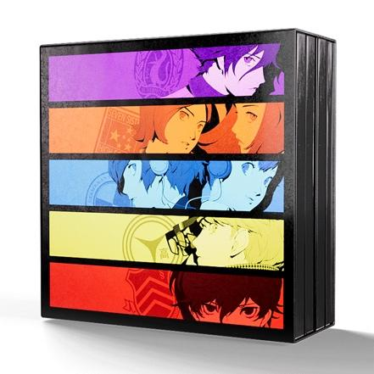

Price：¥50,490
Product Page： https://iam8bit.asia/products/persona-25th-anniversary

・Limited Edition 15-Disc Box Set celebrating the 25th Anniversary of the Persona series
・Includes Certificate of Authenticity
・Featuring Over 8.5 Hours of Newly Remastered Music from Persona 1, 2 (Innocent Sin and Eternal Punishment), 3, 4 and 5
・Colored Vinyl Themed to Each Persona
・Housed in an Elegant 25th Anniversary Slip Case
・Includes Exclusive Sticker Sheets & Post Card Pack-ins Unique to Each Game

◆ Persona 1 & 2 VINYL SOUNDTRACK BUNDLE
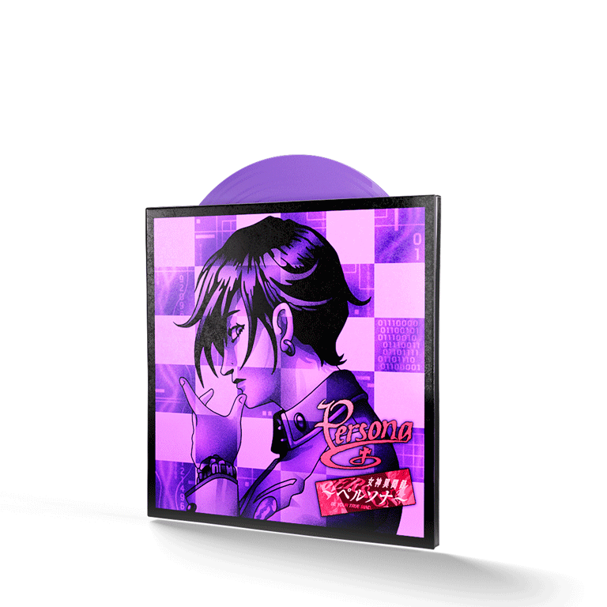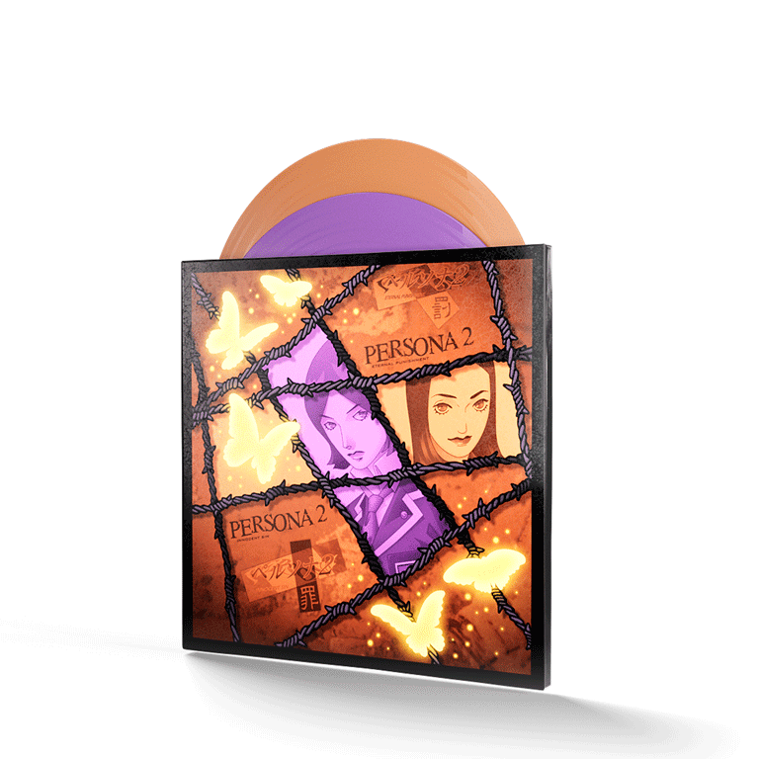
Price：¥11,880
Product Page：https://iam8bit.asia/products/persona1_2_vinyl

・Fully Remastered for Vinyl!
・Revelations: Persona 1xLP with track listing curated by ATLUS Sound Team
・Persona 2: Eternal Punishment and Persona 2: Innocent Sin 2xLP featuring track listing curated by ATLUS Sound Team
・Two Premium Box Set Bundle
・Each Box Includes an Exclusive Customization Sticker Sheet & Postcard Pack-ins

◆ Persona 3 VINYL SOUNDTRACK 4XLP
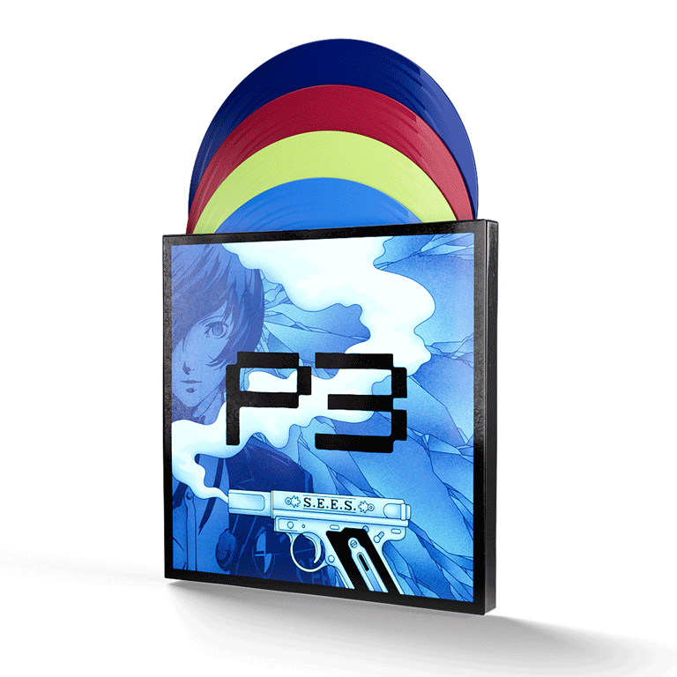
Price：¥12,980
Product Page： https://iam8bit.asia/products/persona3_vinyl

・Fully Remastered for Vinyl!
・4xLP featuring P3's most popular music
・Premium Box Set
・Includes Exclusive Customization Sticker Sheet & Postcard Pack-ins

◆ Persona 4 VINYL SOUNDTRACK 4XLP


Price：¥12,980
Product Page： https://iam8bit.asia/products/persona4_vinyl

・Fully Remastered for Vinyl!
・4xLP featuring P4's most popular music
・Premium Box Set
・Includes Exclusive Customization Sticker Sheet & Postcard Pack-ins

◆ Persona 5 4xLP VINYL SOUNDTRACK - ESSENTIAL EDITION
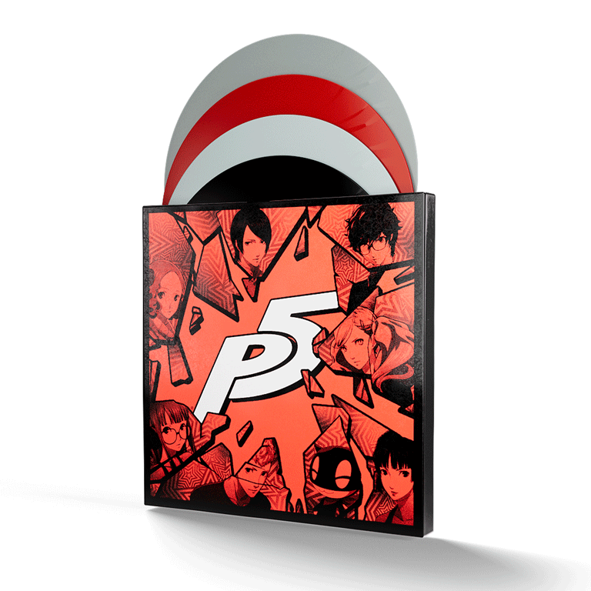

Price：¥12,980
Product Page： https://iam8bit.asia/products/persona5_vinyl
・Track listing includes P5's most popular music
・Premium Box Set

ABOUT iam8bit asia

Founded in 2005, iam8bit is a creative production company that refuses to be pigeonholed, having crafted unique and memorable experiences for a broad spectrum of brands like HBO, Nintendo, PlayStation, Disney, MTV, Activision, Universal, Capcom, Interscope, Warner Bros., Machinima and countless others.

These attentively cultivated experiences come in many forms — from events to one-of-a-kind mailers to commercials and films. In addition, iam8bit is currently developing several original IPs for feature, TV and digital distribution — as well as curating regular exhibitions at their Los Angeles-based gallery.

The company is co-owned by Jon M. Gibson and Amanda White.

CONTACT
メール：contact@iam8bit.jp
iam8bit asia: https://iam8bit.asia/

PRESS KIT
https://www.dropbox.com/sh/3gx9pwrn31ga16n/AAD0zYwmXGmnhSE1V8OK0ogga?dl=0

