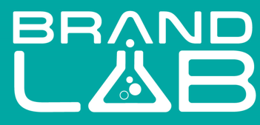
A division of Mitchdowd

Brand Lab teams up with Kmart to release the exclusive ‘Guess How Much I Love You – The Adventures of Little Nutbrown Hare ’ clothing range, just in time for Easter 2022

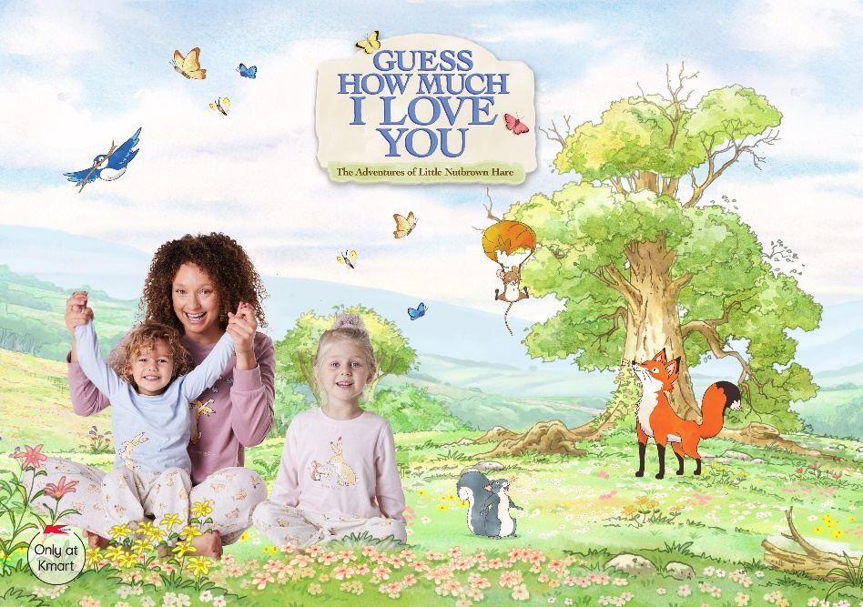

Brand Lab (a division of Australian clothing company Mitchdowd) has teamed up with Kmart to feature a clothing range built upon the award-winning animated television programme Guess How Much I Love You – The Adventures of Little Nutbrown Hare. Based on the best selling classic book written by Sam McBratney and illustrated by Anita Jeram, ‘Guess How Much I Love You’ has captured the hearts of millions of families across the globe for more than 25 years.
The partnership will see 39 ‘Guess How Much I Love You – The Adventures of Little Nutbrown Hare’ products exclusively sold through Kmart. A pastel-perfect collection that spans pyjamas, onesies, dresses, and loungewear, right through to beanies, socks, and slippers. Licensed products previously only available at high end market retailers like David Jones and Peter Alexander.
The collection will feature the beloved characters like Big Nutbrown Hare, Little Nutbrown Hare, Little Field Mouse, Little Redwood Fox, Little Grey Squirrel, Little White Owl and Blue Bird.
“The range is simply beautiful” says Dora Bakasetas, Kmart Business Manager of Children’s Apparel. “An adorable collection of outfits and accessories for parents, families and friends to share with her little ones. Complete with beautiful illustrations and phrases from the much-loved television series. We hope our customers love them as much as we do.”
Dane Totham, CEO for Mitchdowd says, “that Mitchdowd is a proudly Australian-owned Company, and we are delighted to be working with iconic Australian retailer Kmart. Giving families access to on-trend, great value products; and showcasing what Brand Lab has to offer Aussie consumers”.
More styles will be added to the range in coming months. To find out more head to www.kmart.com.au and www.brandlabaus.com.au

For further media information:
Catherine Carnegie
M: 0433 851 015
E: catherine@mitchdowd.com.au

