




AquaterreX
info@aquaterrex.com.au
www.aquaterrex.com.au

For Immediate Release

As spring rains fall in Australia, the Specter of Drought and the devastating images of it remain front of mind for many of the country’s farmers.
Drought Proofing a property is key to avoiding that devastation as the next inevitable Drought rolls through this great country. It is Time to Tap the “Hidden” Source of Water
Adelaide, SA, October 19, 2021 – Following the Primary Industries and Regions (PIRSA) Advance Ag – AgTech showcase on Monday 18th October 2021 at the Adelaide Convention Centre, AquaterreX Managing Director, Darryl Bothe, showcased technology to locate alternative sources of groundwater in even the most arid and unlikely regions.
“The fact is, there is no shortage of water,” said Mr Bothe, “It’s more a lack of understanding about where and how to find it.”
“The US National Groundwater Association estimates that there are 22.6 million cubic kilometers of groundwater in the upper two kilometers of the earth’s crust (1 cubic kilometer of water is 1 million megalitres). Global water usage is just 3,717 cubic kilometers per year. That means there is enough water to supply Earth for over 6,000 years at today’s global consumption rates. Tapping just 10% would supply the planet for 600 years.”
“Vast amounts of fresh water are available in deeper aquifers located below the shallow aquifers that supply nearly all of the world’s groundwater,” said Mr Bothe. “The trick is how to locate this “Deep Seated Water” that has been hidden from view.”
AquaterreX has introduced technology that includes satellite imagery, advanced Multicomponent Spatial Analysis, and proprietary algorithms that enable the company to locate Deep Seated Water with over 90% accuracy. “There are sustainable sources of water that collect and recharge in the deeper aquifers from vast drainage basins through subsurface inflows and outflows,” said Mr Bothe. “With this technology, we are able to locate the near-surface underground channels and pathways to deeper aquifers so that we can reach this water economically without drilling wells many thousands of metres deep,” said Mr Bothe. “In fact, this technology has been used to drill over 1,500 successful water wells on four continents, with a focus on arid or drought-affected regions where they had practically given up on finding water.”
Mr Bothe said that with Australia’s extraordinary drought history, and the inevitable future droughts that will threaten the health and livelihood of many Australians, and indeed billions of people around the world, “It is time to utilize this abundant, supplemental source of fresh water. It is the Missing Piece in any water strategy.”

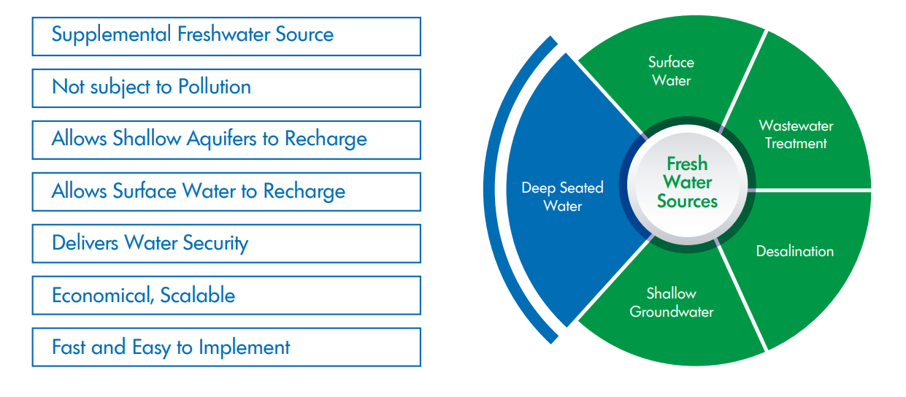
Deep Seated Water is the Missing Piece for any water strategy

Contamination-free water supply and management have become a major challenge for nations, communities, and enterprises. Many water strategies focus on conservation, rather than additional supply. Other solutions such as desalination and wastewater treatment are potential answers for some, but they also come with trade-offs such as high cost, high energy usage, long planning periods, and toxic waste. Deep Seated Water is located almost everywhere on the planet, and it can be added to the mix of solutions as a supplemental freshwater source that is not subject to pollution, is fast and easy to implement, and is economical and scalable. In addition, tapping Deep Seated Water allows both surface water and shallow aquifer sources to recharge, making the total system more environmentally sustainable.
About AquaterreX
AquaterreX (Australia), a subsidiary of AquaterreX LLC (www.aquaterrex.com) is part of the global environmental services organization with a mission to broadly implement effective water and food security solutions. The name AquaterreX comes from the Latin, aqua (water) and French, terre (earth, land) which is a derivative of the Latin, terra, and “X” for exploration. Thus, AquaterreX encompasses water and land solutions for the planet.
The company possesses proprietary technology to locate Deep Seated Water, which is fresh water situated below the shallow groundwater that supplies the majority of fresh water on the planet. This vast new source of water can help solve the water crisis facing billions of people.
AquaterreX acquired the technology in an exclusive licensing agreement with the non-profit Lawrence Anthony Earth Organization in 2018. Since then, a series of enhancements have been made to further improve the accuracy and capability of the technology. AquaterreX continues to partner with The Earth Organization and support its humanitarian efforts to bring effective resolution to environmental issues. www.TheEarthOrganization.org
AquaterreX offers an analysis to municipalities, farms, stations, and organizations experiencing water deficiencies. Request an Analysis
Media Inquiries: contact Darryl Bothe, info@aquaterrex.com.au 0433 877 110
www.aquaterrex.com/deep-seated-water

###

