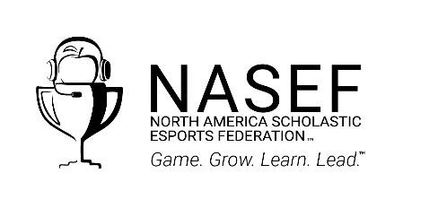 |  | Media Contacts:  NASEF  Claire LaBeaux  claire@nasef.org  STEM Punks®  Damien Aldridge  damien.a@stempunks.com.au

Play and Learning Through Esports: STEM Punks® To Implement Scholastic Esports Programs as it Creates a Local NASEF Affiliate
Strong national network enables STEM Punks® to offer significant learning opportunities related to esports while expanding tournament play through the North America Scholastic Esports Federation

Esports are booming, and students in Australia are excited to not just play the games, but to pursue related careers. To support this thirst for competition and education, STEM Punks® has just become an affiliate of the North America Scholastic Esports Federation. NASEF will provide free tournaments, programs, curriculum, and expertise to help scholastic esports grow and thrive in Australia.

NASEF leverages massive student interest in team-based competitive video gaming, offering meaningful career and STEM education alongside tournaments. Students learn about possible career pathways, enter Beyond the Game creative and analytic challenges, manage clubs and events and fundraising, and compete in tournaments in popular titles including but not limited to: Rocket League, Chess, and Minecraft, to name a few.

STEM Punks® Education Director, Damien Aldridge, says; “the affiliation with NASEF will provide STEM Punks® with a platform to grow eSports in Australia with a core focus on education and innovation. STEM Punks is launching a new initiative called ‘Innovation Sports’ in 2022 that combines the best of eSports, Innovation, and Education where students compete in solving industry-linked problems. The affiliation with NASEF will enhance our message that eSports is more than just gaming but a pathway for students to explore future work in STEM related fields.”

STEM Punks® vision is to create and foster competitive esports programs through the lens of academics and learning in Australian primary schools and high schools by providing assistance, organizing tournaments, and presenting information to schools and advisers. NASEF offers a unique focus on diversity with an emphasis on cultivating talents in potentially underserved populations and provide a pathway to college scholarships and careers in the gaming industry.

“Research demonstrates the effectiveness of esports as a tool for meaningful STEM and social-emotional learning,” said Gerald Solomon, founder and executive director of NASEF. “We’re thrilled to have STEM Punks® in the NASEF family, where educators will be able to learn best practices from other community networks with experience implementing scholastic esports programs. Of course, the students will be thrilled to take part in huge tournaments in popular games. We’re excited to support STEM Punks® and see the growth across the Australia Pacific Region in the coming years.”

Learn more at the NASEF website or the STEM Punks® website. Schools across Australia are invited to join STEM Punks® and NASEF and tap into their events and resources; contact Damine Aldridge for more details: damien.a@stempunks.com.au

About the North America Scholastic Esports Federation
The North America Scholastic Esports Federation (NASEF) is on a mission to provide opportunities for all students to use esports as a platform to acquire STEM/STEAM-based skills and critical communication, collaboration, and problem-solving skills needed to thrive in work and in life. NASEF and its partner HSEL are collaborating to create the leading global esports marketplace and community for play and learning. Find NASEF at NASEF.org and on Twitch, Twitter, Facebook, and Instagram.

###

All trademarks are property of their respective holders.

