Horses Birthday 1st August
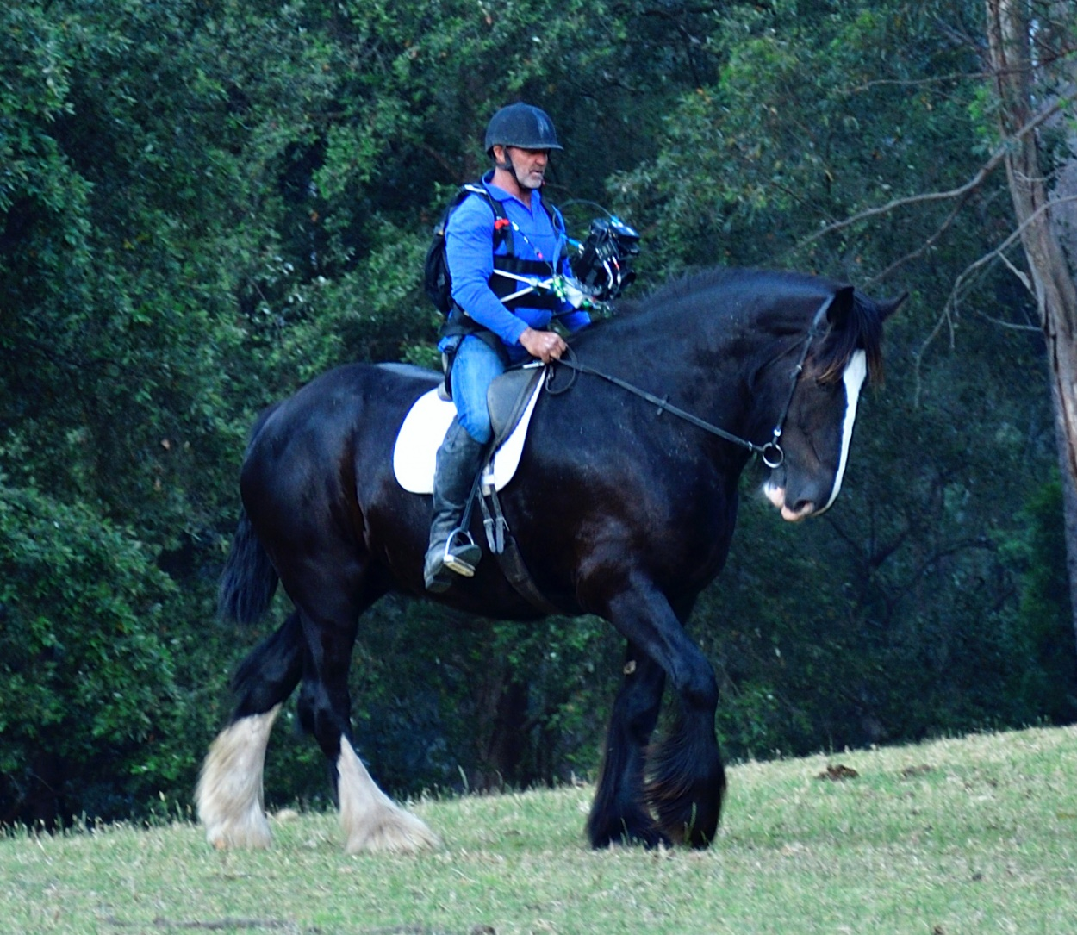
Happy Horses Birthday wishes to all the horses in Australia on the 1st August! All breeds of horses, from the miniatures to the Shire’s, are incredibly special to humans.
Stormy George, pictured above, is Australia’s tallest horse! He is 19 hands (193 cm to the wither) he is a grandson of Australia’s first imported Shire stallion, Ladbrook Edward (also 19 hands) who arrived in Australia on a specially converted jumbo jet in 1981. He was known to his friends as Jock.
The Shire breed had died out in Australia in the early 1900’s and with the importation of Jock and a few years later three mares, Australia’s first Shire Horse Stud was formed in Kangaroo Valley. Cedars Shire Horse Stud is still running today and occupies the marvellous property with Barranca, which is a very exclusive 5-star resort and features in the documentary called “The Healing”.
Horseman Scott Brodie is riding Stormy George holding a movie camera while filming the newly released documentary in Kangaroo Valley.
“The Healing” will be premiered at the Melbourne Documentary Film Festival in August. It is about horses healing soldiers and soldiers healing horses. Both of these groups are broken down in one way or another and suffer from trauma due to their previous professions either on the racetrack or as veterans. Scott Brodie brings these two groups together in a way that gives new hope to both.
The Barranca Equine Program (previously Cedars Equine Program) is proud to host and sponsor these events. Barranca guests are thoroughly spoilt and as well as residing in luxury accommodation, they have the opportunity to get up close and friendly with these marvellous gentle giants during the morning feed ups.
There are now over 400 pure bred registered Shire horses in Australia today.

