

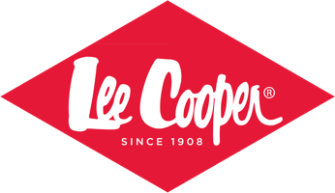

MITCH DOWD
THE PERFECT FIT FOR
LEE COOPER

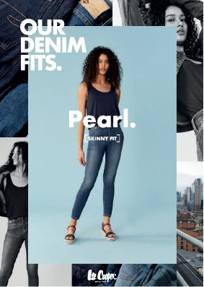
Australia’s favourite sleepwear, underwear and sock brand for men, Mitch Dowd is expanding their category footprint. Six months after announcing that Mitch Dowd is the new home of Russell Athletic apparel, Mitch Dowd announces that they are managing denim giant, Lee Cooper in Australia and New Zealand.

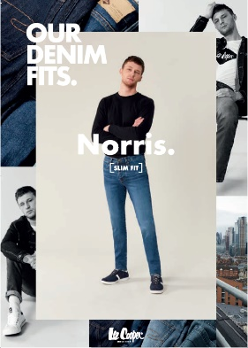
Consisting of a range of core denim styles and complementary co-ordinated apparel, the Lee Cooper London creative hub has been working with Mitch Dowd designers to bring the best that the international collection has to offer, with a touch of local Australian flare.

The brand will be accessible to Men, Women and Children and Lee Cooper will be sold through national retailers and independent stores. Dane Totham, CEO for Mitch Dowd says that “Mitch Dowd has taken bold and decisive acquisition moves in the COVID era and the 6 months it has taken to consummate this deal has been well worth the effort. The entire Mitch Dowd business is more successful, sustainable and pro-active than ever before. We have transformed our business and we are absolutely delighted to be working with Lee Cooper as the brand fits our brand management ethos and our company culture”.

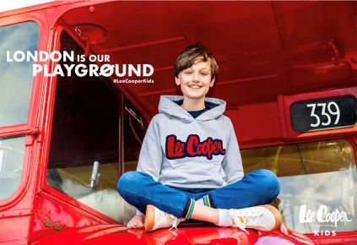
“What is particularly pleasing about the Lee Cooper brand is that research validates that the Lee Cooper brand is well-known and wanted by our consumers and this is particularly pleasing to us. We plan to tap into everything that the brand offers through international styling and sourcing”. Totham says.

Daisy Laramy-Binks, Managing Director for Lee Cooper global said “Lee Cooper's decision to award Mitch Dowd the rights was an easy one given Mitch Dowd's proven capabilities in product design, development, sourcing, logistics and distribution”.

“Mitch Dowd’s passion for the brand, combined with the reaction we are receiving from consumers demanding Lee Cooper in the region leaves me in no doubt that we will see great things for the brand in both Australia and New Zealand” says Laramy-Binks.

For further media information:
Catherine Carnegie
M: 0433 851 015
E: catherine@mitchdowd.com.au

Company information

About Lee Cooper

Founded in London’s East End in 1908, Lee Cooper has a rich history spanning over a century, establishing its iconic status as the original British denim brand. From humble beginnings in workwear, Lee Cooper has become known as a global style innovator with a loyal fanbase worldwide. An essential sartorial ingredient of all the 20th Century’s most progressive youth movements, Lee Cooper’s vast contribution to UK popular culture is undeniable.

Part of the Iconix Brand Group, Inc., Lee Cooper operates in over 125 countries with a retail distribution of over 7,000 points of sale. Iconix Brand Group (ICON) is the world’s premier brand management company and owner of a diversified portfolio of strong global consumer brands across fashion, sports, entertainment, and home. Iconix specializes in marketing, merchandising and licensing its brand portfolio and has over 1,100 licenses with leading retailers and manufacturers worldwide that sell across various distribution channels from the mass tier to the luxury market, as well as through various media outlets.

Leecooper.com / iconixbrand.com
Instagram: @leecooper1908
Facebook: @leecooperbrands

For more information please contact:
Mason Young, Head of Marketing & Product
myoung@leecooperbrands.com

