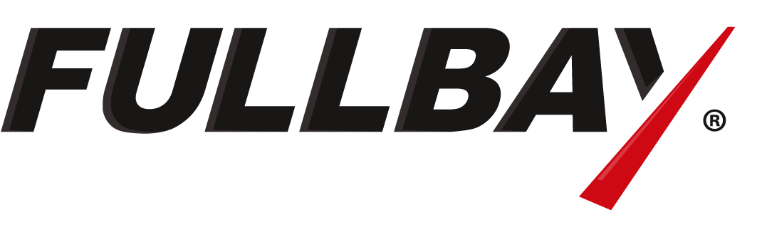
FOR IMMEDIATE RELEASE: 15/4/2021

Fullbay
Matt Stone
+1 (602) 429-9019
matt.stone@fullbay.com

FULLBAY ANNOUNCES TRUCK AND HEAVY VEHICLE REPAIR SHOP MANAGEMENT PLATFORM NOW AVAILABLE IN AUSTRALIA

[Phoenix, AZ – 15 April, 2021] Fullbay, the leading repair shop management software for truck and heavy vehicle repair shops, announced it’s now available in Australia. The repair shop platform made several adjustments to ensure the same high level of performance and support for Australian-based businesses.

Jacob Findlay, CEO and co-founder of Fullbay, said making Fullbay available outside of North America is an exciting achievement. “We wanted to be sure that our software and team would be able to provide the best possible experience for customers before moving forward. The standard we hold ourselves to is nothing less than the best repair shop management platform in existence—and we’re thrilled to be able to now offer that to our friends in Australia.”

Fullbay’s solution enables owners to receive repair requests, invoice customers, and everything in between. Purpose-built for heavy vehicle repair, the platform is uniquely designed to help shops that focus on the repair and maintenance of medium and heavy vehicles, heavy equipment, farm and agricultural machinery, and more. To ensure fleets and shops in Australia have no trouble using the platform, Fullbay added features and extended support hours until 12 p.m. AEDT.

“The features that Fullbay offers let you transform your business, become more efficient and profitable, and get freedom from the shop.” says Findlay

Thousands of repair shops trust Fullbay to help run their business and on average see a 20 percent increase in service revenue and 13 percent increase in technician efficiency after six months of being up and running with the software. Independent repair shops and in-house fleet maintenance teams can receive a free product demonstration of the Fullbay platform and learn more at fullbay.com.

About Fullbay

Fullbay provides heavy vehicle repair shop management software to streamline workflows and improve efficiency. Launched in 2015, Fullbay helps repair shops increase technician productivity, invoice faster, better manage parts, connect with other applications, and more. By reducing administrative and management tasks that have slowed down shops for years, Fullbay customers have better-run and more profitable businesses. For more information, visit fullbay.com.

###

