Media release: For issue: Thursday, 01 April 2021

There’s an Easter egg near your water meter!

In a world first, WaterGroup announced today that its smart water meters come with a hidden surprise, just in time for Easter. Programmers often hide little nuggets of code inside their software that is released upon activating a certain number of events. This is commonly referred to as an “Easter egg”. The team at WaterGroup have taken this one step further. They have programmed their smart water meters to dispense real Easter eggs to a selected group of water meter owners.

To find out if you are one of the lucky ones, check your water meter before 11am today and see if its serial number ends in 14. If it does, then wait until the meter dial shows the digits 1 and 4. But do not waste any water to trigger the meter to show these numbers. The meters are smart and will detect such attempts. When these numbers appear a secret hatch will open and a real Easter egg will pop out.

If for any reason the Easter Bunny got into your meter before you did and has already reallocated the Easter egg, jump onto our website at www.watergroup.com.au/easteregg and upload an image with you and the water meter reading. We will then send you an Easter egg.

Guenter Hauber-Davidson, Managing Director of WaterGroup, Australia’s leading integrated water efficiency company, said: “After the fires, COVID-19, and now the floods we wanted to dial up a smile on everybody's face with this little surprise. We hope it works.”

For further information including how you can use smart meters every day, beyond finding Easter eggs, to help you save water and money head to WaterGroup’s website at www.watergroup.com.au

About us
WaterGroup is a national water savings company. We provide cost effective and innovative solutions to save water and money. Our clients are water suppliers, large corporates, hospitals, shopping centres, universities and schools, and other large water users. For further media inquiries or interviews please contact WaterGroup Marketing on 02 9499 8795.

Attachment: 1 photo – royalty free to use.
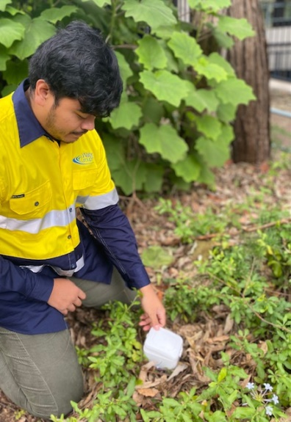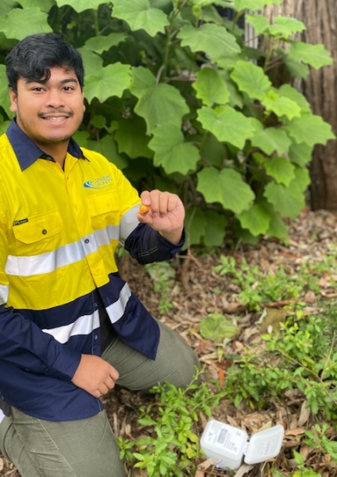
Caption: WaterGroup’s Installer team having a successful trial run.

