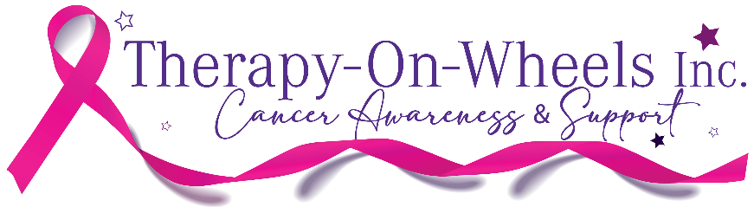
16th March 2021
FOR IMMEDIATE RELEASE
THERAPY IS A DRIVING FORCE
Therapy on Wheels is Bank West’s Best in the West
Therapy on Wheels has won a significant grant from Bank West in their “Best in the West” grant funding.

Therapy On Wheels a not-for-profit organisation- takes passengers down the drag strip (from 0-200+kph in 10 seconds) in a highly modified - only one in the world - Supercharged Hellcat Mercedes Benz. And has received a $5000 grant from Bank West to continue supporting those affected by cancer.

“We do this to not just raise awareness but also improve the mental wellbeing of cancer patients and their families through adrenaline-based participation in motorsport.” Andy Kahle Founder and Director of Therapy on Wheels said.

The motivation behind Therapy on Wheels is Andy’s own cancer survival story. Andy was about to start her dream of drag racing, but a couple of months before she was set to sit her race license, she was diagnosed with aggressive breast cancer.

Deciding to utilise the strength around her of the motorsport community, friends and family Andy set her focus on achieving her dream of drag racing.

After 10 years of all clear cancer tests, and lots of racing, Andy and her husband Mick created Therapy on Wheels sharing the experience and support from the WA Motorsport community.

Therapy on Wheels is an adrenaline-based activity, which has long been used to increase endorphins, in turn aiding in the decrease of stress, depression and anxiety.

This kind of therapy allows patients and families to recharge their emotional batteries with a big smile.

With the Bankwest grant, Andy and her team can continue to provide this unique and adrenaline rush experience to those affected by cancer and their families.

For more information contact:
Andy Kahle – Race Driver, Public Speaker, Breast Cancer Survivor, Author
0437 312 394
andy@therapyonwheels.asn.au
www.therapyonwheels.asn.au

ENDS

