Media Release

EXPANDED CAPABILITY AT CHALLENGER MINE

Great Divide Mining Pty Ltd (ASX:GDM) has announced further progress at the Challenger Mine in Adelong, NSW, as part of the company’s scheduled and staged recommencement of full operations.

Recommissioned equipment, for several weeks now, has performed in line with design specifications, both the Wilfley and Gemini tables delivering steady and increasing gold concentrate outputs.

GDM has chosen to enhance gold recovery rates. The Knelson Concentrator was tested, deemed safe to operate and recommissioned, but repositioned in the process flow to a tailings scavenging role. Additionally, GDM have installed a Knudsen Concentrator to further enhance gold recovery even further.

“It’s all about efficiency,” said GDM’s CEO, Justin Haines, “If we’re going to be extracting gold from Challenger’s milled ore we want to be extracting as many ounces of gold per ton as we possibly can.”

“It’s also about operational stability and sustainability,” he said. “Yes, GDM is still focussed on our first gold pour at the Challenger Mine, without a doubt, but we don’t want to just pour first gold and then be shutting the plant down. We’ve put the plant recommissioning and upgrades out up front.”

“We communicated to shareholders that our aim was a commercial gold mining operation,” he went on “GDM is to be an Explorer and Producer of Gold. When we hit the “Go” button we aim to be in production each and every day. First-pour will be just another milestone achieved on that journey.”

“It’s GDM’s ‘Crawl-Walk-Run’ strategy, followed by our ‘Rinse n Repeat’ strategy, smiles Haines.

“The Knelson Concentrator, which uses centrifugal force to efficiently recover fine free gold, has been fully refurbished and reinstated. The Knudsen Concentrator, newly installed, offers complementary capabilities in handling finer fractions of concentrate, ensuring a higher overall recovery rate,” said Haines

“This marks another major, deliberate and patient step forward, in our mine restart plan,” said Haines, “With key gravity circuits operating to design, we’re laying the foundations for a stable ramp-up and consistent gold concentrate production. Our team’s efforts on site have been outstanding.”

“These developments come as part of GDM’s phased operational recommissioning strategy, which is being executed in accordance with safety and environmental standards,” Haines continues.

“Still I can’t wait for that first pour ! ” he smiles.

ENDS

For further information:

Justin Haines, CEO
e justin.haines@greatdividemining.com.au
m +61 (0)418 876 420

Great Divide Mining Ltd (ASX: GDM)
Great Divide Mining is an Australian Gold, Antimony and critical metals miner, explorer and developer with five projects across 17 tenements (including two in application). GDM’s focus is on operating producing assets within areas of historical mining and past exploration with nearby infrastructure, thus enabling rapid development. Through a staged exploration and development programme, GDM intends to generate cash flow from its initial projects to support further exploration across its portfolio of highly prospective tenements.
https://greatdividemining.com.au/

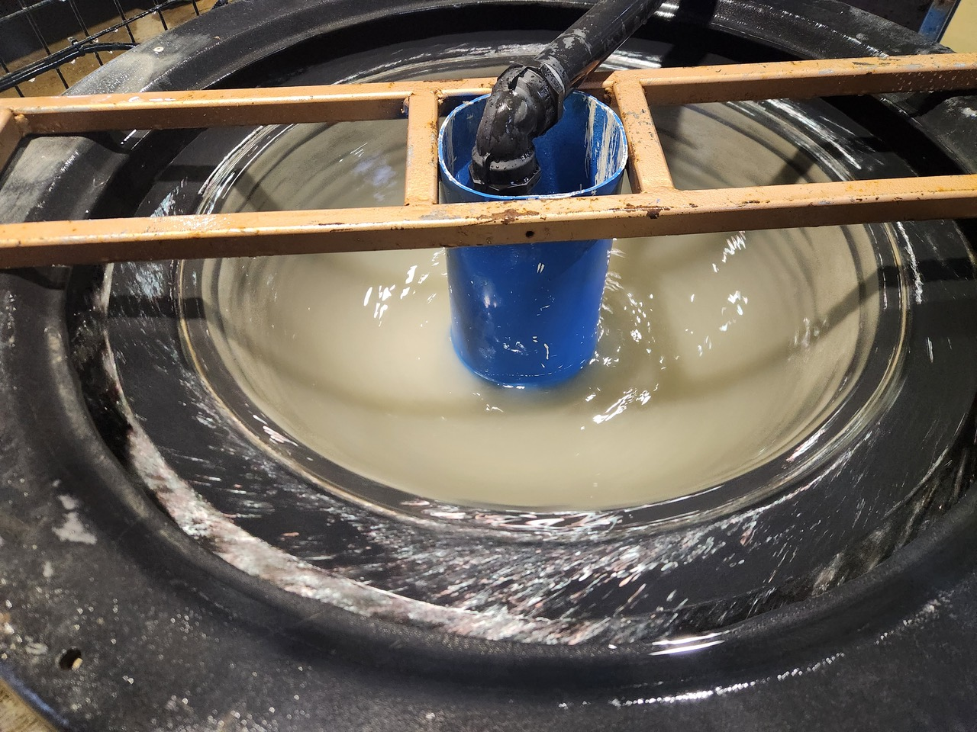
Extracting Gold from Tailings at Great Divide Mining’s Challenger Mine Site

