Revolutionary BioRePeel Treatment Enhances Skin Rejuvenation in Melbourne
Melbourne, Australia
4th September 2024

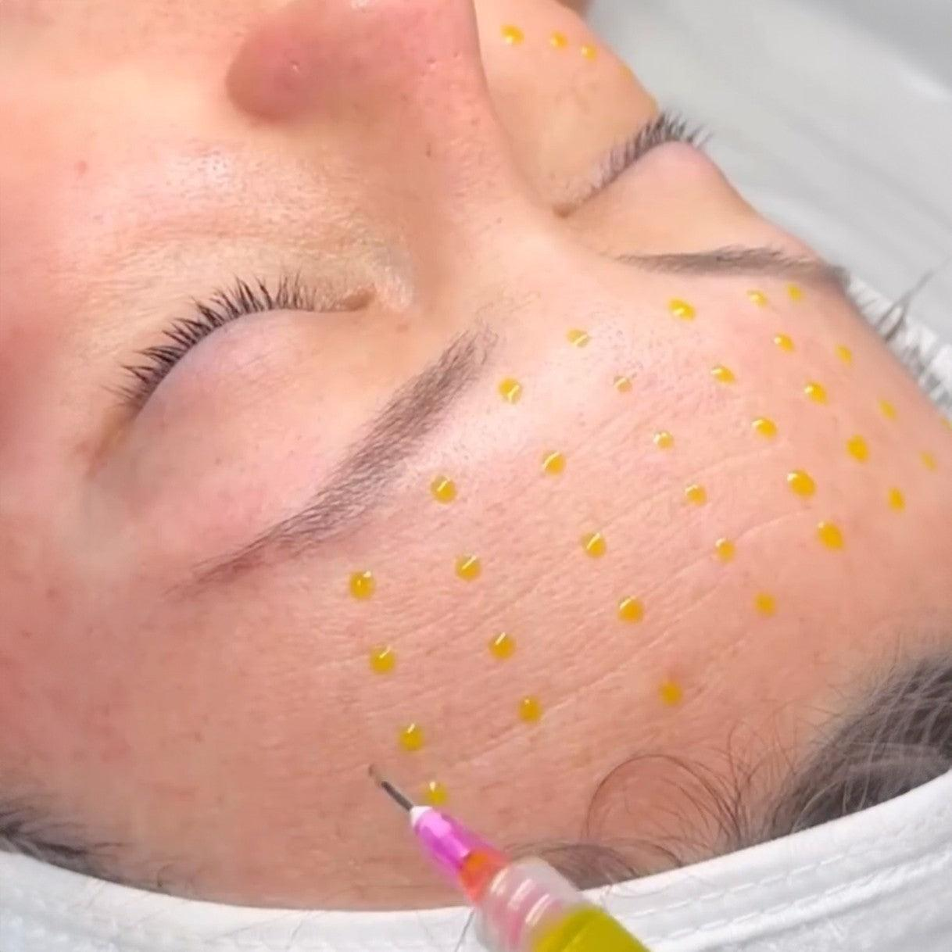
As the demand for advanced skincare solutions continues to rise, the BioRePeel from Italy emerges as a groundbreaking treatment option, now available in Melbourne. This innovative two-phase medical peel is set to transform the way we approach skin rejuvenation, offering a natural and effective method to exfoliate, hydrate, and revitalise the skin.

BioRePeel addresses various skin concerns by leveraging a unique combination of natural acids, enzymes, vitamins, and nutrients. This cutting-edge treatment stimulates cell turnover, deeply revitalises the skin, and combats the effects of aging and acne scarring. Its exfoliating and keratolytic properties ensure that the skin is smoother and more hydrated and exhibits a noticeable reduction in fine lines, wrinkles, and pigmentation, resulting in a youthful and even-toned complexion.

Mal, a cosmetic nurse, dermal clinician, and founder of Melbourne’s renowned Skin & Spa Nirvana, is a leading expert in advanced skincare treatments. She shares her insights on the impact of BioRePeel:
“BioRePeel is the latest skin peel from Italy and has quickly become a favourite among our clients. Its ability to deeply stimulate and revitalise the skin helps us deliver outstanding and personalised results. With a natural formulation tailored for all skin types, it’s the perfect choice for anyone looking to boost their skin’s health and appearance. The immediate glow and long-lasting benefits make this peel truly exceptional.”

For more information on BioRePeel and to book a consultation, please contact:
Name :Mal
Mobile: 0422125569
Email : info@skinandspanirvana.com.au
Website: https://skinandspanirvana.com.au/

Address:

Skin & Spa Nirvana
45 McNamara Ave,
Airport West VIC 3042
P: (03) 9330 2955

About Skin & Spa Nirvana
Skin & Spa Nirvana is a premium Skin & Laser Clinic offering personalised Skin Treatments, Cosmetic Aesthetics, Laser Hair Removal, Vitamin IV Infusions, Teeth Whitening and Spa & Massage in Airport West, Melbourne.
Image - https://drive.google.com/file/d/1ETBOTgv3tuNdYBP_Tq7Trl_IpRYgWhzf/view?usp=sharing

