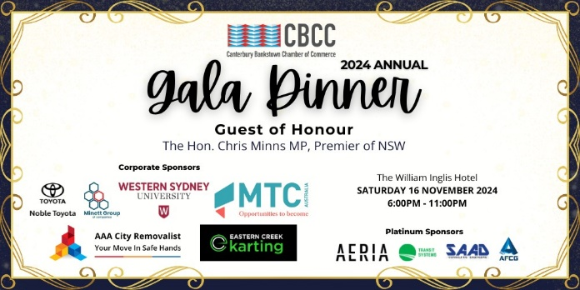
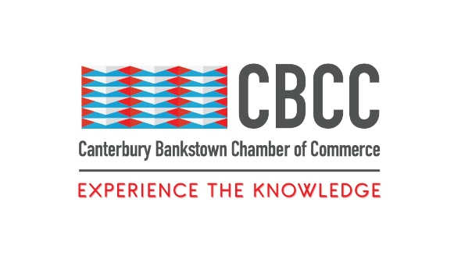
29th August 2024

FOR IMMEDIATE RELEASE

Lighting Up Western Sydney With Glitz, Glamour, and Excellence
Sydney, New South Wales – The Canterbury Bankstown Chamber of Commerce (CBCC) invites you to one of the most glamorous and highly anticipated events in Western Sydney – the CBCC 2024 Gala Dinner.
This prestigious event is a highlight of the CBCC annual calendar. Coming together to highlight and embrace the outstanding achievements of the CBCC’s strong, thriving, and vibrant community, the 2024 Gala Dinner promises to be an evening of unparalleled elegance, celebration, and inspiration.
With a rich history of sold-out crowds and unforgettable moments, the 2024 Gala Dinner is more than just a glamorous night out. It is a celebration of the spirit, resilience, and excellence that defines Western Sydney. Bringing together business leaders, community figures, and local champions who have made significant contributions to the region, this Gala Dinner will inspire attendees to continue driving positive change within their communities.
The CBCC is thrilled to welcome the Hon. Chris Minns MP, Premier of New South Wales, as our distinguished guest of honour. As a leader deeply committed to the growth and prosperity of Western Sydney, the Premier will share his vision for the region’s future and his appreciation for the CBCC community’s contributions. His presence at the Gala elevates the significance of this event and the vital role that Western Sydney plays in the broader landscape of NSW.
The 2024 Gala Dinner would not be possible without the generous support of the event’s corporate sponsors: Western Sydney University (https://www.westernsydney.edu.au/), Noble Toyota (https://www.nobletoyota.com.au/), MTC Australia (https://mtcaustralia.com.au/), Minett Group (https://minettgroup.com.au/), AAA City Removalist (https://www.aaacityremovalist.com.au/), and Eastern Creek Karting (https://easterncreekkarts.com.au/). As leaders in their industries, they share the CBCC’s commitment to making Canterbury-Bankstown and Western Sydney the top place to live, study, play, and do business.
The CBCC is also proud to highlight the Gala’s Platinum Sponsors, Transit Systems Sydney (https://www.transitsystems.com.au/), Australian First Construction Group Pty Ltd (https://australianfcg.com/), Aeria Precinct (https://aeria.co/), and SAAD Consulting Engineers (https://saadconsulting.com.au/). Their contribution is key to the success of this event and the ongoing development of Western Sydney.
The CBCC 2024 Gala Dinner promises to be the epitome of sophistication and glamour, designed to dazzle and delight. Whether you are a business leader, a community advocate, or simply someone who loves Western Sydney, this Gala is an event you won’t want to miss. Reserve your ticket as soon as possible! https://events.humanitix.com/cbcc-2024-gala-dinner
Event Details:
- Date: Saturday 16th November 2024
- Time: 6:00pm – 11:00pm
- Venue: The William Inglis Hotel, 155 Gov Macquarie Dr, Warwick Farm NSW 2170
- Dress Code: Black Tie
About Canterbury Bankstown Chamber of Commerce:
The Canterbury Bankstown Chamber of Commerce is the fastest-growing Chamber in Greater Sydney, counting over 680 members from various industries and cultural and religious backgrounds. Our mission is to support and uplift the local community through connection and collaboration to make Canterbury Bankstown the most ideal place to live, study, work, and do business.
###
Contact Information
Wally Mehanna
CEO of the Canterbury Bankstown Chamber of Commerce
M: 0416 012 747
E: ceo@cbchamber.org.au

