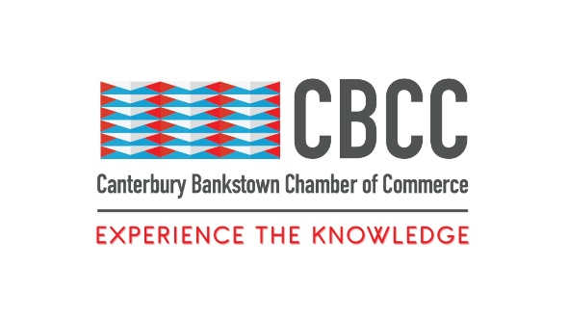
15th August 2024

FOR IMMEDIATE RELEASE

More than just a handshake: Harness The Power of Networking
The CBCC invites all to learn about ‘The Science of Networking’ at 6:00pm on Monday 26th August 2024 at the Canterbury League Club.
Sydney, New South Wales – The Canterbury Bankstown Chamber of Commerce (CBCC) invites business professionals, entrepreneurs, and community leaders to join them for their highly anticipated August BA5 event, ‘The Science of Networking’. Designed to provide you with the tools, insights, and opportunities to elevate your networking game, this event will help you build lasting relationships that can transform your business.
As the fastest-growing Chamber in Greater Sydney, with over 680 members from diverse industries, cultural backgrounds, and religious beliefs, the CBCC knows deeply how powerful networking can be for businesses. It is an essential skill in the business world, but mastering it requires more than just exchanging handshakes and business cards.
‘The Science of Networking’ will delve into the science behind effective networking, offering practical strategies and real-world examples from seasoned professionals. Topics include Social Psychology, Relationship Building, Networking Strategies, Communication Skills, Networking Etiquette, and Maintaining Relationships. From a networking veteran with decades of experience to a bright-eyed young entrepreneur, this event is tailored to help everyone navigate the complexities of building meaningful connections in today’s fast-paced business environment.
At the heart of this event is a panel of industry experts who will share their insights and experiences on networking and encourage active participation and engagement. With their guidance, leave the event with an expanded professional network and new contacts of like-minded people.
The CBCC would like to thank the generous support of the event sponsors, BNI Sydney South West, Perfect Square Design, Sydney Building Group Pty Ltd, BOSS Projects Aust, and Steel Renew. Without their commitment to the Western Sydney community and their belief in the power of networking, this event would not have been possible.
Experience the knowledge and learn about ‘The Science of Networking’ at this event. Spaces are limited, so don’t miss out! This event is free for CBCC members and $10 for non-members. Buy tickets today. < https://events.humanitix.com/cbcc-business-after-five-ba5-the-science-of-networking >
Event Details:
- Date: August 26th 2024
- Time: 6:00pm – 8:30pm
- Venue: Canterbury League Club

About Canterbury Bankstown Chamber of Commerce:
The Canterbury Bankstown Chamber of Commerce is the fastest-growing Chamber in Greater Sydney, counting over 680 members from various industries and cultural and religious backgrounds. Our mission is to support and uplift the local community through connection and collaboration to make Canterbury Bankstown the most ideal place to live, study, work, and do business.
###
Contact Information
Wally Mehanna
CEO of the Canterbury Bankstown Chamber of Commerce
M: 0416 012 747
E: ceo@cbchamber.org.au
