Revolutionary Partnership Announced: How Wandarra and PAPACKS® Aim to Turn the Tide on Plastic Waste in Australia
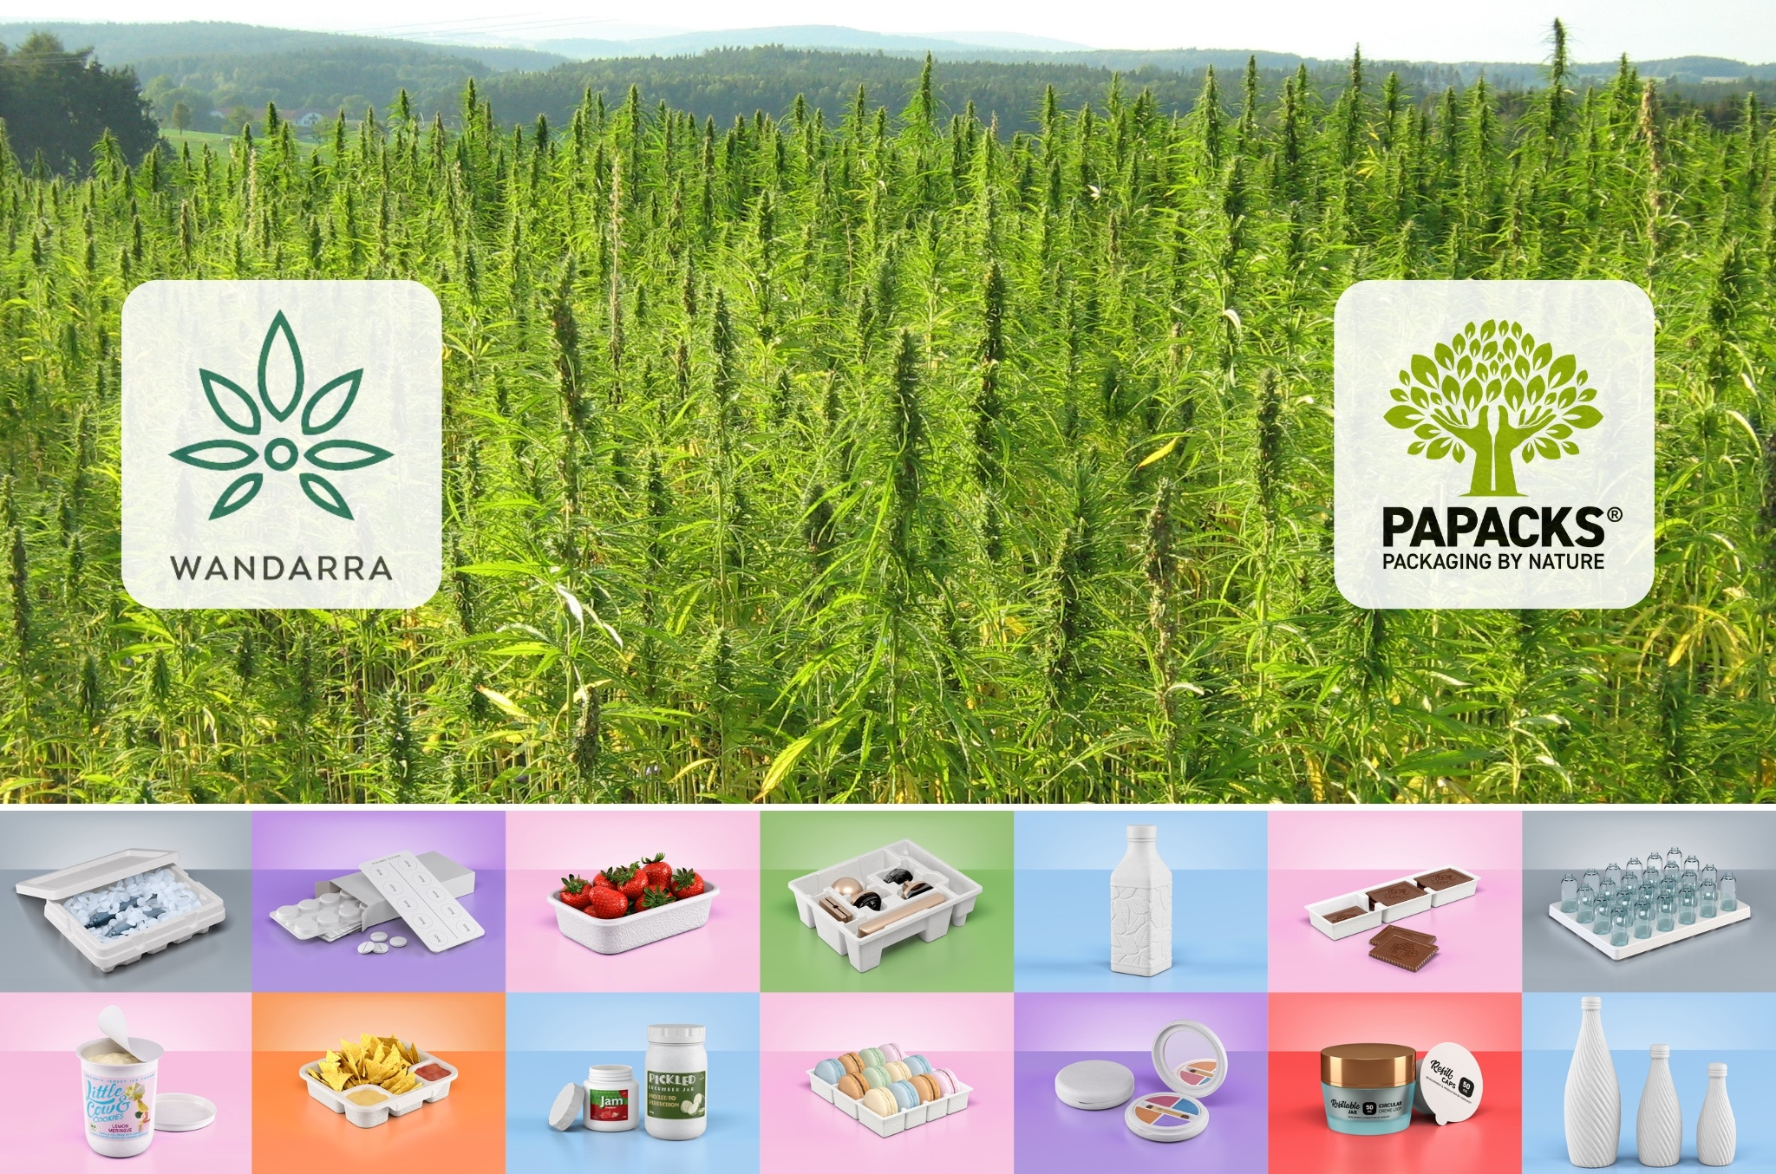

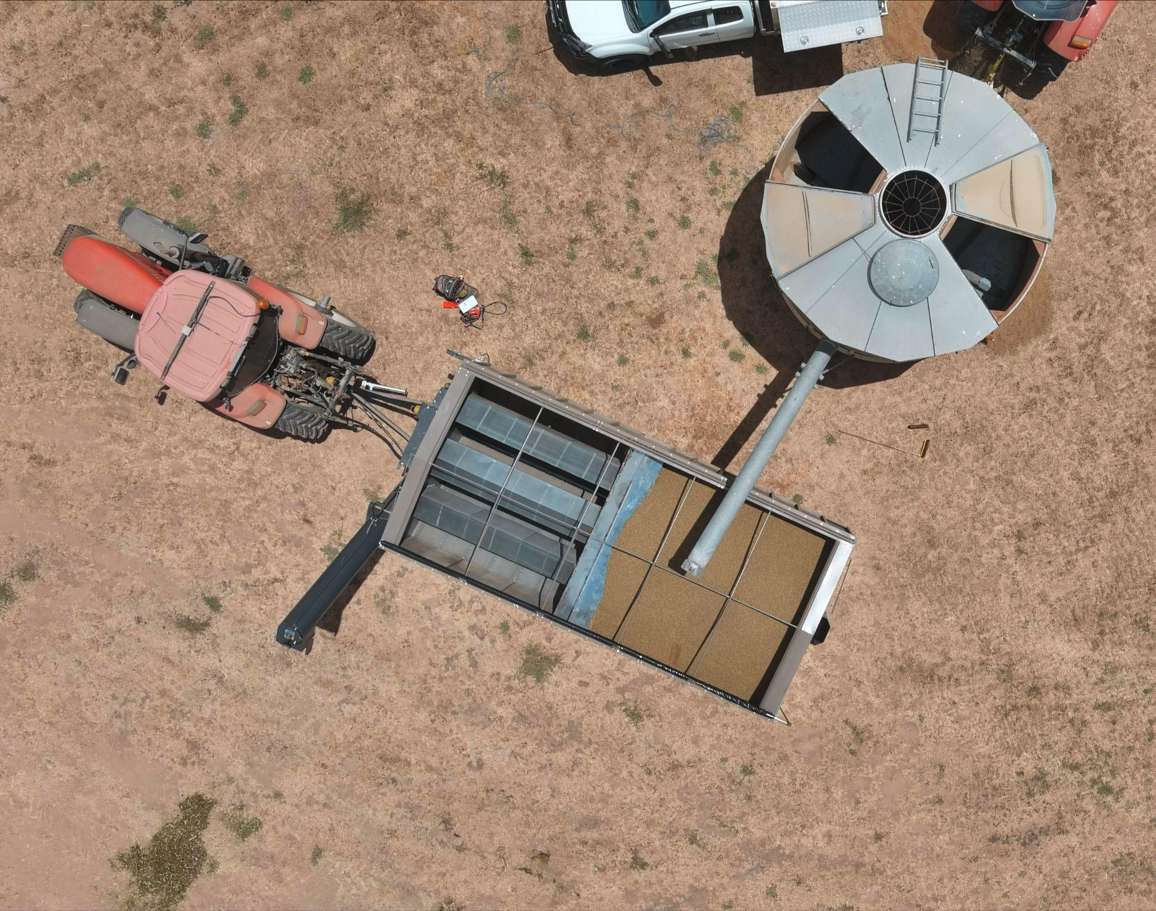
Townsville, North Queensland, July 10, 2024 – Wandarra, an innovative ag-tech solutions firm based in Townsville, North Queensland, and PAPACKS®, a global leader in sustainable packaging based in Cologne, Germany, are excited to announce a strategic partnership via a recently executed Memorandum of Understanding (MoU). The parties are currently working together to formalize the Australia-APAC exclusive IP licensing agreement with the target end date intended over the next few weeks.
This partnership aims to transform the packaging industry across Australia and the Asia-Pacific, reducing plastic waste and supporting environmental sustainability by leveraging Wandarra’s regional resources and PAPACKS®’ cutting-edge technologies.

Wandarra, based in the eco-friendly hub of Townsville near the Great Barrier Reef, capitalizes on its robust and efficient logistics network to distribute innovative hemp-based products. This location underscores Wandarra’s commitment to environmental stewardship and positions the company as a leader in climate protection, the circular economy and regenerative agriculture. Townsville’s logistics network, including rail, road, sea, and air, enables Wandarra to efficiently distribute goods and services.
Initially, with sustainable alternatives through Smart Precinct NQ Queensland, the partnership will target the fresh produce sector, a vital industry in North Queensland, aiming to replace single-use plastics.

The Circular Economy program supported by this partnership, aims to develop sustainable packaging solutions to replace single-use plastics and position the region as a leader in this industry.

PAPACKS® provides a turnkey solution, including equipment training and commissioning, to ensure seamless production and adoption of sustainable packaging technologies.
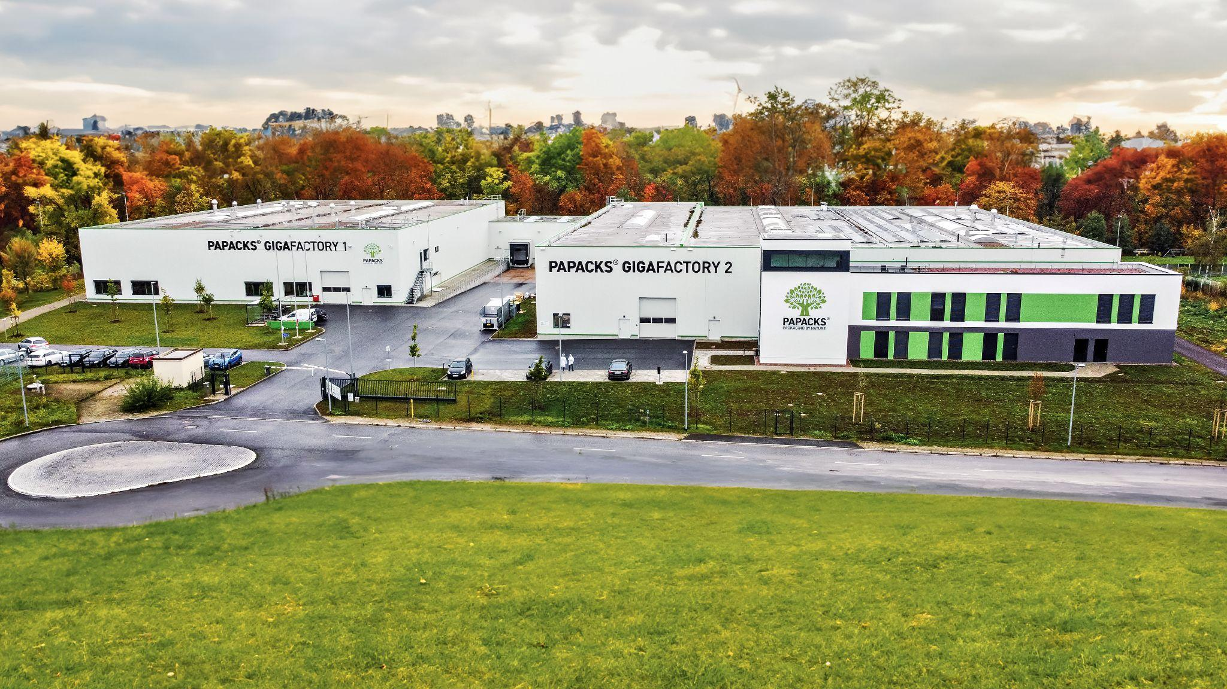
The production timeline plans for initial testing by way of samples produced in Germany, and delivered to North Queensland, to accommodate local consumer preferences. Concurrently, the Australian production team will be trained in Germany on the production lines, followed by commissioning and acceptance of the equipment and transport to the final Wandarra production site. This phase is scheduled to start in Q4 2024.

PAPACKS® also offers expertise from over 75 patent families, including the preparation and processing of hemp as the most sustainable fiber raw material. Over the past seven years, PAPACKS® has advanced these developments with HempPulp® to achieve optimal product results.
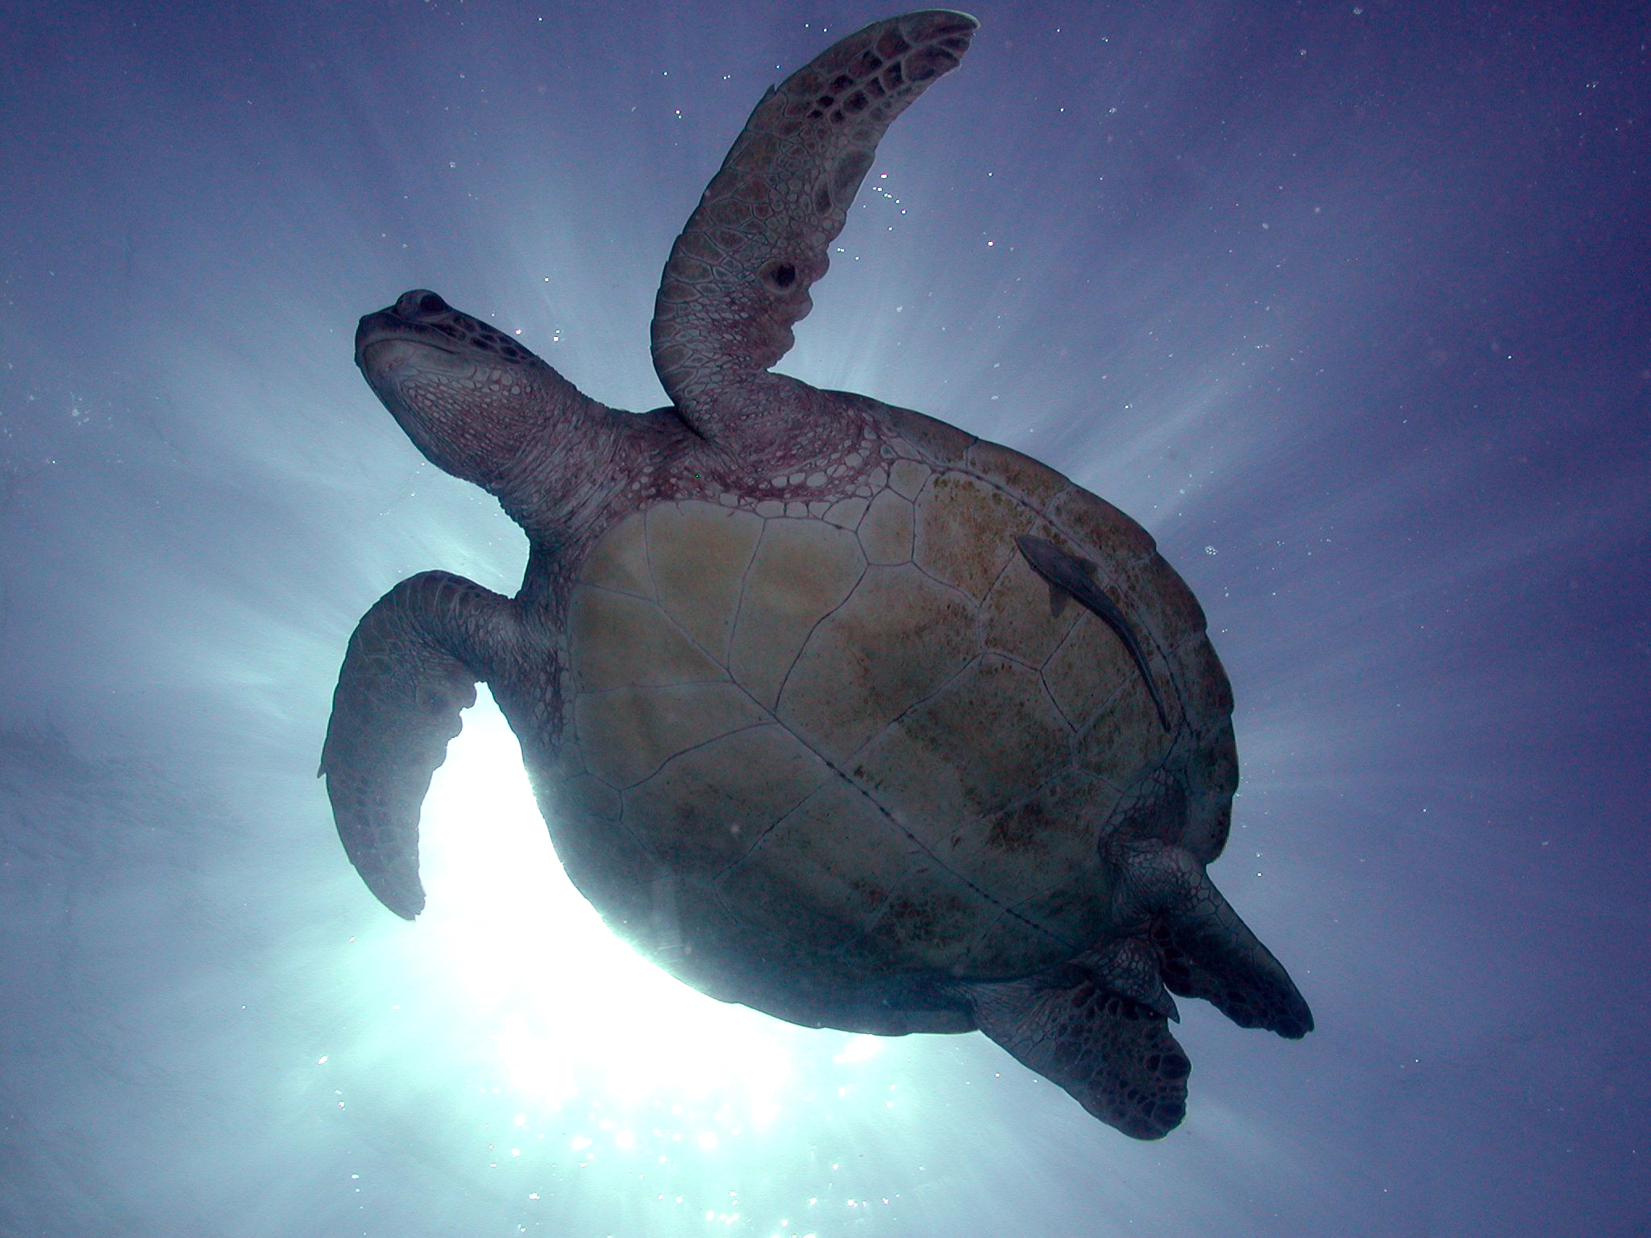
Australia generates 5.5 million tonnes of packaging material annually, with only 49% being recycled. This collaboration will have significant market impact by introducing world-leading sustainable packaging solutions, that include the reduction of landfill waste and marine litter. It will also enhance industrial hemp cultivation in North Queensland and position Wandarra as a strong innovator and leader in the Asia-Pacific region.

Quote from Steve Tiley, CEO of Wandarra
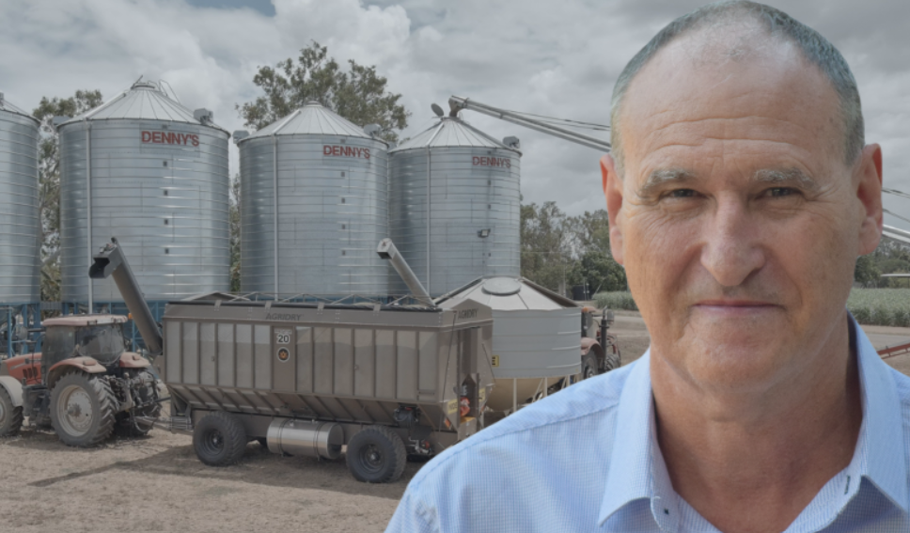

“North Queensland’s responsibility to the Great Barrier Reef is unique, and the news of plastic detected on the outer reef is disturbing. Our collaboration with PAPACKS® provides an immediate solution for food and beverage manufacturers to meet their sustainability goals. The PAPACKS® team has developed world-leading technology that started as a concept in a garage, just 10 years ago. Their perseverance in research and development is an outstanding achievement.”

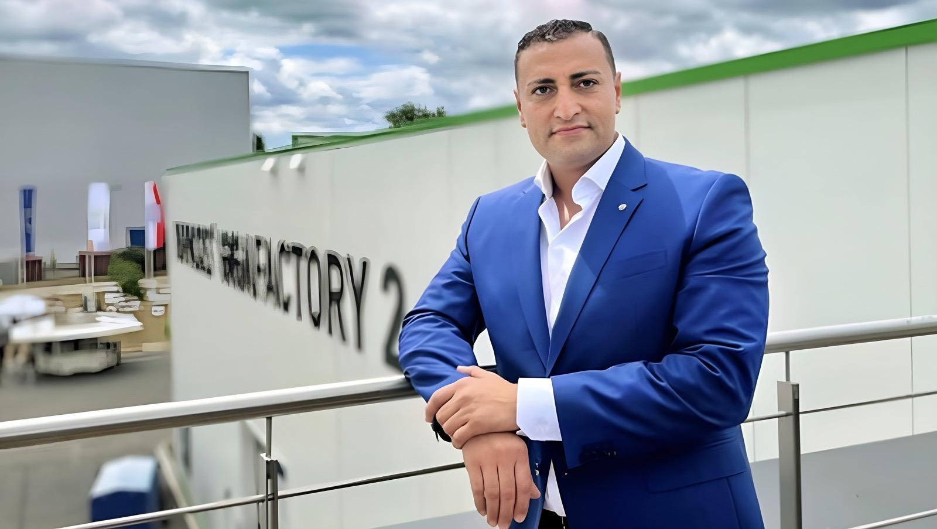
Quote from Tahsin Dag, Founder & CEO of PAPACKS®
“Our partnership with Wandarra is a significant step towards eliminating single-use plastics and protecting valuable ecosystems like the Great Barrier Reef. By combining Wandarra’s resources with our innovative technologies, we will sustainably influence the packaging industry in Australia and the Asia-Pacific region. This collaboration demonstrates, and practically implements, our shared commitment to sustainability and environmental protection.”
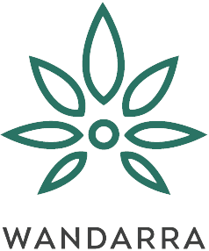
About Wandarra
Founded in 2019 in Townsville, Wandarra adopts an integrated industrial hub and spoke model that sources hemp raw materials from regional farmers. This model enables the processing and manufacturing of hemp products such as food items, edible oils and industrial products for domestic and international markets. Thanks to North Queensland’s first-class soils, reliable water supply, existing infrastructure, and a skilled workforce, Wandarra is uniquely positioned to promote hemp as a high-yield rotational crop.

With community and government support, Wandarra meets the growing demand for hemp products. Industrial hemp offers solutions to global challenges such as food security, climate change, regenerative agriculture, and the circular economy which is supported by its ThriveTech™ process.

Wandarra’s mission is clear: To be a leading Australian industrial hemp enterprise that leverages the advantages of North Queensland to support local communities and the environment, through sustainable practices and innovative solutions, Wandarra aims to contribute to a greener future.
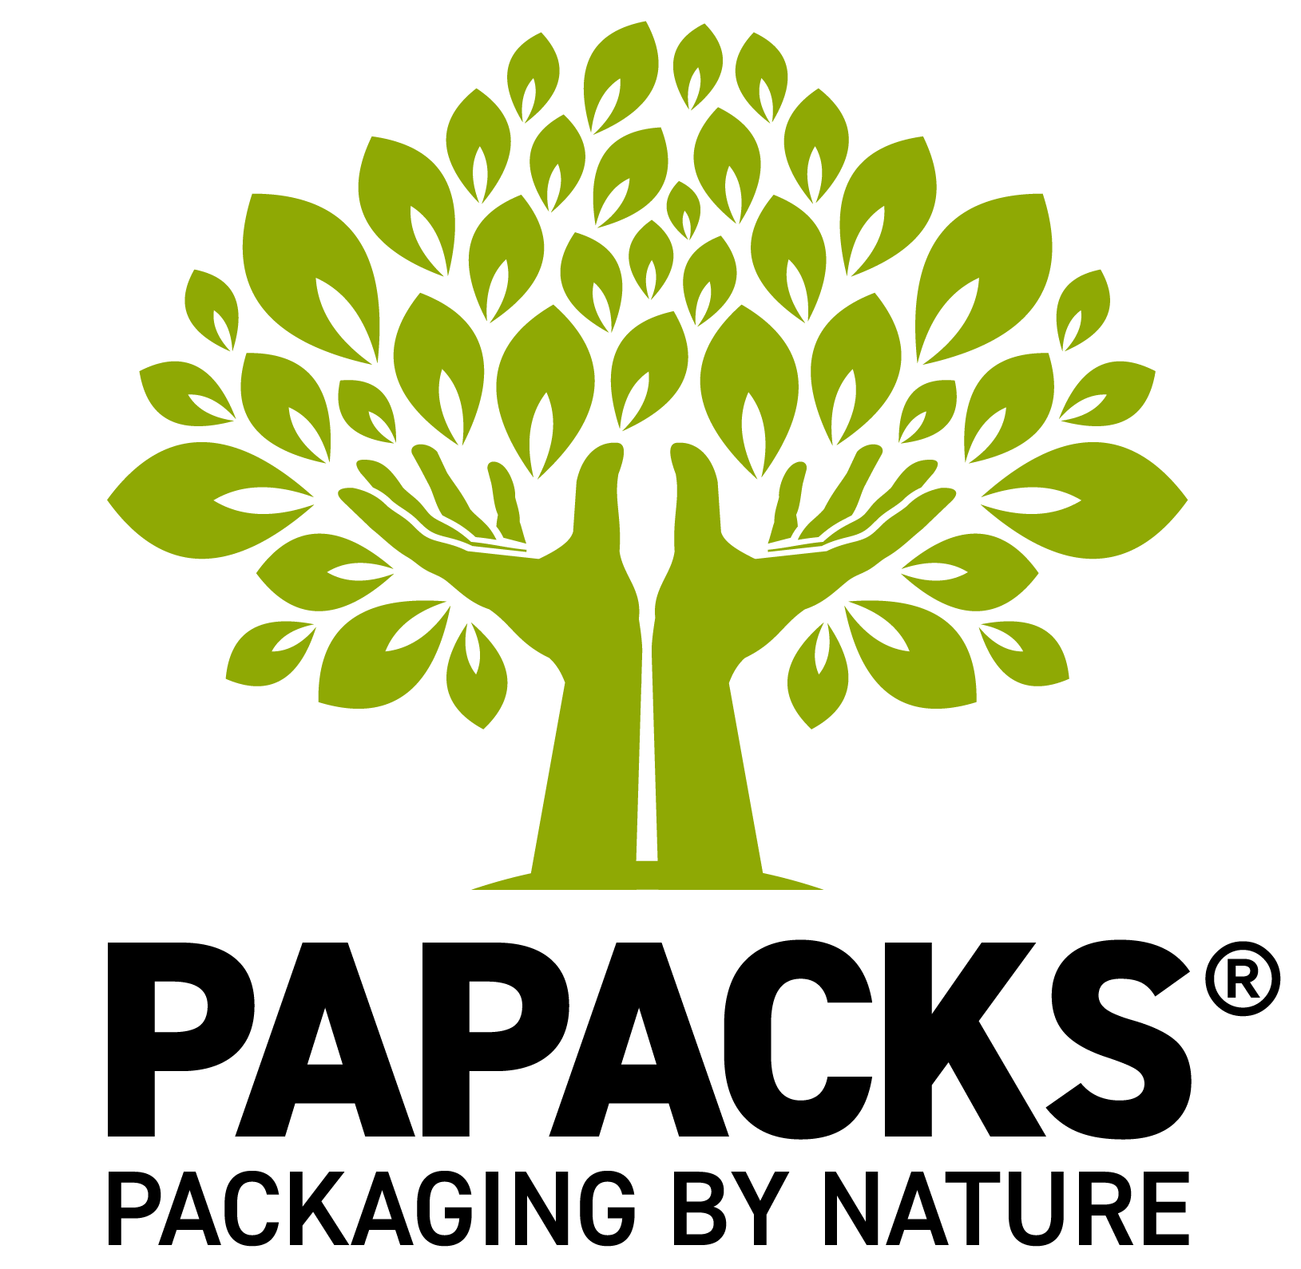
About PAPACKS®
PAPACKS® is a pioneering company dedicated to developing and producing sustainable, plastic-free packaging solutions. PAPACKS® specializes in molded fiber packaging made primarily from fresh fibers from trees and hemp plants, which are approved for use with food. Through advanced technologies and a commitment to environmental protection, PAPACKS® drives the shift towards a circular economy and significantly reduces plastic pollution. The company’s philosophy combines technology, art, and science to create packaging that is environmentally friendly, aesthetically pleasing, and functional. PAPACKS® invites companies worldwide to join this revolutionary movement.

For more information, visit Wandarra’s website and PAPACKS®’ website.

Media Contacts:
Iljko Miocevic, CMO Wandarra, media@wandarra.com.au
Manuel Leibrock, CMO PAPACKS®, press@papacks.com

