How a Pool-to-Pond Conversion Can Bring Nature to Your Backyard!
Perth, WA
7th June 2024.

Homeowners are discovering the joys of transforming their traditional swimming pools into natural, eco-friendly ponds with the help of PASES Aqua, a leading company specialising in natural pond conversions and sustainable water management.
Dr. Dulana Herath, the founder of PASES Aqua, emphasises that converting pools into ponds is a perfect way to repurpose backyard infrastructure to benefit both biodiversity and the community. Natural ponds attract a variety of wildlife, including birds, bees, frogs, and beneficial insects, creating a thriving ecosystem right in your backyard.
A lush green pond is far more attractive than a blue chlorinated pool that requires constant dosing and maintenance with high-wattage pumps. Natural Ponds are relatively easier to maintain, look stunning when filled with plants, serve as carbon dioxide sinks, and are constantly evolving ecosystems that will keep you fascinated.
The conversion process, guided by PASES Aqua, involves meticulous design and integration of natural and artificial filtration systems to ensure the health and clarity of the water. These ponds can also support aquaponics, allowing homeowners to grow edible fish and vegetables, blending beauty with functionality.
PASES Aqua's projects are distinguished by their innovative approach to water management, emphasising the importance of biodiversity, sustainability, and minimal environmental impact. These natural ponds require minimal maintenance, making them an attractive option for homeowners seeking to enhance their property's value and utility.
"Our mission at PASES Aqua is to blend aesthetic beauty with ecological function. The transformation of pools into natural ponds is a perfect example of how we can repurpose backyard infrastructure to benefit both biodiversity and the community. These natural aquatic ecosystems are designed to be self-sustaining, supporting diverse flora and fauna while providing a serene escape for people," said Dr. Herath.

Additional benefits of converting a pool to a pond include:
- Stunning appearance and experience akin to having a natural lake or billabong in your backyard.
- Being salt- and chlorine-free prevents irritation to the skin and eyes.
- Eco-friendliness brings you closer to nature. Frogs, ducks, and low numbers of fish can inhabit your pond if desired.
- Cost-effectiveness, as low-wattage pond pumps use less than a third of the wattage compared to traditional pool pumps.
- Plants naturally filter the waterbody, and larger biological and mechanical filter media clear the water, requiring less maintenance.
By leveraging natural processes, these ponds require minimal maintenance, making them an attractive option for homeowners seeking to enhance their property’s value and utility.
Contact Information
For more information about transforming pools into natural ponds with the expertise of PASES Aqua, please contact:
Dr. Dulana Herath
PASES Aqua
Email: admin@pases.com.au
Phone: +61 407 372 156
Website: PASES Aqua
Video: Watch the Transformation
Images:
https://photos.google.com/share/AF1QipOnnR_HFJJHliZKiR-T7MesgwHyGzqm4dQYlLPbdpLUNClVlS_67k4cBBpkbmgZiQ/photo/AF1QipMaDZwEPwLkt0dQddV12TqZ7rsb_03Cm1H_wyzF?key=bW5MYlVrTFRJdEV2R2J2bC1PVUYyWkx5YWVzc0hB

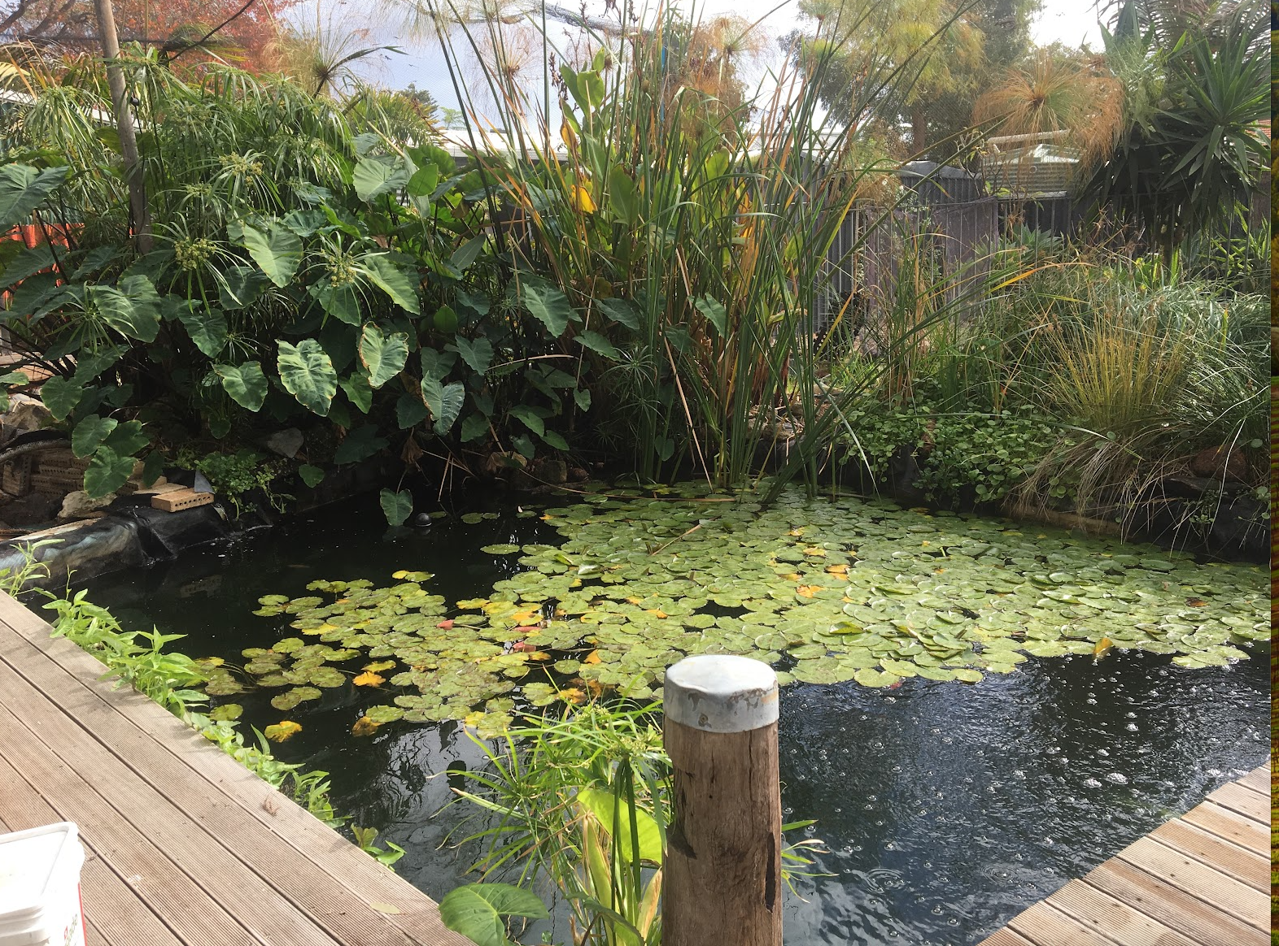
https://photos.google.com/share/AF1QipOnnR_HFJJHliZKiR-T7MesgwHyGzqm4dQYlLPbdpLUNClVlS_67k4cBBpkbmgZiQ/photo/AF1QipPtxD94V1qvdeY3JbGX0_DvoTjfdxB7GYJ5xGxl?key=bW5MYlVrTFRJdEV2R2J2bC1PVUYyWkx5YWVzc0hB
