MEDIA RELEASE
Sydney NSW 2000
March 27, 2024

Can Stranded Office Buildings Become Logistics Hubs?

FOR IMMEDIATE RELEASE
The e-commerce industry needs more last-mile delivery centres, but logistics space is tight. Here's a novel idea: Could we repurpose stranded, suburban office assets into logistics hubs?
Pros:
- Prime Locations: Suburban offices are often conveniently located near arterial roads and connections, ideal for last-mile delivery.
- Revitalisation Play: Filling vacancies would boost occupancy and generate income for owners.
Cons:
- Structural Challenges: Upgrading offices for logistics may be expensive and time-consuming.
- Regulatory Hurdles: Zoning changes and permits could slow redevelopment.

The Numbers Tell a Story:
While traditionally, the office-industrial rental delta would exclude this concept from further thought, effective rents for both sectors continue to converge.
Current Average Rent & Incentive Comparison (Indicative, $/sqm):
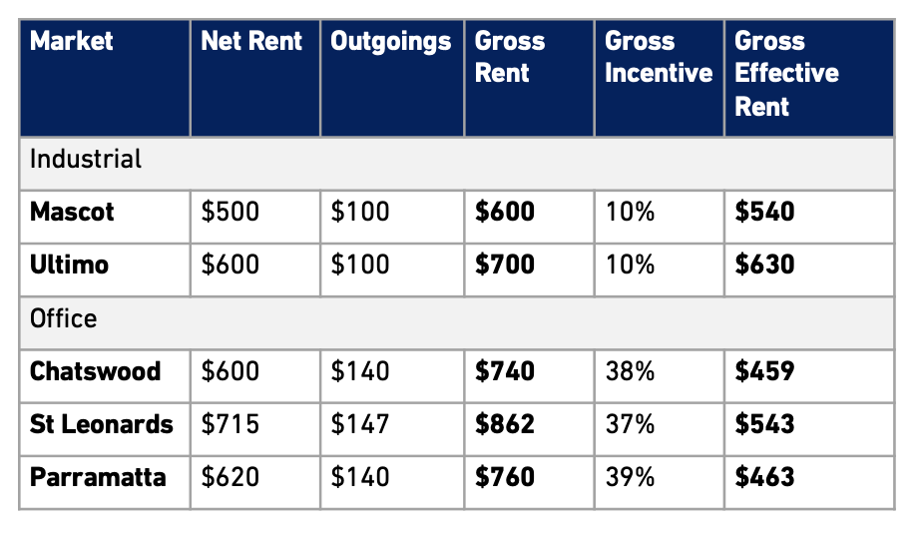
Source: ResolveXO Research

The Takeaway:
Comprehensive analysis is needed but with sustained high office vacancy rates, growing pressure on aging office assets and the continued supply-demand imbalance in logistics hubs, options beyond residential, BTR or assisted living office conversions may be worth exploring.

###
About ResolveXO
ResolveXO exclusively represents business occupiers of commercial and industrial premises to strategically plan, negotiate and secure the best achievable property outcome.

Contact
Kristina Mastrullo
Head of Research & Property Strategist
kristina.mastrullo@resolvexo.com.au
+61 422 126 379
www.resolvexo.com

