Spa Circle Launches Megan Potter Organics: Bridging the Gap Between Quality Beauty Brands and Salon Owners in Australia

Brisbane, Australia - Spa Circle is proud to announce the official launch of Megan Potter Organics on its exclusive marketplace. As a bridge between high quality beauty brands and beauty salon owners in Australia, Spa Circle provides stockists with exclusive access to Megan Potter Organics.

Megan Potter Organics is a female-founded company with a core value in sustainability, offering luxurious and certified organic skin and body care products. When you choose Megan Potter certified organic products, you can be assured of a truly pure and ethical product that supports endangered native animals. The company was accredited to manufacture certified organic skincare in December 2021 and has been creating award-winning skincare in a warehouse in St Marys, Adelaide.

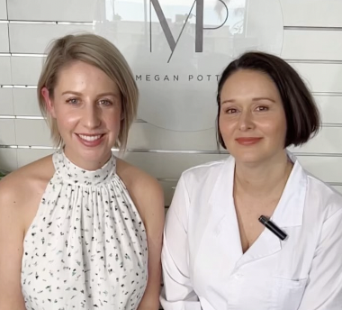
Figure 1 Megan Potter & Mandy Hawtin; Co-Founders of Megan Potter Organics

Spa Circle is committed to providing customers with the very best in high-performing beauty products, and Megan Potter Organics is no exception. By partnering with Megan Potter Organics, Spa Circle ensures that its stockists have access to some of the most sought-after organic beauty products in Australia.

"We are thrilled to partner with Megan Potter Organics and bring their amazing products to life with our new facial experience the Megan Potter Organic Wellness Facial" said Danielle McDonald, General Manager of Spa Circle. "Their commitment to sustainability and quality is perfectly aligned with our mission to bridge the gap between high-quality beauty brands and salon owners in Australia. We believe our stockists will love the luxurious and ethical products from Megan Potter Organics, and we are excited to offer this exclusive range on our marketplace."

With this exciting partnership, Spa Circle and Megan Potter Organics are poised to change the face of the Australian beauty industry. Together, they are committed to delivering the best in high-performing, sustainable, and ethical beauty products to beauty salons and customers across the country.

Connect with Spa Circle Brands on Instagram www.instagram.com/myspacircle

# # #

About Spa Circle Brands
Spa Circle Brands is an Australian distributor that specialises in supply to salons, spas and skin clinics. Originally launched in 2019 by bringing the viral Los Angeles based professional spa brand Esthemax to Australian shores, the husband and wife team quickly grew to representing Esthemax, emerginC, Scientific Organics, Rawceuticals, Bryght Skin Lightening, MSKIN PRO and their own mineral sunscreen brand, Sunny Skin. For more information, visit www.spacircle.au

MEDIA CONTACT
Danielle McDonald
danielle@spacircle.au

