Australian Distributors Spa Circle Partners with Kelly Skin Queen to Offer Exclusive Education on the Spa Circle Marketplace

Brisbane, Australia - Spa Circle, the leading beauty marketplace in Australia, is excited to announce its partnership with Kelly Noone Skin Queen, a renowned educator and business coach in the aesthetics industry. The partnership aims to bridge the gap between high-quality beauty brands, educators, and salon owners in Australia, providing them with access to exclusive skin science and business development education courses.

Kelly Skin Queen is an expert in the field of skin, with years of experience in the aesthetics industry. She has created a range of courses to help beauty business owners and therapists improve their digital marketing skills, skin science knowledge, and business development strategies. Her courses include "Teach Me Marketing," "Digital Product Academy," and "Explain Like a Boss!".

Spa Circle Stockists will have access to these exclusive courses, which will help them grow their businesses and improve their skills. The courses are designed to provide practical knowledge and skills that can be applied in a salon or spa environment. Participants will gain a deeper understanding of skin histology, nail their social media marketing, and confidently explain skin concerns to their clients.

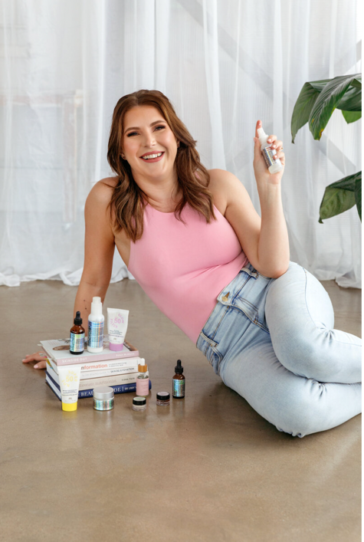
Figure 1 Kelly Noone from Skin Queen

Spa Circle's Director, Brad McDonald, stated, "We are excited to partner with Kelly Skin Queen to offer our stockists exclusive access to her courses. Our mission is to bridge the gap between high-quality beauty brands, educators, and salon owners in Australia, and we believe that Kelly's courses will help us achieve this goal. We look forward to seeing the positive impact this partnership will have on the industry."

The Spa Circle Marketplace is committed to providing high-quality beauty products and education to its customers. With the new partnership with Kelly Skin Queen, they are furthering their commitment to offering the best in beauty education to their clients.

For more information on the Spa Circle Marketplace and its partnership with Kelly Skin Queen, please visit the website at www.spacircle.au

Connect with Spa Circle Brands on Instagram www.instagram.com/myspacircle

# # #

About Spa Circle Brands
Spa Circle Brands is an Australian distributor that specialises in supply to salons, spas and skin clinics. Originally launched in 2019 by bringing the viral Los Angeles based professional spa brand Esthemax to Australian shores, the husband and wife team quickly grew to representing Esthemax, emerginC, Scientific Organics, Rawceuticals, Bryght Skin Lightening, MSKIN PRO and their own mineral sunscreen brand, Sunny Skin. For more information, visit www.spacircle.au

MEDIA CONTACT
Danielle McDonald
danielle@spacircle.au

