MEDIA RELEASE
17 February 2023
drop the stigma & embrace our
stories instead! WORLD CARE DAY 2023
Today CREATE invites you to celebrate the global community of 4.4 Million* children (approximately) aged up to 17 years who could be living in care this World Care Day - the world’s biggest celebration of children with a lived experience in out-of-home care.
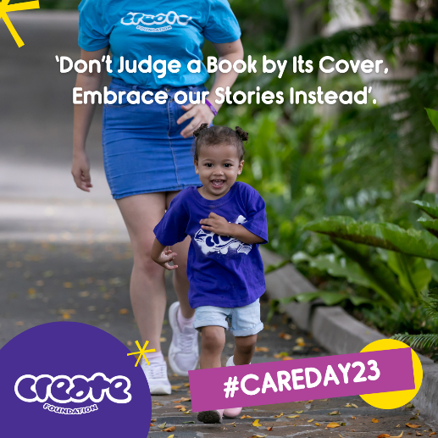
This year’s theme is: ‘Don’t Judge a Book by Its Cover, Embrace our Stories Instead’ and CREATE thoroughly supports this message! In fact, CREATE continues the #snapthatstigma social media campaign to call out the outdated beliefs that a person’s past care experience determines who they are today.
Instead of making a snap judgement about a child or young person, CREATE shares the message of their strength, resilience, and greater potential than their past care experience!
This World Care Day, we continue to #snapthatstigma and celebrate all young people’s rights, resilience, stories and achievements. CREATE stands with young people and asks that their collective voices are heard and celebrated to inform decision makers and support positive change.
CREATE Foundation’s Chief Executive Officer, Ms Jacqui Reed, shares: “World Care Day shines a light on the amazing young people who have experienced being in the care system and although, at times may appear to be thwarted by the negative impact of the stigma associated with being in care, continue to demonstrate an incredible resilience and courage to make their lives the best they can be.”
“Help us create a positive self-image for these incredible young people and celebrate their achievements through World Care Day.”
Now is the time to reflect on the stories, achievements and unique value of each and every child and young person, to listen to their perspective, look beyond the surface, and to see that every care-experienced person holds their own unique valuable story, ambitions, and dreams for the future.
CREATE Foundation is the national consumer body representing the voices of children and young people with an out-of-home care experience (including kinship care, foster care and residential care). CREATE develops policy and research to report on and advocate for a better care system.
Read more at: https://create.org.au/world-care-day/ and watch CREATE’s World Care Day video here: https://youtu.be/WpyfB6e3hSM
For further comment from CREATE’s Chief Executive, Ms Jacqui Reed, and/or a young person with care experience contact Leigh White, CREATE Communications Advisor, via (m) 0431 932 122 or leigh.white@create.org.au
Source: * “Estimating the number of children in formal alternative care: Challenges and results” N. Petrowski, C. Cappa, P. Gross UNICEF, web page accessed 16/2/23 https://doi.org/10.1016/j.chiabu.2016.11.026
Key statistics on the care sector in Australia:
- 46,212 children and young people were reported in 2020-21 as living in out-of-home care across Australia (Australian Institute of Health & Welfare, 2022).
- Young people in out-of-home care are 16 times more likely to be under a youth justice order than the general population.
- 30% of young people experience homelessness within the first year of leaving care. (McDowall, 2020).
- 38% of young people have been involved with the justice system.
- 30% of young people who have left care or preparing to leave care are unemployed.
- 36% children and young people in care do not live with any of their siblings.
- 35% of young people in care have five or more caseworkers during their time in care.
- 67% of young people in care over the age of 15 are not aware of having a leaving care plan.
McDowall, J. J. (2018). Out-of-home care in Australia: Children and young people’s views after five years of National Standards. CREATE Foundation.
McDowall, J. J. (2020). Transitioning to adulthood from out-of-home care: Independence or interdependence? CREATE Foundation.

