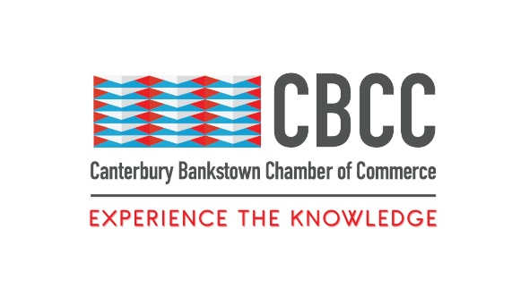
29th December 2022

FOR IMMEDIATE RELEASE

2022 Wrap-Up: A Year Of Triumphs For Canterbury Bankstown

Sydney, New South Wales – Despite record-breaking rains and flooding, dramatic increases in costs of living, and rising global political and economic uncertainty, the Canterbury Bankstown Chamber of Commerce (CBCC) has witnessed a year of triumphs within Canterbury Bankstown and South-West Sydney.
Emerging into 2022 with hope for COVID recovery, the CBCC kicked into gear with a Social Media Workshop in February. Held at Panania Diggers, the Business After 5 (BA5) helped the attending business owners and managers learn ways to manage their Social Media to strengthen and grow their brand in the new year.
Other workshops throughout 2022, such as ‘Entrepreneurship’ in March or ‘Building Safe Workplaces’ in October, continued to build the business knowledge and skillset of small and medium businesses and organisations in Southwest Sydney.
2022 also provided the CBCC with the opportunity to kickstart or relaunch programs paused due to COVID restrictions, such as the CBCC Round Tables to discuss mental health, networking, and leadership for small business owners and managers, or CEO For A Day, which introduces high school students to entrepreneurship through mentoring and work experience.
Larger events throughout 2022 gave the local business community opportunities to network with other like-minded people whilst hearing from inspiring community leaders. The CBCC’s annual Women in Leadership event in March saw over 300 women in business listening to a panel of noteworthy and motivating women, led by Karen Webb, the 1st female police commissioner in NSW.
“We want our local business community members to have the opportunity to meet and talk to those who have the power to change and affect the way their businesses are run,” says Wally Mehanna, CEO of the CBCC.
“We invited the NSW Treasurer, [the Hon.] Matt Kean [MP], to discuss the new 22/23 budget with our local businesses. We also invited [the Hon.] Eleni Petino [MP], the NSW Small Business Minister, and Chris Lamont, the NSW Small Business Commissioner, to Bankstown in June for a BA5 panel, and over 200 CBCC members came to hear them speak. [The Hon.] Victor Dominello [MP=, Minister for Customer Service and Digital Government, also came down to speak to our community in September.
“Our members are passionate and ambitious and seeing our government leaders come to Bankstown to talk to them directly really helps them understand that our government wants to support them. It keeps them motivated and pushes them to keep working to achieve their business goals and dreams.”
Despite the restrictions caused by COVID lockdowns in 2020 and 2021, and the devastating effects of the rains and floods in 2022, the CBCC has seen its membership grow enormously.
“We were only established in 2017, but we already have 630 member businesses, with 28% of these businesses actively engaging in our activities regularly,” says Mehanna.
“We continuously try to think of new ways to support our community because we really believe in supporting the local business community, and our business community has reciprocated our enthusiasm with their own.”
The CBCC thanks its members, corporate partners, and major sponsors for their support, hard work, and enthusiasm in 2022.
“Without our members, partners, or sponsors, we wouldn’t be able to do what we do for the Canterbury Bankstown business community,” says Mehanna. “The 2022 Annual Gala showcased just how spectacular the CBCC membership really is, and we are certain that next year will be bigger and better."
“We have a busy 2023 planned, with our first major event in March for Women in Leadership. We are excited to bring our community more events, workshops, and programs to keep our local business communities strong, thriving, and resilient.”
The CBCC wishes its members and community a happy and safe New Year, and warmly welcomes any new members and newcomers to the CBCC community .Let’s work together to make 2023 an amazing year for the business community in Canterbury Bankstown and Southwest Sydney!
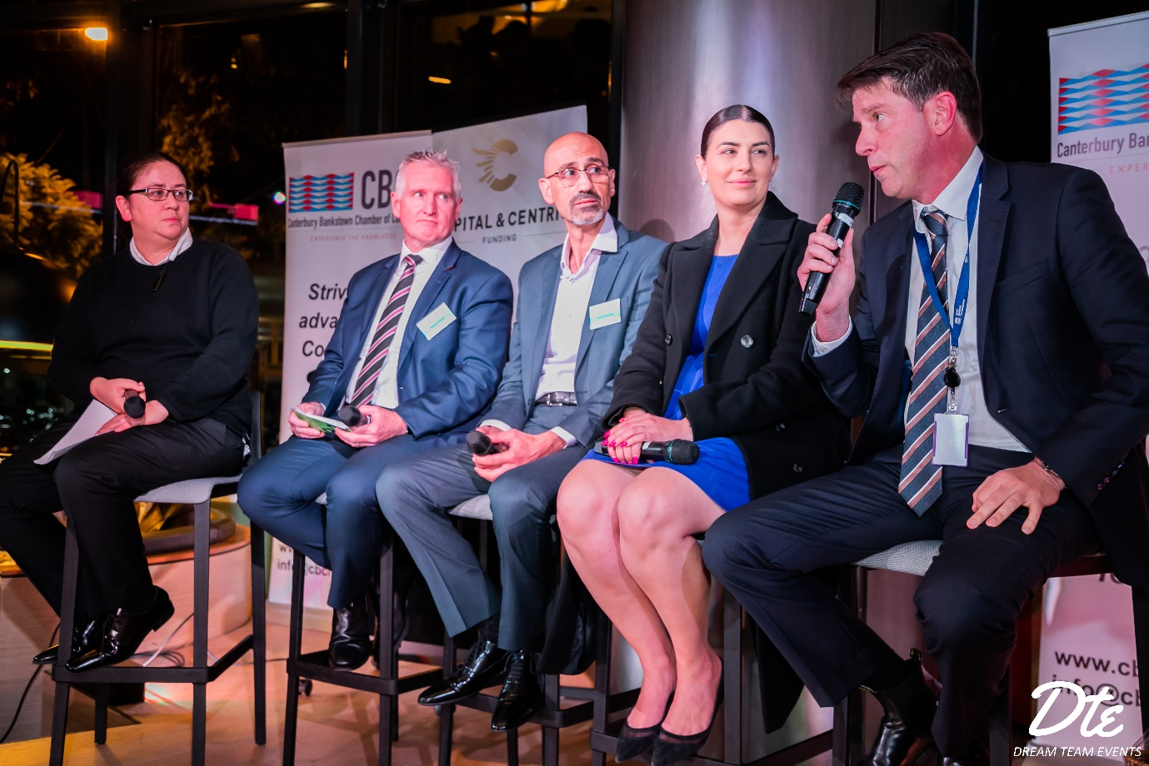
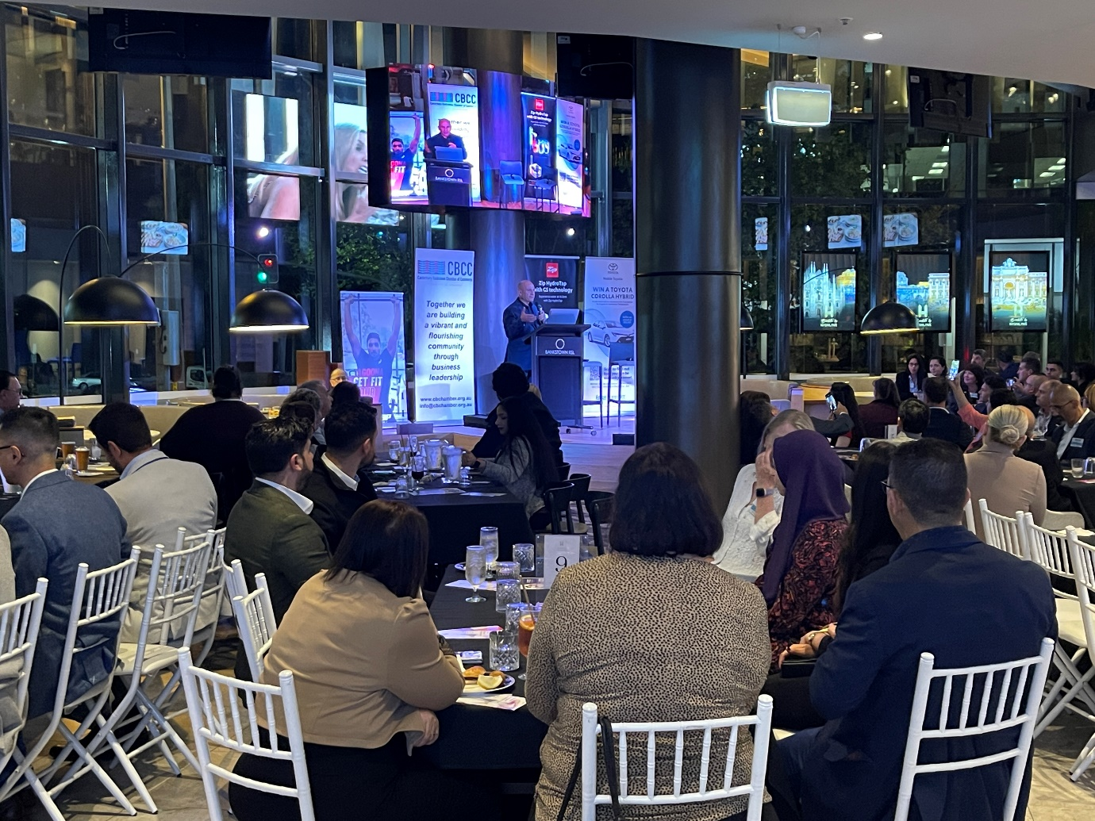
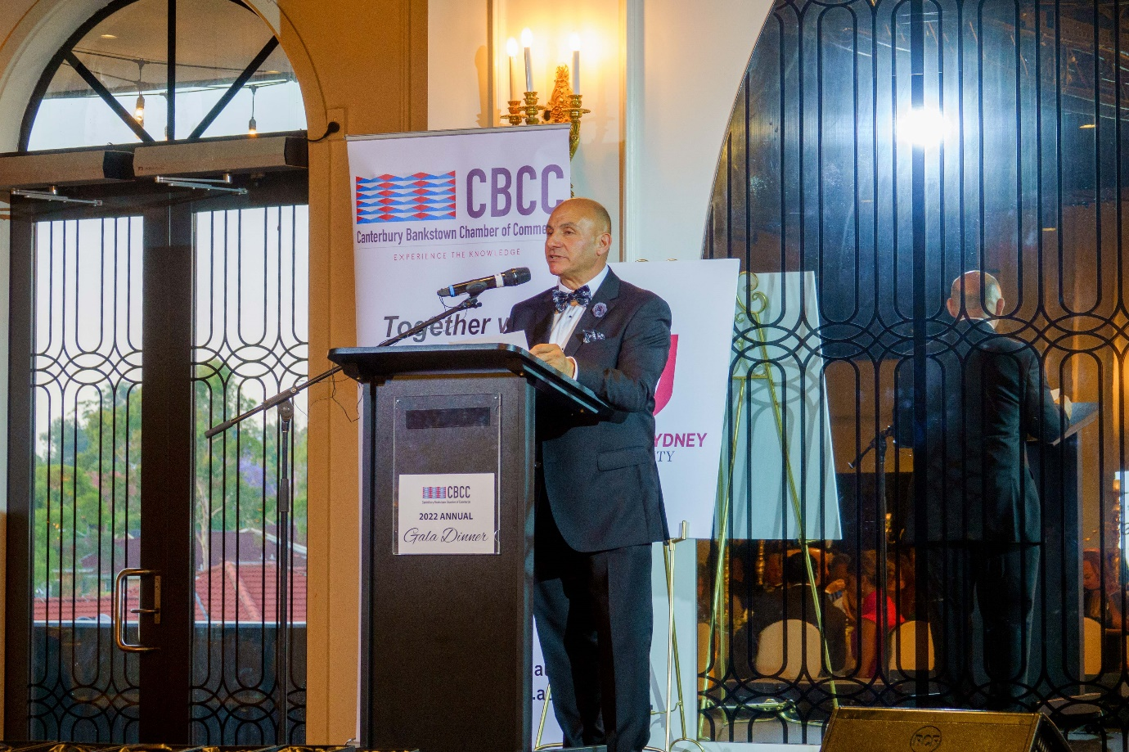

####
Contact Information
Wally Mehanna
CEO of the Canterbury Bankstown Chamber of Commerce
M: 0416 012 747
E: ceo@cbchamber.org.au

