
22nd December 2022

FOR IMMEDIATE RELEASE

It’s Beginning To Look A Lot Like Christmas In Canterbury Bankstown

Sydney, New South Wales – The Canterbury Bankstown Chamber of Commerce brought some serious Christmas vibes and cheer to the Entertainment Park in Milperra, Canterbury-Bankstown with their Christmas Party on Monday 12th December 2022. Inviting Chamber members, local families, and the wider community to the Christmas party, the Chamber successfully brought joy and happiness to attendees with a fantastic, fun-filled night.
With the generous support of Major Sponsor Allied Integrated Management, guests were treated to a delicious and diverse buffet and free-flow soft drinks for the duration of the event whilst enjoying the wide variety of activities available at the Entertainment Park. From ten-pin bowling sessions, generously provided for the CBCC Christmas Party by the Entertainment Park, to indoor e-karting and arcade games, to a play area for children under 8, there was something for everyone.
Corporate partner Collappor8 added a special touch to the party with a themed scavenger hunt for guests to participate in during the event. A lucky door prize also added to the festivities and general cheer of the event.
“The Christmas Party is one of the biggest opportunities for our members, our Board, and the wider community to get together informally and celebrate another successful year,” says Wally Mehanna, CEO of the CBCC.
“Especially with the record-breaking rains and floods this year, our community has really risen to the challenge to stay strong and support each other. We want this Christmas Party to be a chance for them to just enjoy themselves without worries.”
Families of the Australian Defence Force stationed at Holsworthy and Bankstown Police Command were specially invited to join the CBCC’s Christmas Party this year.
“Their work and efforts to keep our local communities safe throughout the floods this year were invaluable. They made a huge impact on so many families in the area, and we are grateful that we can thank them personally like this [at the Christmas Party],” says Mehanna.
To spread the Christmas spirit beyond Canterbury-Bankstown, the CBCC held a Christmas Tree appeal to collect donations and gifts that will be sent to Lismore through St Euthemia College’s project, ‘Library for Lismore’.
“Lismore was devastated by flooding, and the students at St Euthemia College have really taken the initiative to support Lismore South Public School by turning a shipping container into a library and functional classroom whilst they rebuild,” says Mehanna. “The CBCC is delighted to contribute to their project by donating gifts to the children of Lismore for a very special Christmas.”
The CBCC wishes to thank all its members, partners, and sponsors for a successful Christmas Party and overall year in 2022 and look forward to a stronger and brighter 2023 for Canterbury-Bankstown!
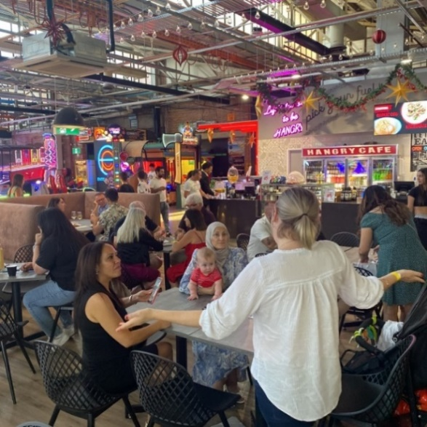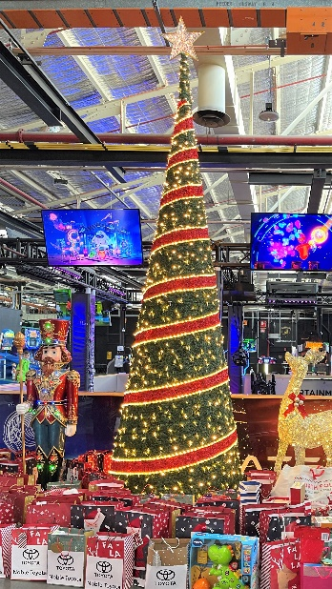
####
Contact Information
Wally Mehanna
CEO of the Canterbury Bankstown Chamber of Commerce
M: 0416 012 747
E: ceo@cbchamber.org.au

