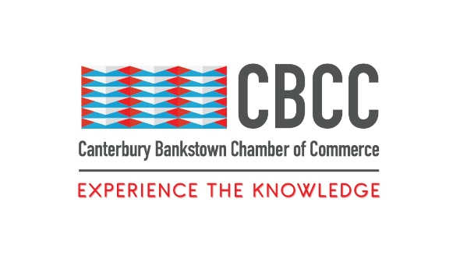
15 December 2022

FOR IMMEDIATE RELEASE

Canterbury Bankstown Businesses Shine Bright Like A Diamond In 2022

Sydney, New South Wales – All that glitters is not gold as Canterbury Bankstown businesses dressed up in their finest to celebrate a successful 2022 in business. Held on Saturday 3rd December 2022, the Canterbury Bankstown Chamber of Commerce hosted its 2022 Inaugural Gala Dinner at The HIGHLINE Venue in Bankstown. With over 600 attendees representing businesses and politicians across Canterbury Bankstown and the wider Western Sydney area, the Gala was a glamourous, sparkling, and spectacular celebration of the Chamber and its members’ accomplishments and milestones in 2022.
The Chamber was especially honoured and privileged to welcome the Hon. Dominic Perrotett MP, Premier of NSW, to the Canterbury Bankstown Chamber of Commerce 2022 Inaugural Gala Dinner, along with the Hon. Jason Clare MP Federal Minister for Education and Patron, and our Chamber Ambassadors Jihad Dib MP and Wendy Lindsay MP. Canterbury Bankstown Mayor Khal Asfour and Liverpool Mayor Ned Mannoun and their ladies, plus a number of Local, State, and Federal members and various Community and Business leaders were also specially invited and welcomed to the Chamber’s Inaugural Gala Dinner.
Held for the 6th consecutive year, the Gala was filled with invigorating discussions, memorable moments, and vibrant entertainment. Catered by award-winning restauranteurs Al Aseel, Gala attendees were serenaded by the hugely talented musicians at Evoke Entertainment and wowed by Sydney’s premier illusionist, Jackson Aces.
“Our Gala is one of the largest opportunities for local businesses and organisations to receive the recognition they deserve to acknowledge their efforts and contributions to creating a better business society,” says Wally Mehanna, CEO of Canterbury Bankstown Chamber of Commerce.
In particular, the resilience of the community in the face of severe weather and extensive flooding in many areas of Canterbury Bankstown throughout 2022 was to be celebrated.
“So many businesses and organisations were facing a huge challenge of recovering from the effects of COVID-19 lockdowns in 2021 without needing to deal with the rains and floods this year,” says Mehanna. “Our community really rose to the challenge of overcoming these difficulties to become stronger than ever as 2022 ends.”
Winners included Centric and Capital Funding for CBCC Business of the Year 2022, Marina Toailoa for CBCC Rising Star 2022, Ahmad Harb from Al Aseel for CBCC Business Person of the Year 2022, and Nader Petroleum for CBCC 50 Years of Business Trading 2022. The Chamber is thankful for their incredible work and is delighted to be able to shine a light on and share their tremendous contributions to the Greater Sydney community.
In partnership with Noble Toyota, the Chamber held a raffle for a brand-new Toyota Corolla Ascent Sport Hatch Hybrid, with net profits from the raffle to be donated to the Foundation for Angelman Syndrome Therapeutic (FAST) Australia.
“Angelman Syndrome is a rare neurogenetic disorder that has no cure at the moment. FAST is doing great work towards providing people with Angelman Syndrome with the care that they need and doing ground-breaking research, and we are happy that our community can contribute to their cause,” says Mehanna.
The Gala also included a silent auction hosted during the event that will raise money to support the Chamber’s operations in 2023.
“We have big plans for our community next year, including bigger events, more workshops, and more advocacy to keep empowering our local businesses,” says Mehanna. “We are deeply thankful for those who participated in the silent auction and for their ongoing support of the Chamber.”
A huge thank you goes to the Canterbury Bankstown Chamber of Commerce’s Sponsors: Western Sydney University, AFCG, Sydney Metro Airports, Transdev, Unity Bank, Walker Corporation, Superior Training Centre, Minett Group, and Hope & Care. With these sponsors’ great support, the Chamber can continue working to build a stronger community and create a transformative network of businesses. By providing incredible opportunities for the Chamber’s sponsors to run events and workshops for the Canterbury Bankstown businesses community, small and medium businesses in Western Sydney receive the support that they need to flourish and grow.
Additionally, the Chamber would like to express its unending gratitude for CEO Wally Mehanna, whose unwavering focus and tireless efforts to support the CBCC’s operations, contribute significantly to the CBCC’s success. Finally, a big thank you goes to those who attended the Gala Dinner. The Chamber wishes you a great ending to 2022 and looks forward to continuing to support you in 2023.
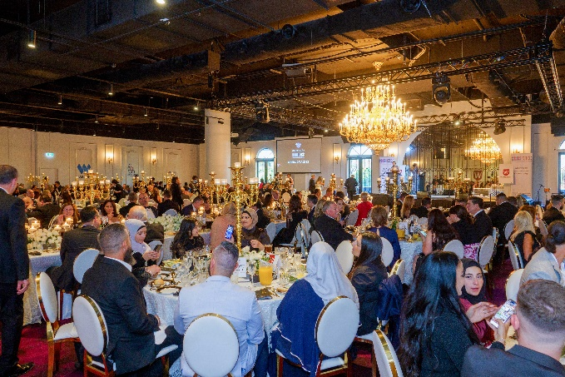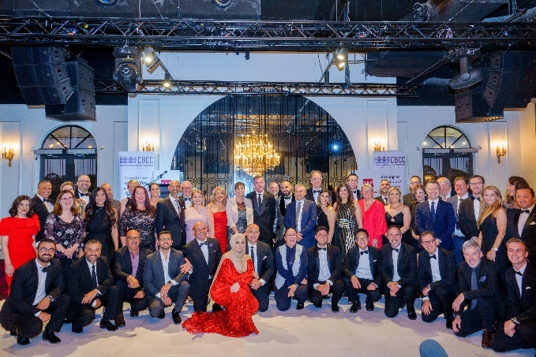
####
Contact Information
Wally Mehanna
CEO of the Canterbury Bankstown Chamber of Commerce
M: 0416 012 747
E: ceo@cbchamber.org.au

