Spa Circle Brands Brings the emerginC Signature Range to Australia
The US-based, salon-focussed skincare brand’s Signature line re-enters Australian spas and salons

Spa Circle Brands, the exclusive distribution office for salon exclusive US brands in Australia, announced the relaunch of the emerginC Signature range to the Australian market. Since launch in 1996, emerginC has established itself as a luxury, sustainably minded, results-focused skincare brand found at THE top spas and salons around the world.

“We are excited to bring the Signature range back to salons and spas exclusively here in Australia,” Spa Circle Brand’s Director Brad McDonald said. “There aren’t many brands that have been able to do what emerginC has done since 1996. I’m proud to represent emerginC here in Australia. They are market leaders in the spa and salon industry globally and we now have a very diverse range here at Spa Circle that focuses on elevating experiences in the treatment room.”

emerginC works with top chemists and state-of-the-art labs to create cutting-edge, high-performance facial treatments and at-home products for all skin types and concerns. emerginC is a broad, deep range, with a wide variety of luxury, results oriented treatments, from their Apple Stem Cell Facial, Swift Lift Peptide Firming Facial, to their iconic Signature Radiance Facial. Cult at-home favorites include the 20% Vitamin C serum, Hyper-Vitalizer Face Cream, the beautifully beaded Multi-Vitamin + Retinol serum and more.

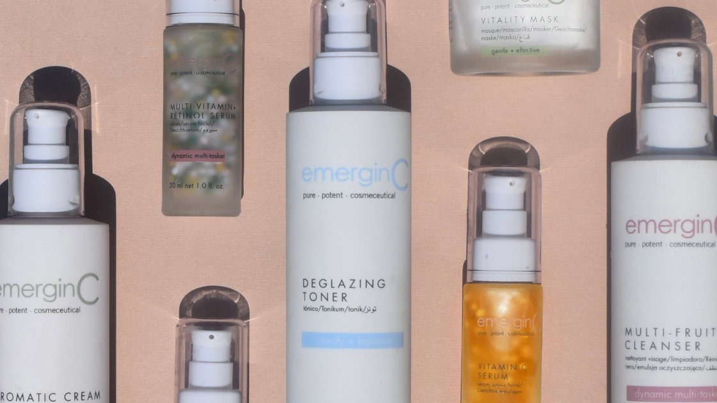

“We are so pleased to join forces with Danielle and Brad at Spa Circle,” emerginC’s Founder Ian Lirenman said. “We are looking forward to cleaning up the online space with them and re-focusing on spa and salon partners. emerginC is already available at the top salons and spas in the US and elsewhere across the globe, and we look forward to expanding our results-driven, luxury spa offerings to more places in Australia.”

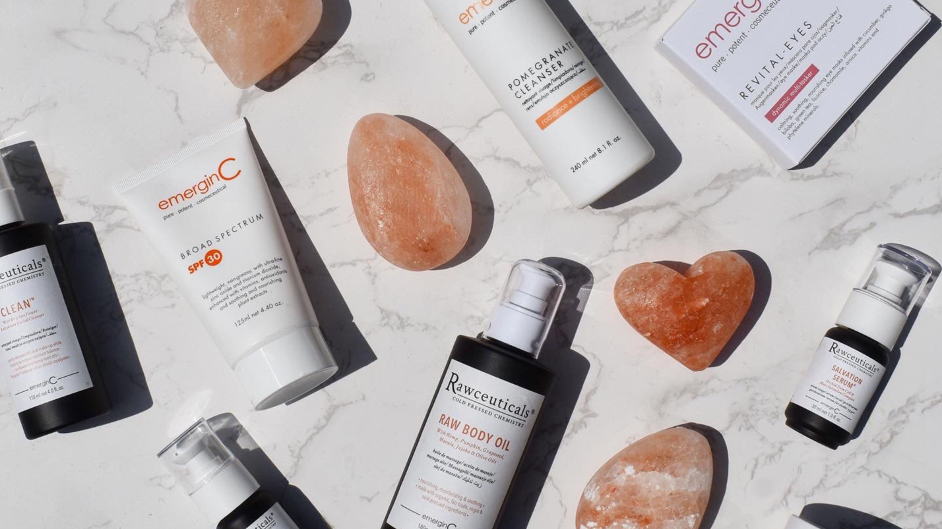

emerginC strives to be an industry leader in sustainability, from their their industry-first “buy one, plant one” tree planting program (over one million trees planted and counting), their innovative emerginBees bee habitat initiative and emeginCeeds organic vegetable seed program, aimed at providing a healthy and thriving ecosystem for plants, people and animals in local communities. Packaging choices include glass, biodegradable jar caps, and other sustainable choices. emerginC also works with carbonfund.org to reduce its environmental impact and also strives to source its ingredients ethically and sustainably wherever possible, including the use of natural, organic and fair trade ingredients. Its offices operate on wind power and approximately 80 percent of its products are manufactured with with wind power.

Learn more about emerginC and all of their brands at www.emerginc.com.au To become a salon or spa stockist, visit www.spacircle.au

# # #

About Spa Circle Brands
Spa Circle Brands is an Australian distributor that specialises in supply to salons, spas and skin clinics. Originally launched in 2019 by bringing the viral Los Angeles based professional spa brand Esthemax to Australian shores, the husband and wife team quickly grew to representing Esthemax, emerginC, Scientific Organics, Rawceuticals, Bryght Skin Lightening, MSKIN PRO and their own mineral sunscreen brand, Sunny Skin. For more information, visit spacircle.au.

MEDIA CONTACT
Contact: Danielle McDonald
Danielle@spacircle.au

