emerginC Relaunches Scientific Organics with new Australian Distributor
Spa Circle Brands partners with the US-based, salon-focused skincare brand to bring their sustainable and and nourishing product to Australia

US-based salon-focused, award-winning skincare brand emerginC today announced the relaunch of Scientific Organics with their new Australian distributor Spa Circle Brands. The move brings the world-renowned and sustainable skincare brand to spas and salons across Australia.

“We are over the moon to be representing emerginC’s Scientific Organics as a distributor for salons, spas and skin clinics across Australia,” Brad McDonald, Director of Spa Circle Brands, said. “It ticks all the boxes. It’s a range that delivers results, creates memorable experiences in a treatment room, looks incredible on a shelf and their sustainability initiatives help make the world a better place.”

emerginC’s Scientific Organics is an active, 100% naturally-formulated, paraben-free and synthetic fragrance-free face & body line. Each item contains a minimum of 70 percent organic ingredients, including a variety of antioxidant-rich plant extracts, stem cells, peptides, natural fruit acids, proprietary hydrating and brightening complexes and more.

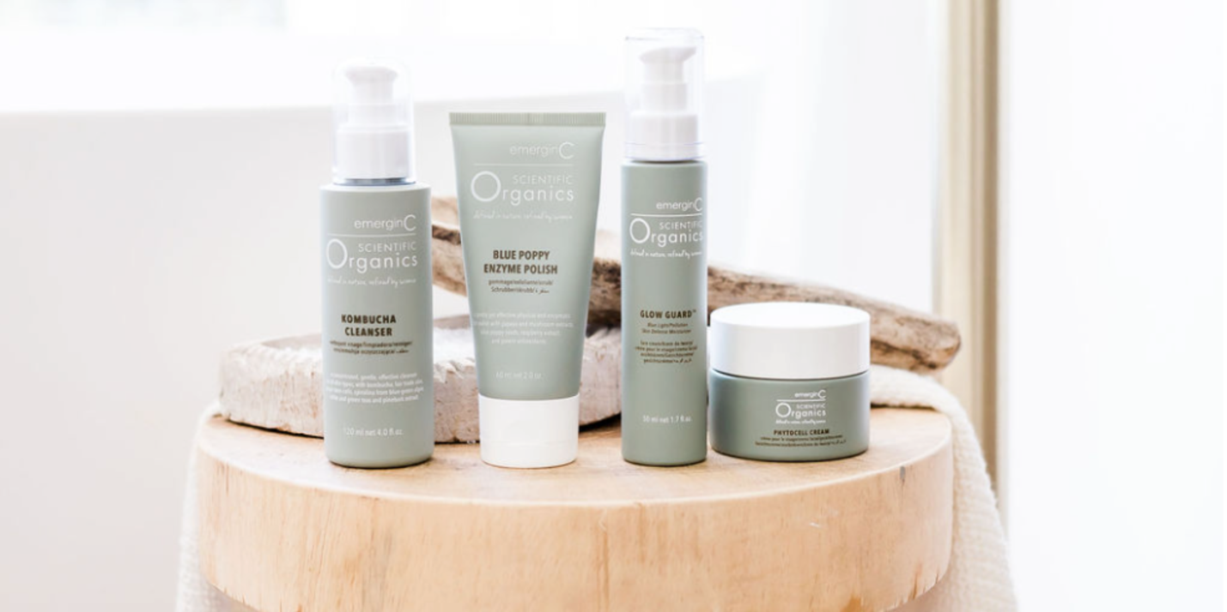

Scientific Organics provides spas and salons with a variety of face and body treatments to showcase its luxurious results. The Water Lily Radiance, Organic Peptide Brightening, Blue Poppy Enzyme and Aromatic Signature Facials are just a few options performed in many of THE top U.S. spas and salons.

“We wanted to combine the appeal of active, natural and organic face and body care with cutting-edge natural technologies – peptides, stem cells, peels and more – so results are never compromised,” Ian Lirenman, Founder of emerginC, said. “With us, you can have your cake and eat it, too!”

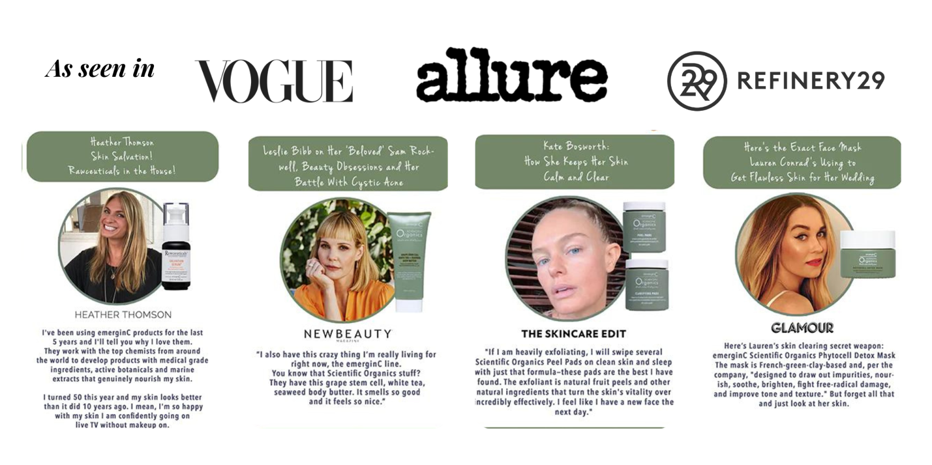

emerginC strives to be an industry leader in sustainability, from their their industry-first “buy one, plant one” tree planting program (over one million trees planted and counting), their innovative emerginBees bee habitat initiative and its emeginCeeds organic vegetable seed program, aimed at providing a healthy and thriving ecosystem for plants, people and animals in local communities. Packaging choices include glass, biodegradable jar caps, and other sustainable choices. emerginC also works with carbonfund.org to reduce its environmental impact and strives to source its ingredients ethically and sustainably wherever possible, including the use of natural, organic and fair trade ingredients. Its offices operate on wind power and approximately 80 percent of its products are manufactured with with wind power.

Learn more about emerginC’s Scientific Organics range or any of their other brands at www.emerginc.com.au To become a salon or spa stockist, visit www.spacircle.au

Connect with Spa Circle Brands on Instagram www.instagram.com/myspacircle

# # #

About Spa Circle Brands
Spa Circle Brands is an Australian distributor that specialises in supply to salons, spas and skin clinics. Originally launched in 2019 by bringing the viral Los Angeles based professional spa brand Esthemax to Australian shores, the husband and wife team quickly grew to representing Esthemax, emerginC, Scientific Organics, Rawceuticals, Bryght Skin Lightening, MSKIN PRO and their own mineral sunscreen brand, Sunny Skin. For more information, visit www.spacircle.au

MEDIA CONTACT
Danielle McDonald
danielle@spacircle.au

