MEDIA RELEASE
8 June 2022
YOUNG PEOPLE MAKE HISTORY
IN BRISBANE PARLIAMENT HOUSE

Wednesday evening, May 11, Parliament Brisbane hosted a group of Queensland young people with a care experience to witness history in the making after years of collectively speaking up for systemic change. As guests of Minister for Children, Leanne Linard, the young people had the opportunity to see, first-hand, the culmination of their efforts in the passing of the Child Protection Reform and Other Legislation Amendment Bill 2021.
The legislation was amended and a new Bill passed giving the right to children and young people to have a direct say in decisions that affect their lives – which has not been an option in the past.
For too long, children and young people have been without a voice and as a result their life outcomes have been dramatically impacted. CREATE Foundation’s focus is listening to the voices of those with a lived experience of the care system, sharing their views through research and advocacy with and for them to achieve significant systemic change.
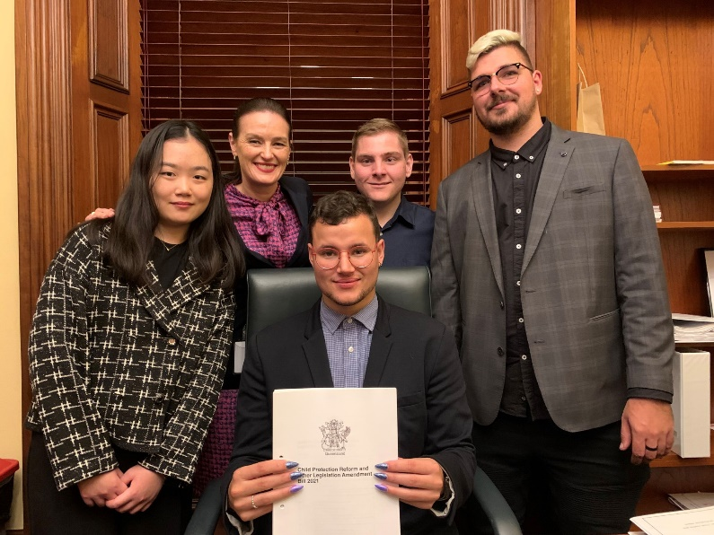
CREATE Young Consultants attended Parliament to observe Members of Parliament sitting and debating legislation. CREATE’s Young Consultants keenly looked on as the Bill was passed and went on to passionately share their perspectives on a specific Bill after listening to the debate with Leanne Linard, Minister for Children.
Later in the evening, they joined Minister Linard for dinner at the Parliament House Dining Room. Each of the young people attending received a book about Parliament house signed by the current Speaker of the Legislative Assembly, Curtis Pitt. This was followed by a tour of Brisbane Parliament with the Ministerial team.
Minister for Children, Leanne Linard MP said the Bill creates a framework which can achieve better outcomes for Queensland’s children and young people.

“During the consultation period, children and young people spoke about the importance of knowing their rights and having their voices heard. They told us about the rights they want to see protected, including the right to be treated with respect and the right to be treated fairly,” Ms Linard said.
“The CREATE Foundation and their young consultants have been instrumental in shaping these reforms and creating this meaningful change in the child protection system.”
“This reform is theirs and I proudly acknowledge their voices.”
CREATE Foundation Chief Executive, Ms Jacqui Reed shared that this day will remain etched in their memories for a long time. “Seeing young people leading in this way, standing front and centre of positive change is precisely what we as an organisation work towards.”
“Not only does this moment bring us great pride, but it demonstrates the power of speaking up as a means of influencing change for the better, and in addition this is a powerful and public acknowledgement of the unique contribution by each CREATE Young Consultant, individually and collectively through the reforms that were legislated,” added Ms Reed.
CREATE Foundation is the national consumer body representing the voices of children and young people with an out-of-home care experience (including kinship care, foster care and residential care). CREATE develops policy and research to report on and advocate for a better care system.
Listen to the voices of children and young people with a lived experience of out-of-home care by reading CREATE's independent consultations and research here, or learn about CREATE's awareness campaign to change out-dated stigma experienced by those with a care experience through our #SnapthatStigma campaign here
For more information please visit the CREATE website at www.create.org.au
For further comment from CREATE’s Chief Executive, Ms Jacqui Reed, and/or a young person with care experience contact Leigh White, CREATE Media Advisor, via (m) 0431 932 122 or leigh.white@create.org.au
Key statistics on the care sector in Australia:
- 45,996 children and young people were reported in 2019-20 as living in out-of-home care across Australia (Australian Institute of Health & Welfare, 2021).
- Young people in out-of-home care are 16 times more likely to be under a youth justice order than the general population.
- 30% of young people experience homelessness within the first year of leaving care. (McDowall, J. J. (2020).
- 46% of males have been involved with the justice system since leaving care.
- 29% of young people who have left care or preparing to leave care are unemployed.
- 36% children and young people in care do not live with any of their siblings.
- 35% of young people in care have five or more caseworkers during their time in care.
- 67% of young people in care over the age of 15 are not aware of having a leaving care plan.
McDowall, J. J. (2018). Out-of-home care in Australia: Children and young people’s views after five years of National Standards. Sydney: CREATE Foundation.

