Off-track action excites at Rockynats 02

From long “grubby” mullets and intricate body ink to live wrestling demonstrations, the Rare Spares Rockynats 02 program offered plenty of entertainment for those looking to take a break from the tyre smoke and petrol fumes of the track.

Contestants of all ages let their hair down at Rockynats instalment of Mulletfest; a competition that celebrates the quintessential Aussie hairstyle all while raising funds in support of brain cancer and the Mark Hughes Foundation. With die-hard mullet fans competing across six categories including ‘vintage’ for over 50s, ‘rangers’, ‘grubby’, ‘everyday’ and ‘extreme’ and the winners of each earning a highly contested ticket to the Mulletfest grand finale held in Kurri Kurri in December, enthusiasm was high as entrants took to the stage to show off their long locks.

Winner of the Ranga category, Adam Sargent, reveals how long it took to prepare his luscious locks, “I’ve been growing my mullet since February last year when I went to Frazer and cut it with a pair of kitchen scissors.”

Everyday mullet entrant and CQ coal miner, Jezza, is no stranger to the mullet game, having sported the hairstyle that’s business at the front and party at the back for quite some time, “I’ve had my mullet for a long time, on and off since high school,” he says. When asked his styling product of choice, the key is to keep it simple: “Just a bit of water and coal dust.”

There was plenty of noise from the packed crowd at the McDonald’s Showgrounds Precinct for the Queensland Wrestling Alliance Rockhampton Pro Wrestling performance, as the tough roster of athletes battled it out with hard hitting, high flying, death-defying action. Dick Storm and Colt Winchester took out the final match of the day, defeating Sam Cannon and 17thStep with a double tag-team clothesline.

Advance Rockhampton Executive Manager, Greg Bowden, says the diverse program of Rockynats 02 has attracted a range of people of all ages, with something for everyone to enjoy across the entire weekend.

“You’ve got drifting, drags, burnouts, live music and now with the addition of things like the Mulletfest, wrestling and pinup competition, there’s a huge amount of variety and something on offer for everyone.”

Congratulations to the Rare Spares Rockynats 02 Mulletfest Winners:
Grubby – Ben Conissis
Ranga – Adam Sargent
Everyday – Kane Wright
Vintage – Leslie Fry
Extreme – Bretto Kidd
Rookie – Johno Michelmore

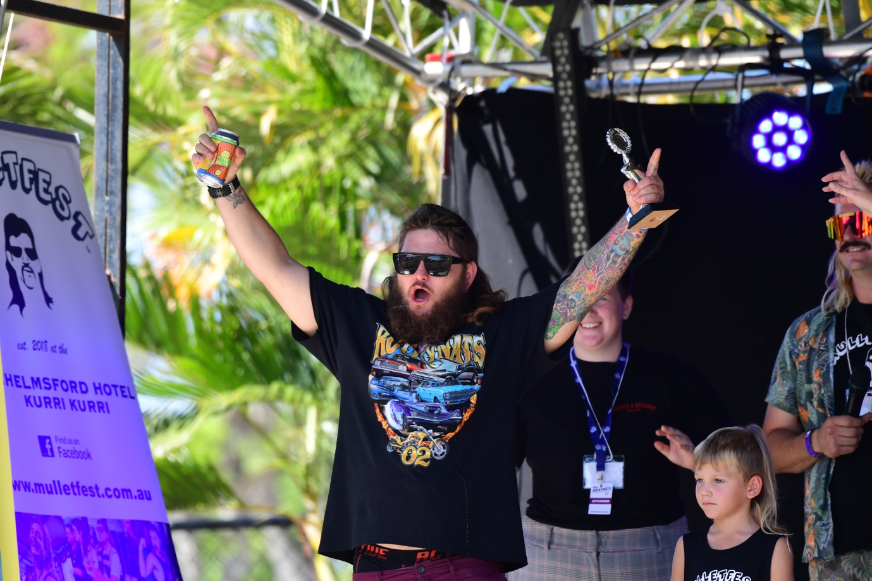

CAPTION: Kane Wright celebrating his win in the Everyday Mullet Category at Rockynats 02

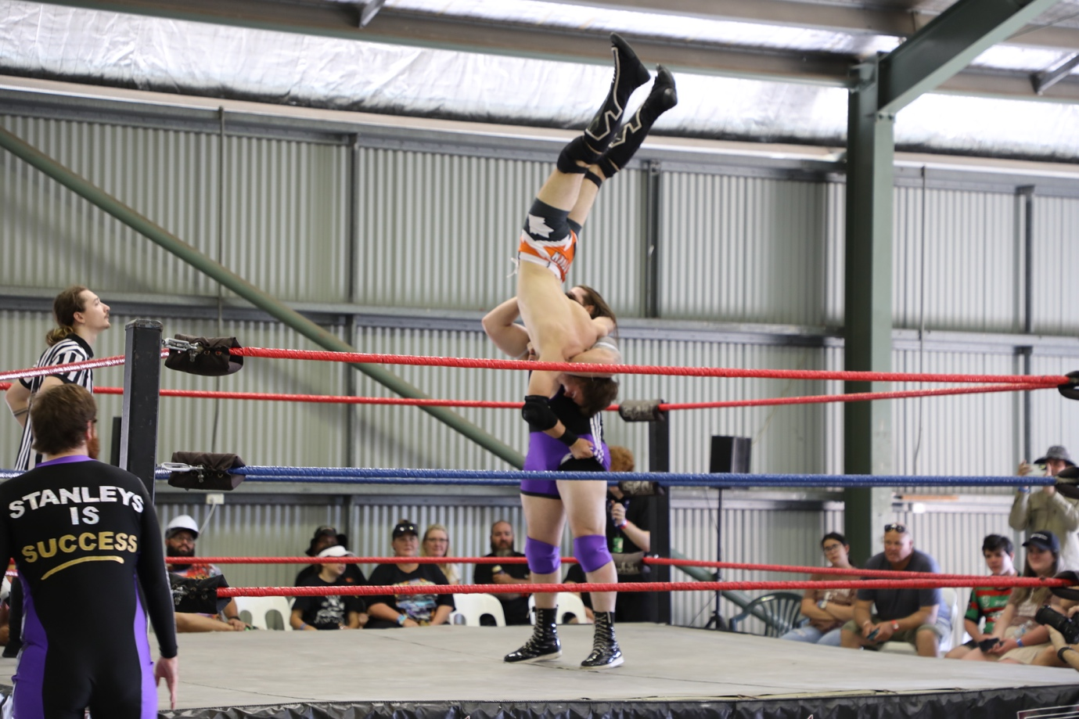

CAPTION: EC Brownie taking down Jason Storm in the Pro Wrestling Match at Rockynats 02

