[Media Release – Rockabillynats Pin-Up Comp]

All new pinup pageant set to rock the stage at this year’s Rare Spares Rockynats festival

The inaugural Miss Rockabilly-Nats Pinup Competition is set to bring plenty of garage glam to this year’s Rare Spares Rockynats festival when entrants take to the stage in what will be the first major pinup pageant of its kind to be held in the Rockhampton region.

Open to entrants aged 18 and over, competition host and 10-time pinup champion, Billiejean Sweets, says it’s an opportunity for everyone to express their individuality, personality, and rockabilly style.

“Pinup is all about dressing up, having fun, and expressing yourself with no judgement. It’s not like a beauty pageant where your performance is based on your height, body type or size,” says Billiejean, who hosts and competes under the name ‘Miss B Sweet’. “Literally anyone and everyone can do it and it’s the most open, accepting environment to be a part of.”

This is something she’s experienced first-hand, having won her first pinup competition with no prior pinup experience.

“I’ve been part of the car scene for as long as I can remember, and my love of pinup started when my father and I bought a 1953 Chevvy together back in 2017. I bought my first dress from my friend Tegan at Atomic Vintage and somehow, despite just showing up on the day and giving it a go, I walked away with the 2017 Classics by the Coast Pinup crown,” she explains. “I was hooked, and that one pinup dress has since turned into a collection of over 120!”

Billiejean has since gone on to add several pinup titles to her name and now competes with her son, Beau, who has special needs.

“My favourite thing about pinup is that you’re part of such a great, supportive community. Everyone is encouraged to get up, have a go and just be themselves up on stage. You’re allowed to be who you want to be.”

As a born and bred Rockhampton local who made the move to Brisbane in 2019, the city holds a special place in her heart and the inaugural Rockabilly-Nats Pinup Competition is something she couldn’t be happier to see come to fruition.

“I’m so excited to be back in my hometown and to show the pinup world what our little city is capable of,” she says. “We don’t have a big pinup scene up here and so bringing such as high calibre pageant to Rockhampton is something I’m incredibly proud to be a part of.”

“It’ll also be one of the few pageants attached to a street parade, which makes it even more exciting. I know girls who are travelling from all over to be a part of it.”

Entries for the 2022 Miss Rockabilly-Nats competition remain open until Sunday March 27, with everyone 18 and over able to take part. Entrants must submit two photos that reflect their best ‘Rockabilly-nats’ style via the form on the Rockynats website, with the top 10 finalists to be announced prior to the event. These finalists will then compete for the inaugural Miss Rockabilly-Nats title during the event in Rockhampton on Friday April 15, with a host of cash and prizes on offer.

“The sponsors we’ve been able to get on board are amazing, with prizes for 1st, 2nd, 3rd and two encouragement awards” says Billiejean.

Prizes include vouchers and hair products from Cut Throat and Curls Hair Studio, clothing vouchers from online vintage retailer Rumbling Hearts and a photoshoot for the Retro Lovely Magazine courtesy of Elite Photo Studio.

As for tips on nailing this year’s theme, Billiejean says channelling a glam garage look will be key. “Think race car drivers, Rosie Rivert and take inspiration from that,” she says. “At the end of the day though, just be confident, don’t second guess yourself and have fun!”

Enter today at https://www.rockynats.com.au/Get-Involved/Miss-Rockabilly-Nats-Pinup-Competition

ENDS.

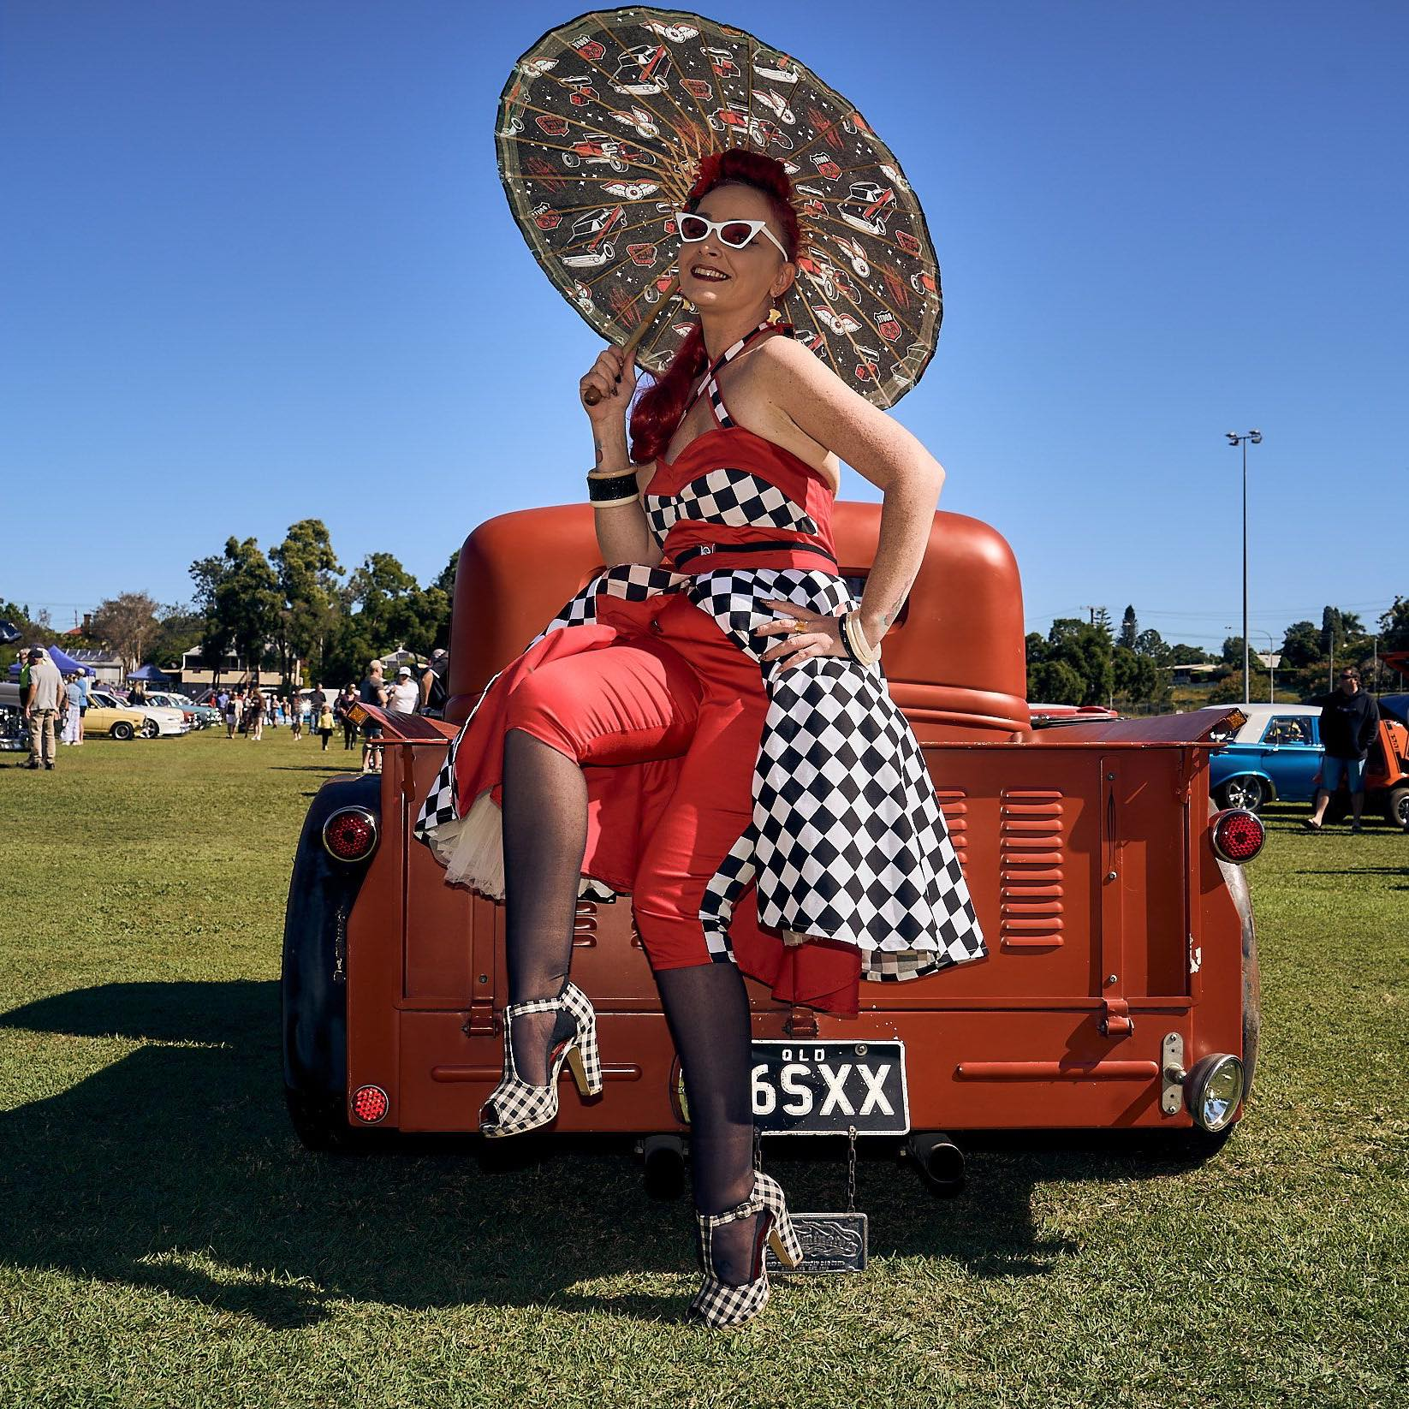

CAPTION: Pageant host and 10-time pinup champion, Billiejean Sweets, can’t wait for the inaugural Miss Rockabilly-Nats Pinup Competition to be held as part of this year’s Rockynats festival.
Photographer: B Harris Photography.

