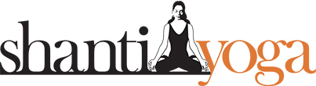

7-10-21

Using Ancient Medicine in Modern Times Workshop is on 14th October Southport QLD
FOR IMMEDIATE RELEASE

World Renowned Yogi, author, TV celebrity and the founder of the Ayurvedic Medicine RTO in Australia Shanti Gowans is doing a rare public workshop on restoring health in these chaotic times at 126 Scarborough St Southport QLD on the 14th and 19th October at 6.30pm
The goal of the workshop is to help the community that is suffering during these trying times and sharing simple proven solutions that have worked for the last 5000 years.
The Title of the workshop is “Ancient Medicine for Modern Day Living”
Aruveydic medicine is an alternative form of medicine that has been used since before the time of the Buddha.
The word Ayurveda means "not to cause harm." It uses special diets, herbs, treatments and massage, along with meditation to heal and detoxify the body. It is also the oldest surviving medical system in the world.
According to the Tribune India recently Prince Charles used these techniques when he came down with a “mysterious illness”
This is a free public event where all questions are encouraged.
###
Shanti Yoga has been helping people on the Gold Coast for over 50 years achieve better health naturally treating clients and patients at their Health Retreat located in Beechmont
Contact Information:
Shanti Gowans – 0413542154
Sonja – 0422216372
Ian Marsh – 0466427900 (best contact)
Shantiyoga.com.au
streetsmarts@me.com

