MEDIA RELEASE
14 September 2021
CREATE FOUNDATION CALLS FOR
MAKING IT 21 NATIONALLY!
CREATE supports Homestretch Symposium #2, the continued collaborative effort to elevate the voices of children and young people in care, towards the urgently needed implementation of options for support and housing for care leavers to the age of 21 - nationally.
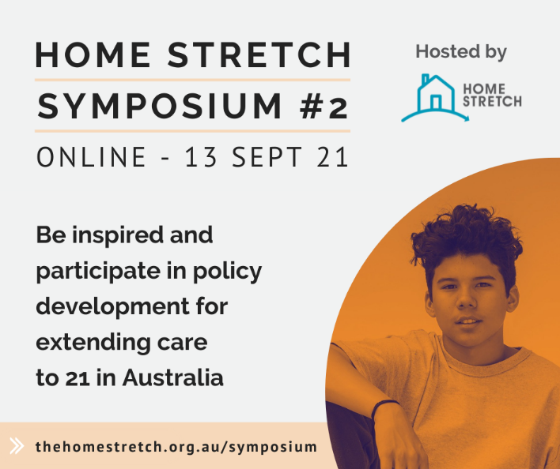
In Australia alone, over 44,906¹ children did not sleep in their own home last night and are presently growing up in out-of-home care. CREATE Foundation’s two decades of independent consultations with children and young people in care highlight the importance of providing options for young care leavers to have placement choices till 21.
During yesterday’s Homestretch Symposium, Dr Joseph McDowall, CREATE Foundation’s Executive Director of Research, delivered a presentation sharing the voices of children and young people with a care experience via the findings of the latest Post-Care Report.
Two starkly contrasting stories revealed in the Post-Care Report clearly illustrate the difference between having support past 18 and being without.
“I was homeless and paying $80 a week for bus tickets… I’d used the sink and the soap dispenser in the public toilets to wash my clothes, and I still went to school every day without anyone knowing my position. It all got too much, I just kept going downhill. My life eventually fell in to turmoil. I wasn’t able to keep on top of things. My troubles outweighed my happiness and I became overwhelmed. I had to give up on my education because I could no longer do everything by myself. It was really quite sad, because all I wanted was to complete year 12…” (Male, 21 years)
“I’m blessed and very fortunate to have been given all the opportunities and support in my life so far, from my carers, relatives, and school communities. I can only hope that my future in studying and other areas of life can be as fruitful and fulfilling as it has been so far.” (Male, 19 years)
Recently, Ms Jacqui Reed, CREATE’s Chief Executive, and 22-year-old Caroline, CREATE Young Consultant, were featured ‘live’ on ABC Brisbane Mornings with Rebecca Levingston radio program, where Caroline spoke candidly about her care experience and Ms Reed spoke of the urgent need for all states and territories to step up and enable young people to have a choice regarding supports and housing to age 21.
Caroline grew up in care and when asked about making it 21 she said, “I’m yet to meet a parent who says that their kid won’t need them when they are 18.” Caroline shared that when she turned 18 she was given a cake by workers, a small gift and then wished “goodbye”. This was an abrupt and disarming exit from care and no avenue for return when she needed support.
CREATE Foundation is the national consumer body representing the voices of children and young people with an out-of-home care experience (including kinship care, foster care and residential care). CREATE develops policy and research to report on and advocate for a better care system.
“In recent years, we are encouraged to see more young people completing their education, yet there is still so much work to do when we are seeing 35% of young people becoming homeless in the first year of leaving care or turning,” shared Ms Jacqui Reed.
“That figure of 35% has not changed and this is very distressing when the data shows the sector and decision makers what is needed, when. Queensland and New South Wales seem to be lagging and potentially thinking that carers are going to come to the rescue, or that other priorities come before raising the age to 21.”
“These vulnerable young people need support and they are not doing a great job at transitioning these traumatised young people out of care. There is a lack of planning or safe housing, to say the least,” added Ms Reed.
CREATE calls for nation-wide recognition of the need for all young people with a care experience to have the option of resourcing and supports to 21.
Find out more about Homestretch Symposium: https://thehomestretch.org.au/symposium

Read about young people’s transitioning from care experiences in CREATE’s independent consultations on CREATE's Research Page or, visit CREATE’s website at www.create.org.au

For further comment from CREATE’s Chief Executive, Ms Jacqui Reed, and/or a young person with care experience contact Leigh White, CREATE Communications Advisor, via (m) 0431 932 122 or leigh.white@create.org.au
Key statistics on the care sector in Australia:
- 44,906 children were in out-of-home care across Australia, June 30, 2019 (AIHW 2020)
- Young people in out-of-home care are 16 times more likely to be under a youth justice order than the general population
- 35% of young people experience homelessness within the first year of leaving care
- 46% of males have been involved with the justice system since leaving care
- 29% of young people who have left care or preparing to leave care are unemployed
- 36% children and young people in care do not live with any of their siblings
- 35% of young people in care have five or more caseworkers during their time in care
- 67% of young people in care over the age of 15 are not aware of having a leaving care plan
McDowall, J. J. (2018). Out-of-home care in Australia: Children and young people’s views after five years of National Standards. Sydney: CREATE Foundation.

