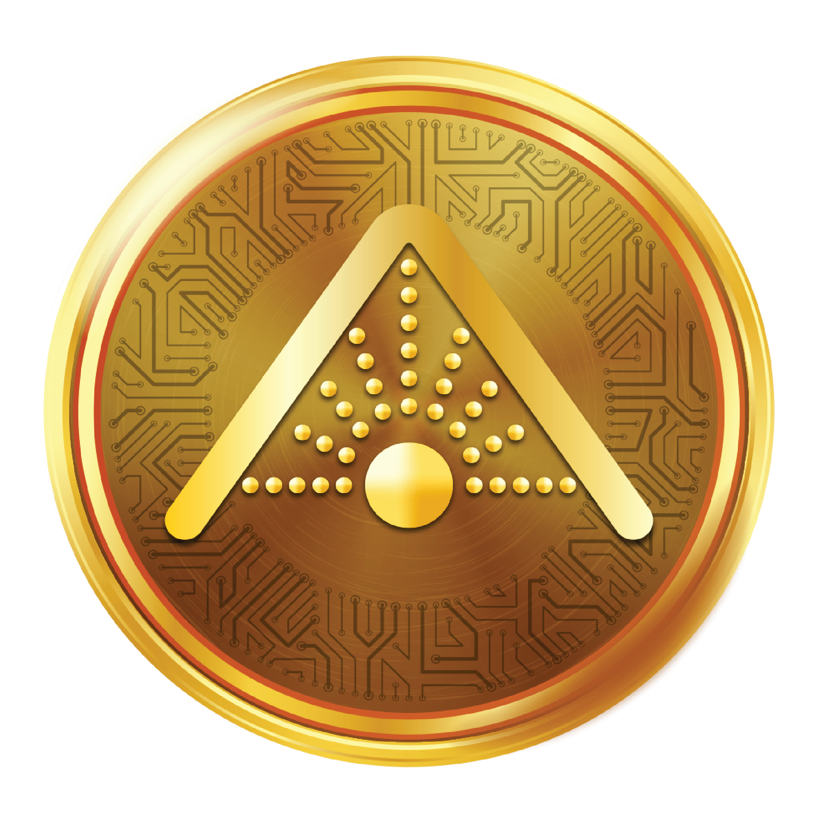

PRESS RELEASE:

ASTRcoin™ Listing Starts on Emirex
ASTEROID AUSTRALIA PTY LTD
“The Stars Are Ours!”
11/241 Arthur Street, Teneriffe, QLD 4006
+61 1.800.950206
Asteroidltd.com | ASTRcoin.io | Emirex.com
FOR IMMEDIATE RELEASE
ASTRcoin™ Listing on EMIREX
Teneriffe, QLD March 10 2021 – ASTEROID AUSTRALIA PTY LTD. (“ASTEROID”), announce the listing of ASTRcoin™ on EMIREX



EMIREX is a leading Middle-East cryptocurrency exchange:
• $100,241,991+ 24h volume daily turnover
• ZERO Trading Fees 15 March – 16 April
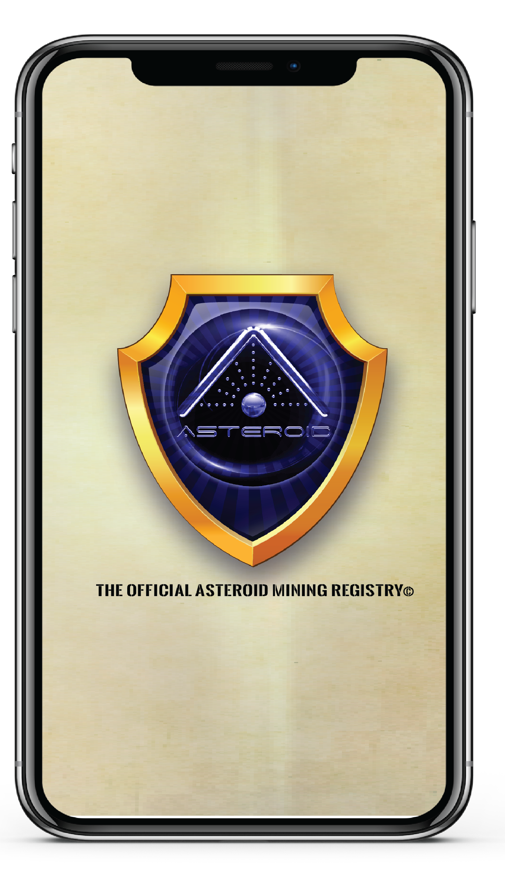
ASTEROID has codified over 937,163 asteroids, 2.5 years in the making, in a DLT (“distributed ledger environment) worth some $700 Quintillion dollars, allowing people to register their “claim” to space on an immutable blockchain ledger called a BlockClaim™. The BlockClaim Protocol uses a commodity token called an ASTRcoin™. Each ASTRcoin™ represents one Block Claim™. Liquidity and sustainability are ensured as the protocol develops. The ASTRcoin™ is unlike any other cryptocurrency, in that, each ASTR token is backed by a BlockClaim™ of $1,000,000 USD. The intrinsic value of the ASTRcoin™ is presently $200 Billion Dollars, with 200,000,000 ASTRcoin™ in circulation and thus each ASTRcoin™ has an intrinsic value of $1000. As the system deploys the market will respond in both liquidity and value. As in the advent of the internet each .dotcom grew in value as the marketplace understood the protocol. In much the same way, The ASTRcoin™ is positioned to be the new Bitcoin of space.
The BlockClaim™ Protocol is a proprietary ecosystem was designed to allow space to be democratised for all. humankind. Of course, this is, as the Outer Space Treaty of 1967 specifically requires. Simply, no sovereignty, no nation-state, nor any empire may claim space for themselves, but rather space will be for all humankind.
“The BlockClaim™ ecosystem will allow anyone the ability to claim the vast wealth contained in space. Our goal is to enhance the lives of millions upon millions of people worldwide. Everyone needs to be allowed to partake in the abundance that is set before us. What the internet did for the flow of information and education, in the Information Age; the ability to register and receive the benefit from a BlockClaim™, will help us all come into the Space Age. It could be an age where every person will be allowed to develop their individual potential and receive a significant share of the final frontier.
To learn more …
About ASTEROID AUSTRALIA PTY LTD.
ASTEROID is a space technology company using innovative blockchain protocols to deploy the BlockClaim™ Protocol. The company’s mission is to provide a distributed ledger registration technology and make it available to all humankind. What the internet has done for the Information Age, BlockClaims™ will do in the Space Age. To learn more about the BlockClaim™ Protocol in this new trillion-dollar market of Asteroid Mining, and ASTRcoin™, visit its websites at:
For BLOCKCLAIM™ Protocol
Info: www.asteroidltd.com
For ASTRcoin™ Information
Info: www.astrcoin.io
For EMIREX EXCHANGE Information
Info: www.EMIREX.com
For ASTEROID SOCIETY
Info: www.asteroid.org
For ASTEROID Associate
Info: www.asteroid.rocks

