Australia’s Rarest Gold Coins and Colonial Currency at Auction

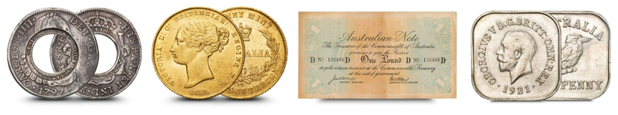

Roxbury’s Signature Sale returns next week with over 2,500 lots of rare coins, notes, medals & memorabilia - including several pieces never before offered publicly.

The Australian numismatic world is set to converge once more as Roxbury’s Auction No. 147 ‘Signature Sale’ opens for bidding from Wednesday 23rd to Friday 25th July. This highly anticipated event features more than 2,500 lots, including a stellar array of pre-decimal rarities, historical gold and iconic colonial issues - all offered from Roxbury’s new state-of-the-art headquarters in Brisbane.

Among the standout lots are:
- Australia’s first-ever half sovereign, the 1855 Sydney Mint Type I - a landmark coin in stunning condition (Current bid: $50,000)
- A rare 1914 “Rainbow Pound” emergency banknote, with only ~32 surviving examples (Starting bid: $15,000)
- An exceedingly rare 1857 Proof Half Sovereign (Sydney Mint, Type II), one of very few known examples (Current bid: $50,000)
- An 1813 NSW Holey Dollar featuring a scarce unlisted die pairing - a colonial icon with exceptional pedigree (Starting bid: $90,000)
- Highlights from the RAM Mint Master Collection, early Australian proof sets, military medals, and more

“This sale is a testament to the depth and passion of Australian collectors,” said Roxbury’s Director Scott Waterman. “From museum-level gold to the coins once carried in our early settlements, this auction tells the story of Australia’s numismatic heritage. With growing consignments, enthusiastic buyers and exciting market developments, we’re seeing a lot of momentum in numismatics – particularly here in Queensland.”

Roxbury’s Signature Sales have become known for delivering significant results for vendors and collectors alike, with past highlights including six-figure sovereigns, unique pattern pieces, and previously unseen private collections.

What makes Auction No. 147 unique?
This is the first major sale to be held from Roxbury’s newly expanded headquarters - featuring improved auction facilities, expert on-site grading support, and a growing team of specialists including, notably, Penny (@coincollectingcavoodle), the company’s newly appointed Client Liaison Officer and furry Collector-In-Chief.

Event Details:
📅 Auction Dates: Wednesday 23 – Friday 25 July 2025
🌐 Online Bidding: bid.roxburys.com.au
📘 Full Catalogue Available Now

For media enquiries, high-resolution images, or for more information, please contact:
✉️ scott@roxburys.com.au
📞 07 3831 2599

