Biodiversity Loss 2025
Introduction.
This report updates my paper ‘Biodiversity Loss 2022’ pages 18-22^{[1]}, incorporating added data for the last three years. I define biodiversity, give a measurable definition of biodiversity loss and then develop a trendline over time for biodiversity loss in Australia. This is extended to show that the present trend is unsustainable and set out some suggestions that may alleviate the problem.
Definition of Biodiversity.
Every hectare on earth evolved as a unique community of living organisms, each dependent on the Community and with the Community dependent on each organism. A community is made up of sub-communities and collections of communities make larger communities. Each one is unique, like fingerprints. Sometimes this is called the ‘web of life’. We have somewhere between 3 million and 100 million species of living organisms living within these communities. About 3 million are described and named while the rest are neither described nor named. The collection of all these communities, the organisms within them and the links between the different organisms, all together give us this amazing thing we call biodiversity (biological diversity).
The health of Biodiversity.
We do not have a measure of biodiversity as such, but we can measure Biodiversity Loss. As the links binding these organisms together are broken, some species lose their place and reduce in numbers. When this occurs across many communities, the number of this species decreases dramatically. It loses the niche it evolved to fill, and we class it as threatened with extinction. We define biodiversity loss, for a class of organisms, as the fraction of species, within the class, threatened with extinction.
Whereas we may not know the total number of species threatened with extinction within a class, we can get a fair estimate of the percentage threatened simply by taking a sample and looking at the percentage of the class that is threatened with extinction, as we do with polling to guess who is going to win an election. Overall data from the IUCN shows that 27% of the world’s species are threatened with extinction⁶.
An Example.
In July 1991 Warrawong Sanctuary was busy introducing Australia’s endangered wildlife to the world. It had just won the SA Tourism Awards, and I had worn my infamous cat-hat to the awards night. On the 1st of August 1991 my photo, wearing the hat, was on the front page of the Advertiser. At the same time Australia’s Environment Ministers were meeting in Adelaide. Susan Lenehan was South Australia’s Minister for the Environment. She was a great fan of Warrawong Sanctuary. She told me afterwards the Environment Ministers were all very impressed with the work Warrawong Sanctuary was doing. She had been able to put Australia’s Loss of Nature on the political agenda. In 1992 the first Endangered Species Act was passed by the Federal Government. This was followed by the first Biodiversity Act 1996 which was updated in 2000. And that was the end of that. The Government took my sanctuaries from me and closed me down. Australia’s Loss of Nature was taken off the political agenda. Australia’s Biodiversity continued hurtling towards extinction.
Only one positive came from it all. The Biodiversity Act 1996 commissioned the Australian Department of Environment to set up a monitoring programme to monitor the loss of Australian biodiversity. This means that you can go to the Department of Environment website² and extract the number of Australian Land Vertebrates which are ‘threatened with extinction’. This is the numbers:
Giving these numbers to EXCEL and asking it to give you a trendline gives the following chart:
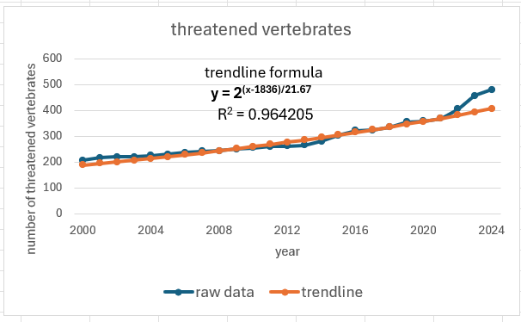
The number of threatened vertebrates = 2^{(x-1836)/21.67}, where x is the year.
The important bits are: The R² value tells us that the correlation between the raw data and trendline is excellent. The ‘1836’ tells us that the first Australian vertebrate to become threatened was around 1836, just 48 years after white settlement. The ‘21.67’ tells us that since 1836 the number of threatened vertebrates have steadily doubled every 21 years and 8 months. Which in turn tells us that we have done nothing, since 1836, to reduce this steady growth. Some may say that the situation would be worse if nothing had been done. But! The fact is that the data shows that things could not be worse. The trendline shows that within 50 years all 2400 Australian Vertebrate species will be threatened with extinction and Nature will no longer exist. Meanwhile, the United Nations tell us that Humanity cannot survive without Nature⁹.
Exponential Growth.
To better understand the gravity of Biodiversity Loss, there is a need to understand Exponential Growth. Every living organism is capable of exponential growth if the environment suits it. It is only because external forces control its growth that we have the feeling of stability. In 2005, Ray Kurzweil published his book titled “THE SINGULARITY IS NEAR” ^{[3]} consisting of 600 odd pages trying to explain exponential growth to non-mathematicians. I will attempt to do it in one page.
An example of exponential growth is fully defined by giving its doubling period, together with one data point. We start with the classic water lily puzzle ^{[4]}, which asks the following:
‘Question: In the middle of a round pool lies a beautiful water lily. The water lily doubles in size every day. After exactly 20 days, the lily will cover the complete pool. After how many days will the water lily cover half of the pool?
Answer: Because the water lily doubles its size every day and the complete pool is covered after 20 days, half of the pool will be covered one day before that, i.e. after 19 days.’
We can extend this puzzle to any example of exponential growth. Every example of exponential growth is associated with a doubling period. We can therefore take our time scale as the number of doubling periods. Since we live on a finite earth any exponential growth must reach a limit. If we designate this limit as 1, we can use fractions of I (the limit) as our measure of the size. In addition, we can take our time as zero when we are at the limit.
By doing this, every example of exponential growth is given by one example as shown below.
Every example of exponential growth is given by the following chart:

In the example given above the doubling period is 21 years and 8 months and at present we have 0.2 of our Land vertebrates threatened with extinction. So! If the present trend continues, we will be at 1 by 2074.
The important point here is that we do not need to know the total number of threatened species in a class. We just need to know the fraction of the class that is threatened with extinction. To find this out, we simply take a random sample. The size of the sample needed can be found simply by going to the Australian Bureau of Statistics’ website ^{[5]}. A sample size of only 250 will give you suitable accuracy.
An interesting point is that you can also project the trendline, in the chart above, back as well as forward. There were 480 Australian vertebrates threatened in 2025 and so there were 240 threatened 21 years and 8 months before that, etc etc etc and so in 1830 the first threatened vertebrate appeared in Australia. Which is probably pretty accurate. So, this means that from 1830 the number of threatened vertebrates in Australia has steadily doubled each 21 years and 8 months up till 2025 and nothing that we have done has slowed that growth one iota.
Another interesting point is that the trend in biodiversity loss for Australian Land Vertebrates correlates exactly with the growth in Australia’s GDP. So, when our Treasurer tells us that he expects 3% growth next year. He is telling us that he expects the number of threatened Land Vertebrates in Australia to increase by 3%. It is as simple as that. Biodiversity loss is totally caused by Human Activity. It is not caused by farmers and miners. It is caused by you and me. Of course, our farmers and miners are causing the damage, but we are demanding they do it.
What we know.
If we look at the world stage. According to the International Union for Conservation of Nature (IUCN) see the table below ^{[6]}, 18% of the 63,761vertebrates they have evaluated are threatened with extinction. 23% of the 27,906 invertebrates they have evaluated are threatened with extinction and 28% of the total number they have evaluated are threatened with extinction. If the present trend continues, and there is no reason to believe it won’t, then in 40 years 100% of the world’s vertebrates will be threatened with extinction. Although IUCN states ‘
Where <80% of species within a group have been evaluated, figures for % threatened species are not provided because there is insufficient coverage for these groups. It is only possible to provide reliable figures for % threatened species for those groups that are completely or almost completely evaluated (e.g., mammals, birds, amphibians and gymnosperms.’
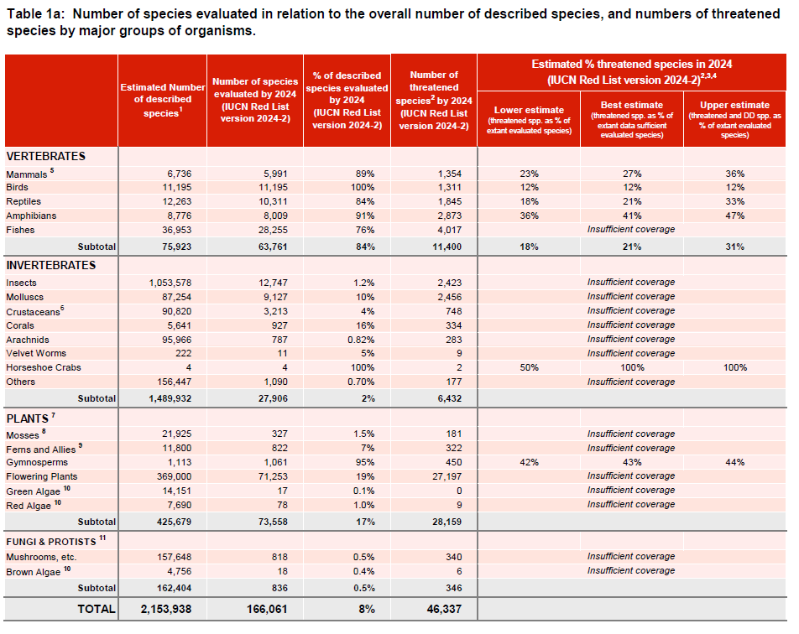
Insects.
Quoting from a United Nations Report of 2019 ^{[7]}:
“Insects make up about half of all known living organisms. They play key roles in, pollination, nutrient cycling, food chains for birds and other insectivores, and are one of the pillars of our ecosystems.
“Across the world, more than 40 per cent of insect species are declining and a third are endangered, the analysis found. The rate of extinction is eight times faster than that of mammals, birds and reptiles.” This means that the period for insect loss is 5 years and 5 months.
Therefore, if 40% were declining 5 years ago, we can assume 80% are declining today. Or! In a recent article I wrote, “There ain’t no insects no more” pages 24-26 ^{[8]}.
If the United Nations figures for insect loss are correct, and there is good reason to believe that they are, then not only do insects have the general problems affecting all other living species, but they are especially affected by climate change, and we wage a relentless war against insects. We have actively targeted them. We have already successfully exterminated so many of them.
Over 1% of Australia is soaked with insecticide every year. Every invertebrate on that 1% is killed every year. The runoff ensures that every invertebrate in every creek from this 1% is also killed.
In addition, most households have a can of fly spray so that any unwary insect venturing into humanity’s living space can be quickly dealt with.
The life cycle of many species of insects is driven by climate. For example, the times of hatching of males and females may vary and depend on climate. I have a cabin in the Flinders Ranges and on a recent visit there was a plague of harlequin bugs. There were literally millions of them. It was early Spring. But there was none of the normal harlequin bug hanky-panky. It turns out they were all female. The males turned in early Autumn. I’m not sure if they can make that work. No baby harlequin bugs this year. Is this the end of this species?

It is interesting to go back in time with the insect trendline. It shows that the first insect to become threatened with extinction in Australia was about the time they figured out that DDT killed insects.
How Biodiversity Loss is managed in Australia.
The short answer to how Australia manages biodiversity loss is that it doesn’t. It monitors some species. If it is decided that a species in threatened, it hands it over to the ‘Threatened Species Commissioner’ whose job it is to make sure they do not go extinct. The trend in threatened species shows that nothing, which works, is done to stop species from becoming threatened. The result is that sometime between now and the end of the century, all Australian species will be classed as threatened.
What does all this mean?
This would mean that, probably the only species left would be those with links to us (homo sapiens) and weed species. There will be domestic stock, pets, plants grown for food and fibre, garden plants, and of course both weeds and animal pests. And of course, there will be Zoos and Botanic Gardens. There will not be this thing called ‘nature’, as we now know it, anymore. According to UNESCO⁹, ‘Humanity cannot survive without nature’. If we lose nature within the next 50 years, where does this leave our grandchildren of today?
Some suggested Directions.
What can be done?
There are three ‘elephants in the room’. Let me start with the first, namely Climate.
Probably about a third of our biodiversity loss is caused by Climate Change. We are fully aware of what causes climate change. We know exactly what needs to be done to reverse climate change. But we do nothing. We yabba on a lot. Our politicians give us targets. However! It is quite clear that they do not even know what they are talking about. They say, we have to reach net zero by 2050. It is clear they do not even know what net zero is. It is estimated that in 2024 our (the world) emissions will increase by about 200,000,000 tonnes on the 2023 number. If you take the excel trendline, it will tell you the 2050 emissions will increase by about 100,000,000 tonnes on the 2049 number. Not only will the emissions not be zero by 2050, but the increase in emissions per annum will not even be zero.
ON PRESENT TRENDS OUR EMISSIONS IN 2050 WILL BE 40 BILLION TONNES.
I will not attempt to try and analyse these numbers further. An excellent book has just been released called ‘THE CLIMATE BOOK’ put together by Greta Thunberg, which features the views of over 100 leading scientists. You should have a look at it if you need to be convinced. I just quote one sentence:
“THE MESSAGE THAT SHOULD LODGE WITH POLITICIANS AND THE PUBLIC IS THAT CLIMATE CHANGE MUST BE AVERTED AT ANY PRICE BECAUSE ITS ULTIMATE COST CAN NEITHER BE IMAGINED NOR CALCULATED.”

The biggest, by far, elephant in the room is AGRICULTURE. Agriculture is the cause of over 50% of biodiversity loss.
Over 60% of Australia's land area is used for farming.
Sixty per cent of all flora and fauna species are fauna species with more than 4 legs. When an area is sprayed with insecticide, all fauna with more than 4 legs are killed (plus others). Over 1% of Australia is sprayed with insecticide each year in the name of agriculture. The insecticide is washed into our waterways and all fauna with more than 4 legs are killed there, etc. etc. etc.
Invasive species from cane toads to buffel grass were introduced to Australia in the name of agriculture.
Regenerative agriculture is an evolution of conventional agriculture, reducing the use of water and other inputs, and preventing land degradation and deforestation. It protects and improves soil, biodiversity, climate resilience and water resources while making farming more productive and profitable. Organic agriculture also called ecological or biological farming, is an agricultural system that uses fertilizers of organic origin such as composted manure, green manure, or bone meal and places emphasis on techniques such as crop rotation and companion planting. Natural farming is an agroecology based diversified farming system which integrates crops, trees and livestock with functional biodiversity. These are all improvements on present farming practices which could greatly reduce biodiversity loss. However! They need to be ‘the norm’ rather than a minority practice.
We, and I mean all of us, must help our farmers transition to sustainable farming. A small portion of our farmers are farming sustainably today. There are economic benefits from farming sustainably, but there are economic costs making the transition.
We all must help to make that change because we all will benefit.
Finally, for the last elephant we have the problem of unprotected protected areas. The Kunming-Montreal Global Framework to save biodiversity has 23 action oriented global targets for urgent action over the decade to 2030. Target 3 of this framework is¹⁰:
‘Ensure and enable that by 2030 at least 30 per cent of terrestrial and inland water areas, and of marine and coastal areas, especially areas of particular importance for biodiversity and ecosystem functions and services, are effectively conserved and managed through ecologically representative, well-connected and equitably governed systems of protected areas and other effective area-based conservation measures, recognizing indigenous and traditional territories, where applicable, and integrated into wider landscapes, seascapes and the ocean, while ensuring that any sustainable use, where appropriate in such areas, is fully consistent with conservation outcomes, recognizing and respecting the rights of indigenous peoples and local communities, including over their traditional territories.’
The Australian Government has agreed with this. So! Why the problem. Our government has jumped on the words “protected areas” and ignored the adjectives in “effectively conserved and managed through ecologically representative, well-connected and equitably governed systems of protected areas”.
There is no way that you can say that an area rife with invasive plants and animals is ‘effectively conserved and managed’.
Our government believes that an area is effectively conserved and managed by putting up a sign saying, ‘this is protected’. Therefore, it is my belief that 15% of our biodiversity loss is caused by us not protecting protected areas.
Conclusion.
Using the accepted definition of biodiversity, together with data supplied by the Australian Department of Environment, the IUCN and the United Nations Environment Programme, it has been shown that biodiversity has continued to be lost above trend and will reach, what some experts consider to be the ‘Tipping Point’ by 2050.

References.
- (https://friendsofscottcreekcp.org.au/wordpress/wp-content/uploads/2022/04/BandicootTails186.pdf
- EPBC Act List of Threatened Fauna
- Ray Kurzweil - The Singularity Is Near: When Humans Transcend Biology.
- https://www.geeksforgeeks.org/puzzle-growing-water-lilly/
- https://www.abs.gov.au/websitedbs/D3310114.nsf/home/Sample+Size+Calculator
- 2024-2_RL_Table_1a (1).pdf
- Insect declines are a stark warning to humanity
- https://friendsofscottcreekcp.org.au/wordpress/wp-content/uploads/2023/11/FoSCCP-Bandicoot-Tails-193-Dec2023-Feb2024.pdf
- https://www.facebook.com/unesco/posts/humanity-cannot-survive-without-nature-yet-we-are-treating-the-planet-like-if-we/686155776893307/
- https://www.cbd.int/gbf/targets

Dr John Wamsley OAM
john@johnwamsley.com

