For immediate release

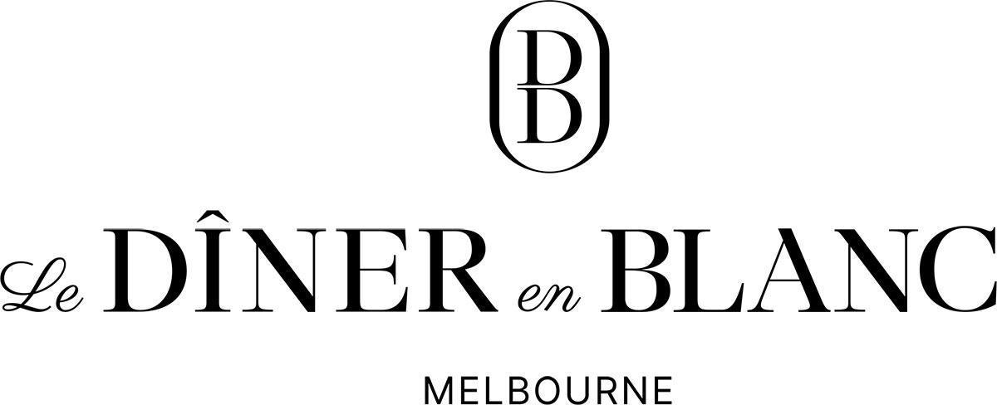

The City’s Largest Dinner Party Returns on Saturday, 29 March 2025

Melbourne, 24 January 2025 - Le Dîner en Blanc returns to Melbourne on Saturday, 29 March 2025, at an exciting new secret location. This chic event is the social gathering of the year, where fashion, gourmet food, and, above all, great company come together in celebration. The sight of hundreds of Melbournians dressed in all-white creates visually stunning, instantly Instagram-worthy moments. Guests will don their finest attire to enjoy a French-inspired evening where conversation and champagne flow freely, adding to the magic of this unforgettable night.

Those wishing to be part of this special night can join the waiting list at melbourne.dinerenblanc.com. Simply click ‘Attend Le Dîner en Blanc’ on the website to create an account and receive an invitation along with all event details as soon as they're released.

Mikaela McKenzie, host of Le Diner en Blanc - Melbourne, is glad that the event is returning to the city: “We’re thrilled to welcome everyone back for another magical year. This event brings together the best of Melbourne's vibrant community, its rich food and wine culture, and its unmistakable elegance - all in one unforgettable night under the stars.”

To maintain the uniqueness of Le Diner en Blanc, every guest has its part to play and observes certain requirements such as:
- Dress code: head-to-toe in white attire only. Elegance and Originality are key!
- Table setting: all white!
- As a French-influenced event, wine and/or Champagne are served.
- As per Victorian liquor licence regulations, guests cannot bring their own alcohol.
  - Guests wishing to enjoy some wine or Champagne, must reserve online through Le Diner en Blanc’s e-store.
  - However, guests are welcome to bring their own non-alcoholic beverages.
  - Security will be conducting bag searches upon entry.
- To ensure that the location secret is kept undisclosed until the last minute, guests meet at their assigned departure location and are escorted by a Diner en Blanc volunteer.
- So, the event location is left as clean as when guests arrived, they are required to leave with all their belongings, leftovers, and litter.

Guests are to bring:
- A table, two white chairs, a white tablecloth.
- A picnic basket comprising fine food and proper stemware and white dinnerware.
  - A catered picnic basket option, or table and chair hire which can be picked up on site, will be available for those who do not wish to bring their own. Guests wishing to do so must reserve online through Le Diner en Blanc’s e-store.

Le Diner en Blanc – Melbourne gratefully acknowledges Pullman and Mercure Melbourne Albert Park, Chocolate in a Bottle, Restaurant Associates, Allegro and Coopers Brewery as official local partners of the 2025 edition of Le Diner en Blanc.

About the Hosts of Le Diner en Blanc – Melbourne
A new hosting team is taking the helm of Le Diner en Blanc – Melbourne in 2025! The new hosts and friends are Kim Thorne, Mikaela McKenzie, and Renee Hundt. They have been avid attendees and volunteers at Le Diner en Blanc in Melbourne for years. Hosting this iconic event is a passion project for them, and with over 40 years of combined event experience, they are excited and privileged to carry on the tradition.

About Le Diner en Blanc
Le Diner en Blanc is so much more than an event. It’s a unique cultural movement that empowers friends of friends to gather and celebrate their shared passions for life, food, fashion, and community, year after year, with a pinch of mystery and large serving of spontaneity. Elegantly dressed all in white, guests arrive at a secret location for a chic picnic en masse. They bring their own tables, chairs, picnic baskets—all the trimmings—to sit down with friends and make new connections in one of their city’s most beautiful public spaces. The location remains secret up until the very moment of arrival. Over the course of the evening, guests from all backgrounds eat, dance, and reconnect with the finer things in life, as they appreciate the night’s magical experience.

To this day, over 120 cities in 40 countries have joined the ever-growing and international network to celebrate gourmet cuisine, offer extraordinary entertainment, and bring together vibrant individuals and bon vivants around the world. While Diner en Blanc International is headquartered in Montreal, Canada, every event in every city is hosted by passionate local organisers who fell in love with the original Parisian concept and wanted to bring it home and dress it up with local flair. For more info, photos, and videos of Le Diner en Blanc events from around the world, visit dinerenblanc.com.

###

To keep up to date on event announcements, visit melbourne.dinerenblanc.com or
 DinerEnBlanc.Melbourne  dinerenblancmelbourne
#dinerenblancmelbourne #debmelbourne2025 #dinerenblanc

For media requests, interviews or images, contact:
Mikaela McKenzie, Evar Events – m. 0431 411 288 – e. media@melbourne.dinerenblanc.com

